**ELECTRIC POTENTIAL**

**Exercises**

**Section 22.1 Electric Potential Difference**

**15.** **Interpret** For this problem, we are to find the work required to move 50 μC of charge through a potential difference of 12 V. Recall that the SI units of potential difference in volts is in J/C, so it represents the potential energy difference per unit charge.

**Develop** The potential difference in volts is the negative of the work required per unit charge in moving a positive charge from point *A* to point *B*. Mathematically, this may be expressed as

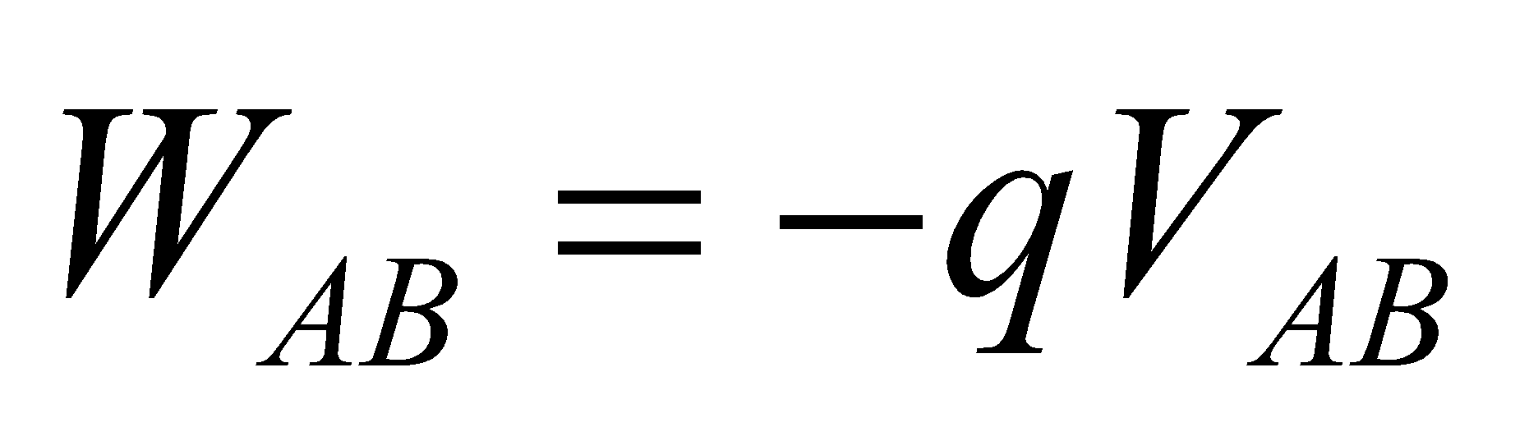

(see also Equation 22.1a). For this problem, the potential difference is −12 V because we are moving against the potential difference (or against the electric field, so from high potential to low potential), so we can solve for *WAB*.

**Evaluate** Inserting the given values gives

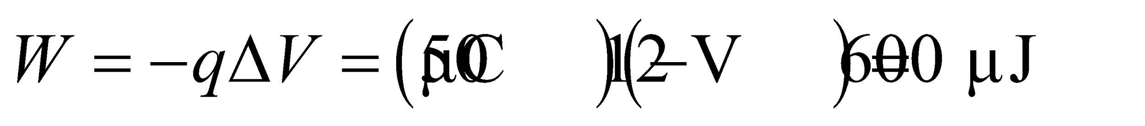

**Assess** Work is required to increase the potential energy of a charge.

**16. Interpret** This problem deals with the energy gained by an electron as it moves through a potential difference *ΔV*.

**Develop** We assume that the electron is initially at rest. When released from the negative plate, it moves toward the positive plate, and the kinetic energy gained is 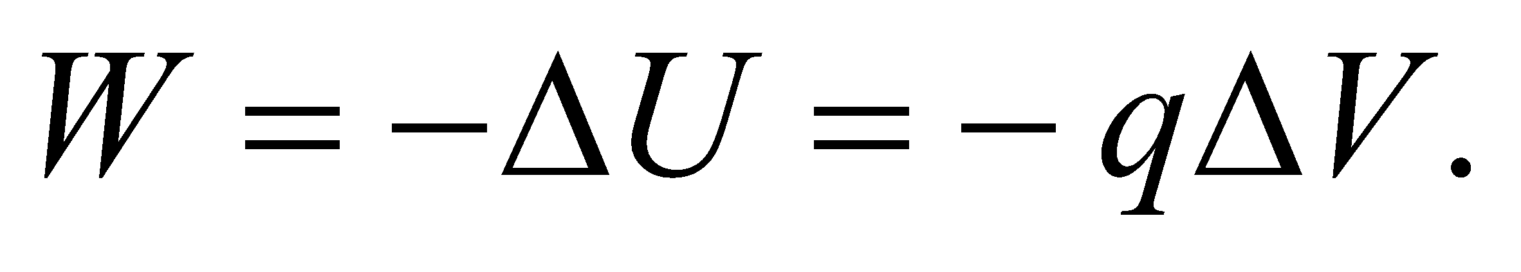

**Evaluate** As the electron moves from the negative side to the positive side (i.e., against the direction of the electric field), the *kinetic* energy it gains is



**Assess** Moving a negative charge through a positive potential difference is like going downhill; potential energy decreases. However, the kinetic energy of the electron is increased.

**17.** **Interpret** This problem involves calculating a potential difference per unit charge between two points given the work required to move a given charge between the two points.

**Develop** The work done by an external agent against the electric field is the potential energy change, 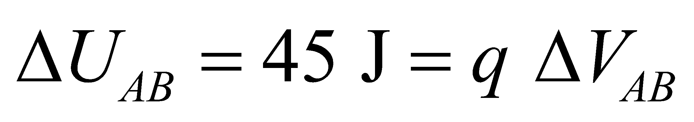.

**Evaluate** Solving for *ΔVAB* and inserting the given values gives

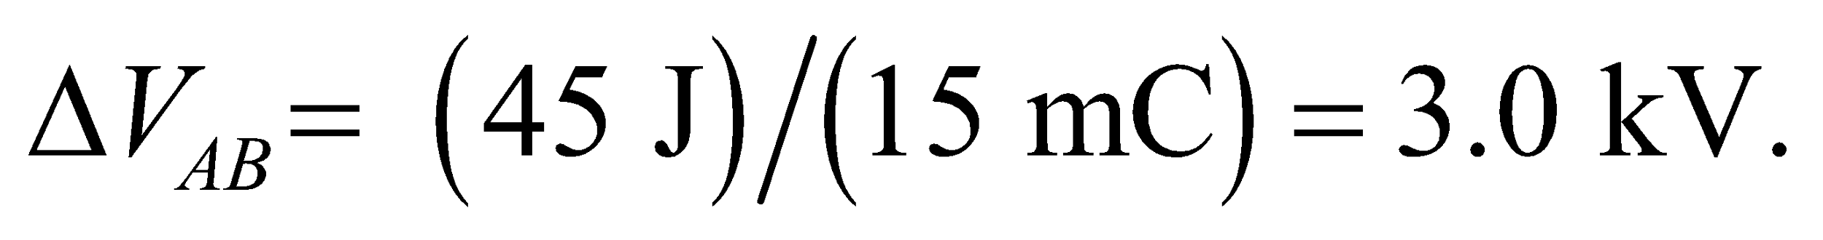

**Assess** Note that the work done *by* the electric field is the negative of the potential difference between two points.

**18. Interpret** This problem is an exercise in converting units.

**Develop** By definition, 1 V = 1 J/C and 1J =1 N·m. Use these relationships to find the relationship between 1 V/m and 1 J/C.

**Evaluate** Combining the two expressions gives

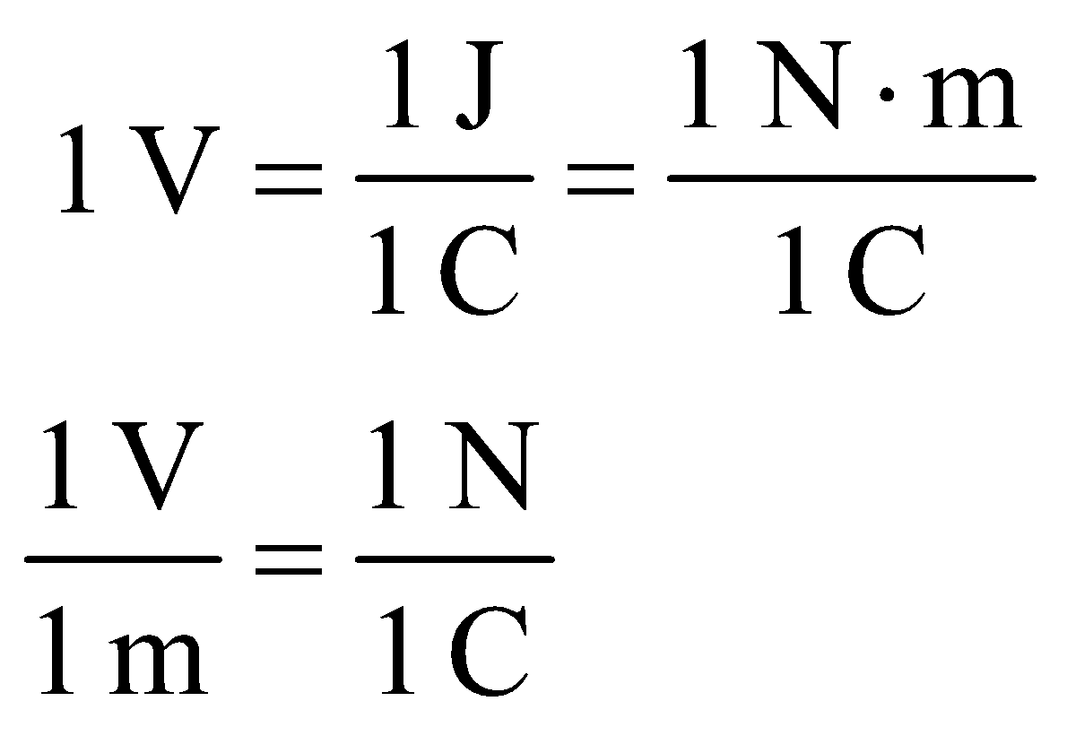

Thus, 1 V/m = 1 N/C.

**Assess** These are the units for the electric field strength.

**19.** **Interpret** This problem is an exercise in calculating the potential difference between two points, given their separation and the magnitude of the uniform electric field between the two points.

**Develop** Apply Equation 22.1b, which applies for a uniform electric field.

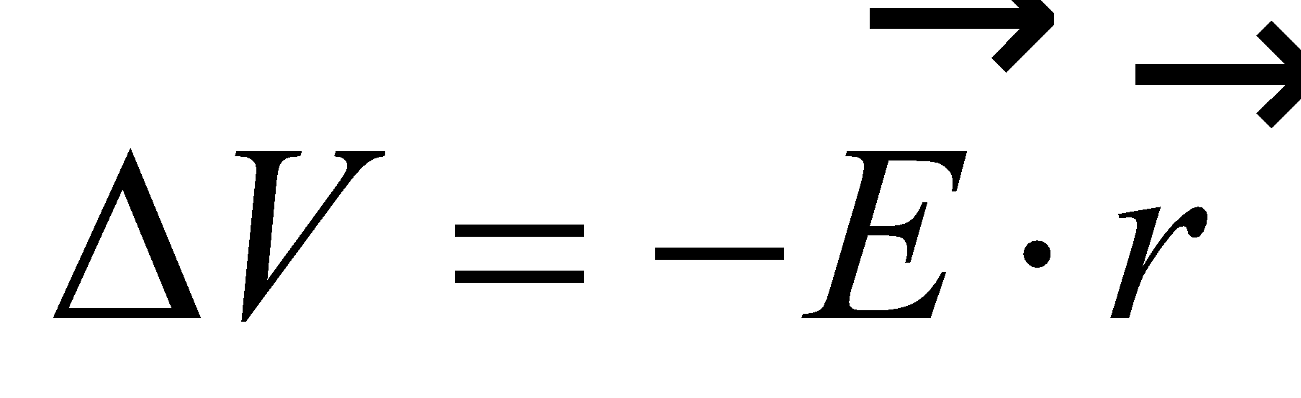

Because we are moving parallel to the electric field, the dot product gives cos(0°) = 1. Also, because we are only interested in the magnitude of the potential difference, we can omit the negative sign.

**Evaluate** The magnitude of the potential difference is

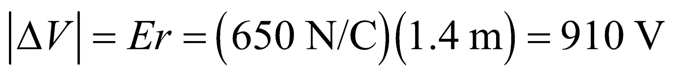

**Assess** If this involves a charge moving with (against) the electric field, the potential will decrease (increase).

**20. Interpret** This problem is about the work done by a 9.0-V battery to move the given (positive) charge from the positive terminal to the negative terminal. The battery is thus moving a positive charge in the direction of the electric field, so the potential difference is negative.

**Develop** The work done by the battery is equal to the kinetic energy gained by the charge, and is given by

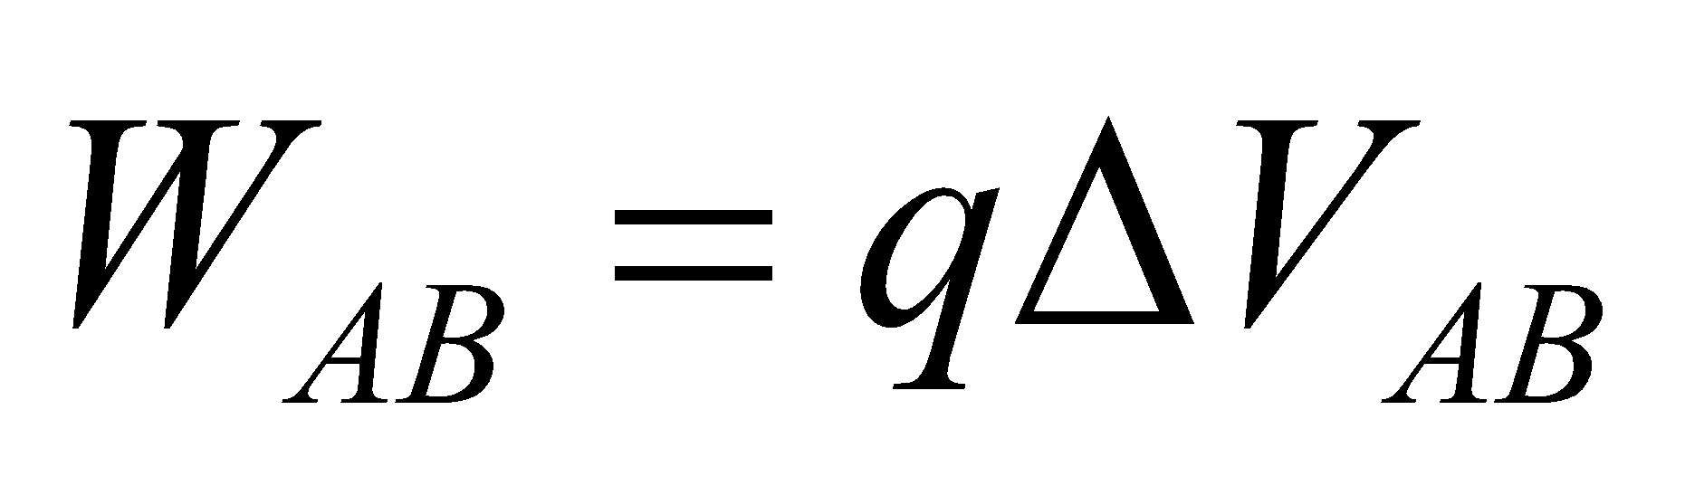 (see discussion in Section 22.1). Because we are moving a positive charge in the direction of the electric field, the potential difference will be negative (see Equation 22.1a), so *ΔVAB* = −9.0 V.

**Evaluate** Substituting the values given, we have

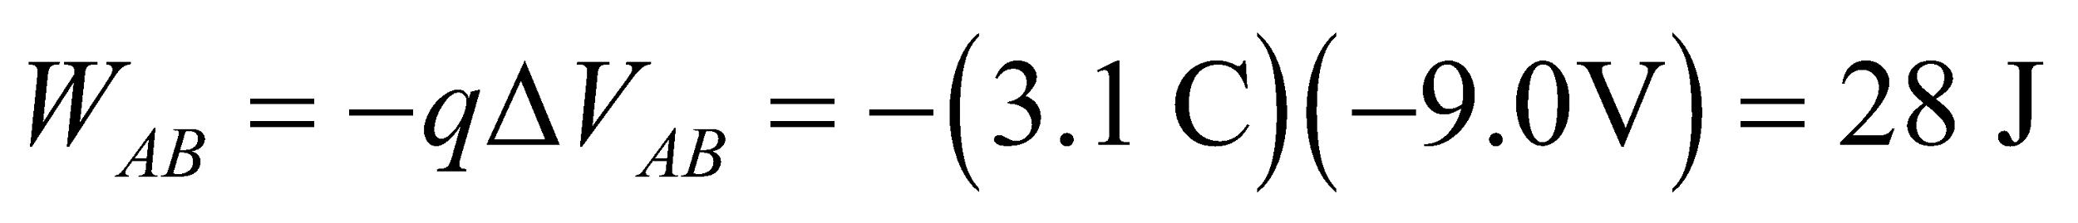

**Assess** The charges gain kinetic energy as it moves toward the negative plate (in the direction of the electric field). The battery is needed to maintain the potential difference between the plates.

**21.** **Interpret** We are to find the energy gained by the three given charged particles as they move through a 100-V potential difference.

**Develop** The energy gained is *qΔV* (see Example 22.1). For the proton, alpha particle, and singly ionized He atom, *q* = *e*, 2*e*, *e*, respectively.

**Evaluate** For proton and the ionized He atom, the energy gained is



For the alpha particle, the charge is twice that of the other particles, so the energy gained is twice: 3.2 × 10−17 J.

**Assess** Note that the velocity of each particle is different at the output because each has a different mass.

**22.** **Interpret** The problem involves the work done on an ion in moving across the potential difference of a cell membrane.

**Develop** The work done on the ion in the electric field of the cell membrane is equal to the increase in the internal energy: 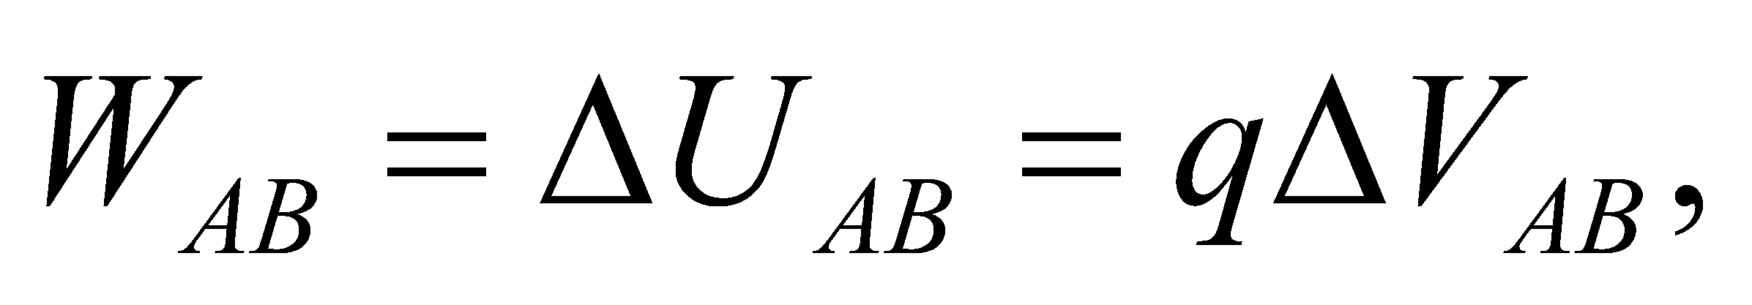 where we have used the definition of the electric potential difference from Equation 22.1a.

**Evaluate** A singly-charged potassium ions has charge +*e*, so the work needed to move it through the cell membrane is



**Assess** This is a small amount of work, since we're dealing with a single fundamental charge. Recall that moving a positive charge across a potential difference is like moving it up a an electric potential "hill."

**Section 22.2 Calculating Potential Difference**

**23. Interpret** In this problem, we are given a uniform electric field and asked to calculate the potential difference between two points.

**Develop** For a uniform field, the potential difference between two points *a* and *b* is given by Equation 22.1b:

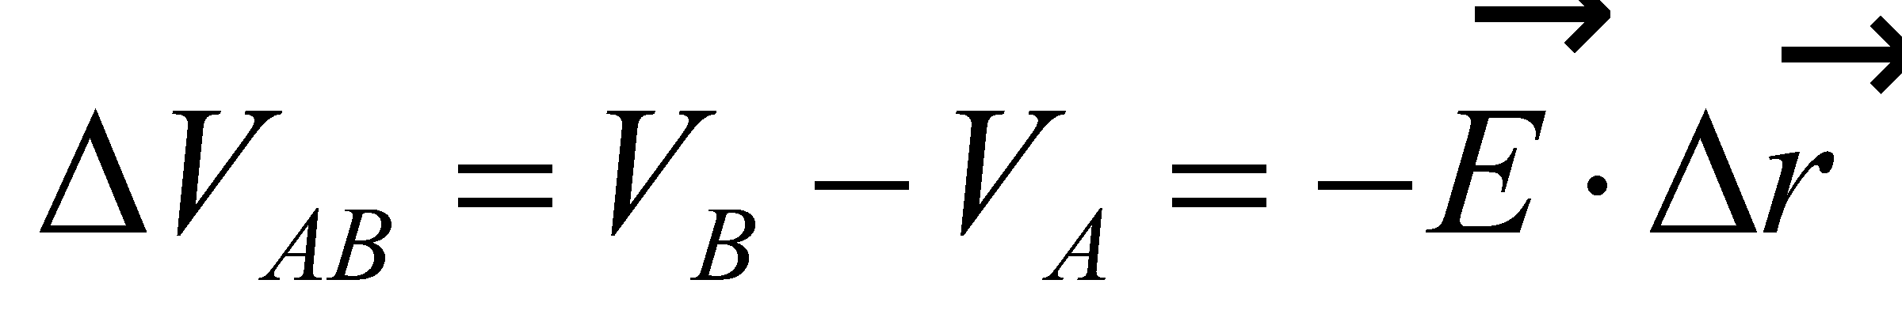

where 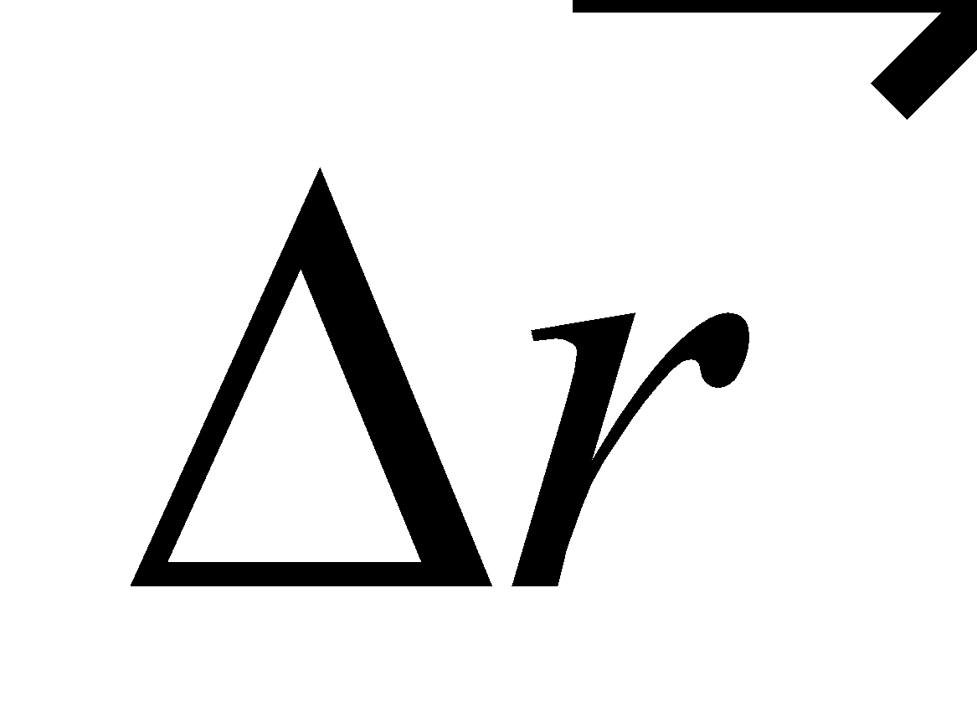 is a vector from *a* to *b*.

**Evaluate** With 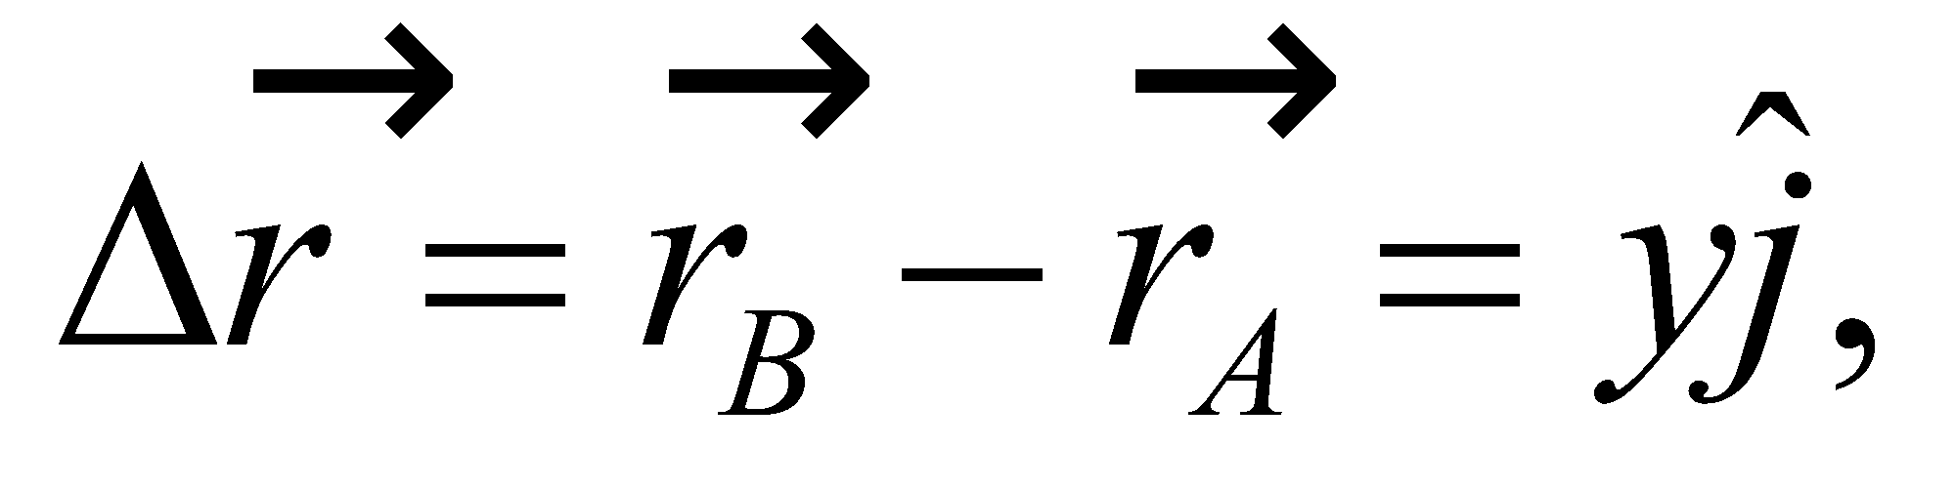 we obtain

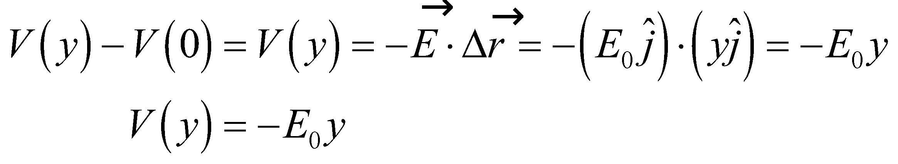

**Assess** The electric potential decreases in the direction of the electric field. In other words, electric field lines always point in the direction of decreasing potential.

**24.** **Interpret** This problem involves finding the potential due to a point charge.

**Develop** The potential of the proton, at the position of the electron (both of which may be regarded as point-charge atomic constituents) is (Equation 22.3) 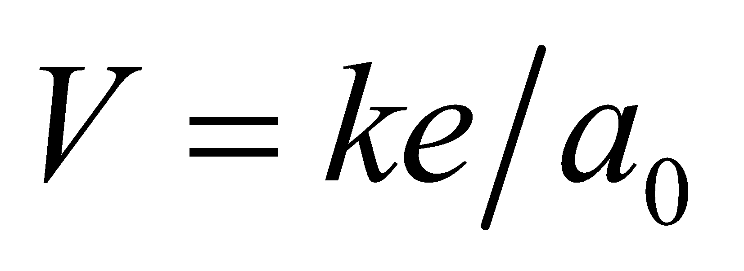 where 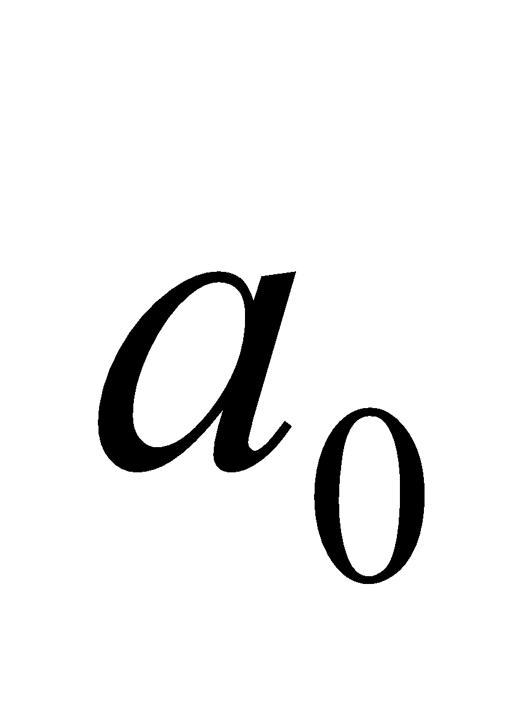 is the Bohr radius.

**Evaluate** Inserting the values given, we find

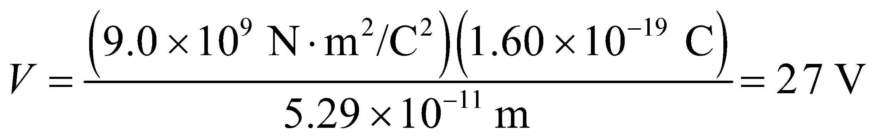

**Assess** The energy of an electron in a classical, circular orbit about a stationary proton is one half its potential energy, or 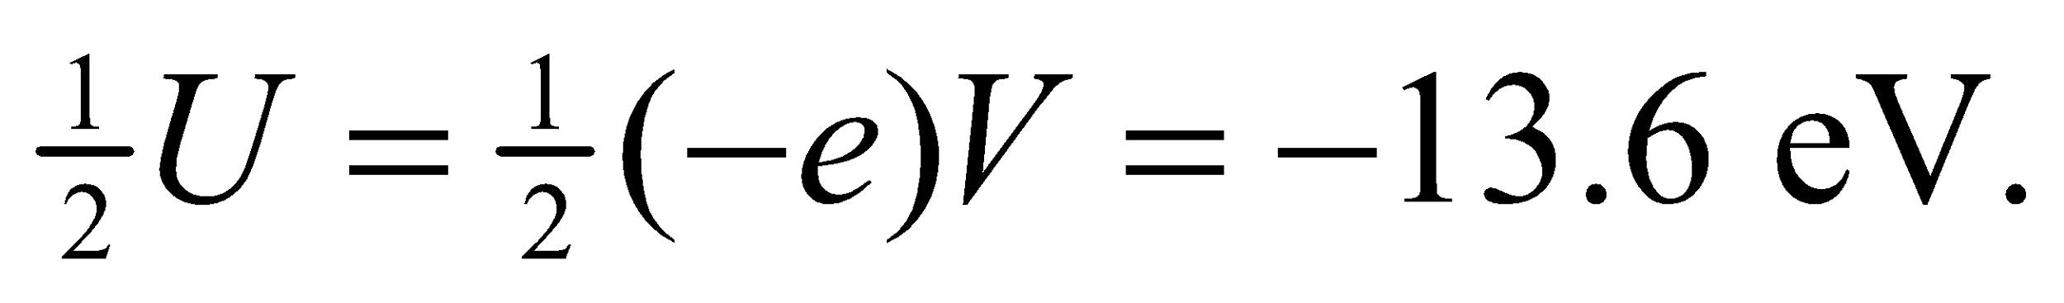 The excellent agreement with the ionization energy of hydrogen was one of the successes of the Bohr model.

**25. Interpret** We are asked to find the charge on a sphere, given the potential at its surface. Because the charge distribution is spherically symmetric, we will use the equation for the potential of a point charge.

**Develop** Equation 22.3 gives the potential for a point charge as

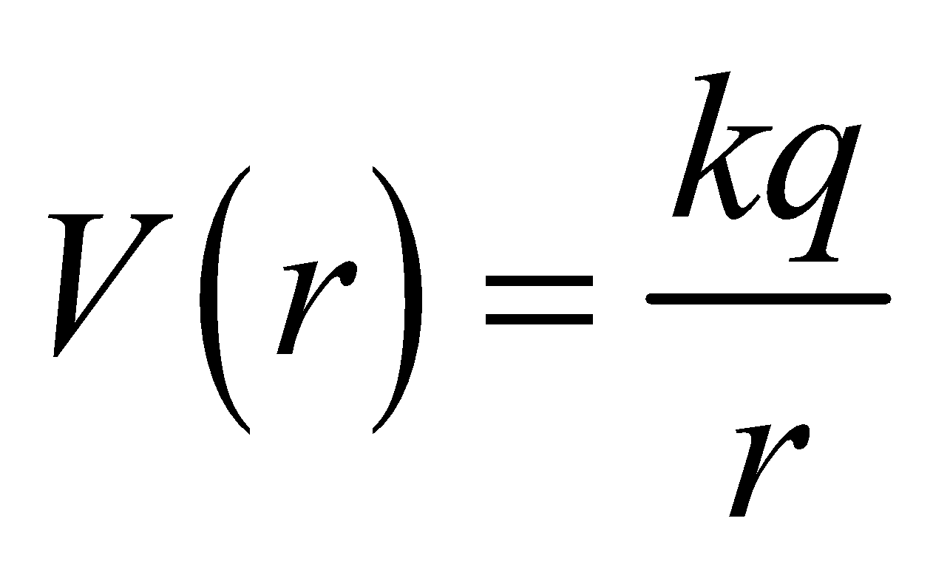

Since any spherically symmetric charge distribution looks like a point charge from outside the distribution, we can solve this for *q*. The potential at the surface of the sphere is *V* = 4.8 kV and the radius is *r* = 0.10 m.

**Evaluate** Inserting the given quantities yields

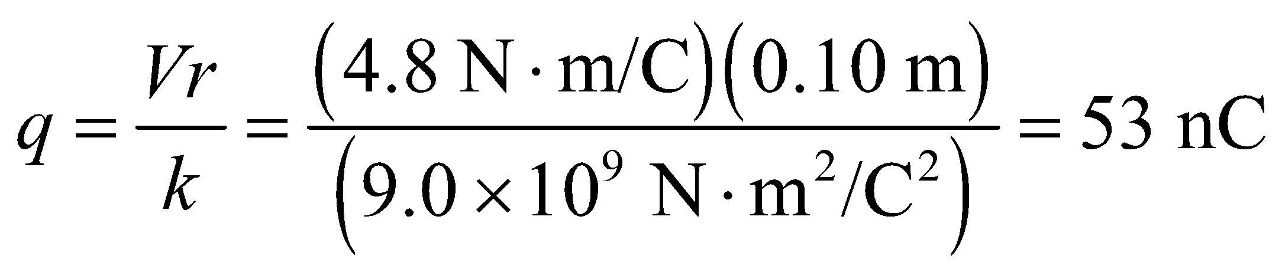

**Assess** The key is to recognize that spherically symmetric charge distributions look like point charges from the outside. This is the same as for gravitational potentials. Note also that the units in the result cancel to give coulombs.

**26.** **Interpret** This problem resembles the previous one in that it deals with the potential at the surface of a sphere. We are to find the maximum potential that a 5.0-cm diameter sphere can withstand given the 3-MV/m maximum electric field of air.

**Develop** For an isolated metal sphere, the electric field at the surface is that of a point charge at a distance *R*:

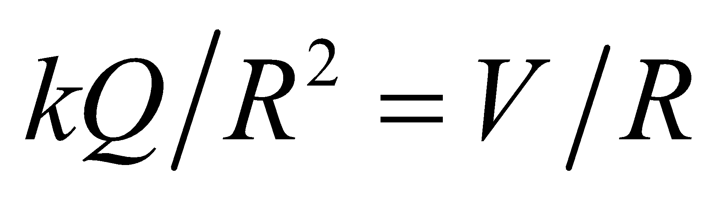

Thus, *V*/*R* < 3 MV/m gives the condition for *V* for a 5.0-cm sphere.

**Evaluate** Inserting the numbers, we find *V* < (3 MV/m)(0.025 m) = 75 kV.

**Assess** This is quite a high voltage (compare to the 120 or 240 V that is typical of household circuits).

**27. Interpret** This problem is about the electric potential of a spherically symmetric charge distribution. We are to find the potential at the surface of a charged conducting sphere and the kinetic energy (or speed) of a proton accelerated from the surface to infinity by the sphere’s potential.

**Develop** Since the electric field outside the spherical charge distribution is the same as that of a point charge, the electric potential outside the metal sphere 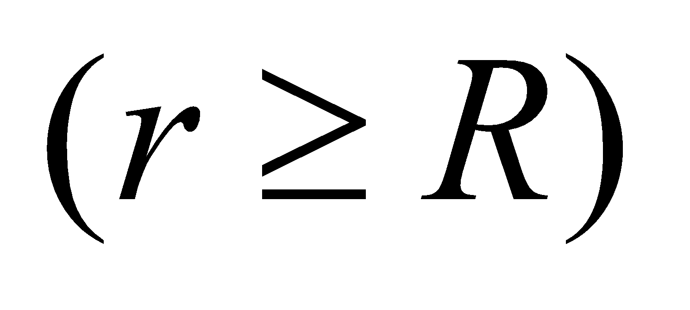 is given by Equation 22.3:

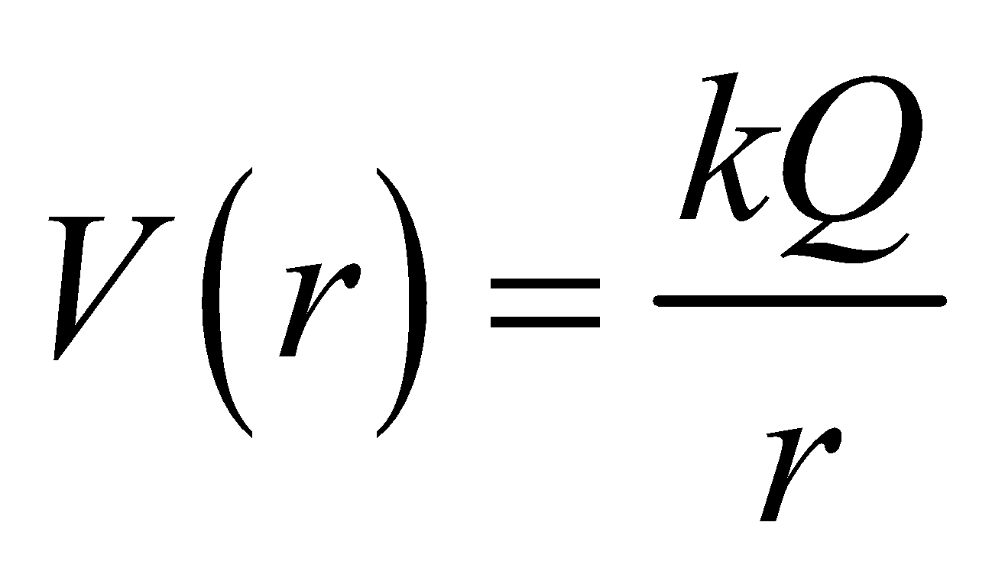

Note that we have taken the zero of the potential to be at infinity.

**Evaluate (a)** An isolated metal sphere has a uniform surface charge density, so the potential at its surface is

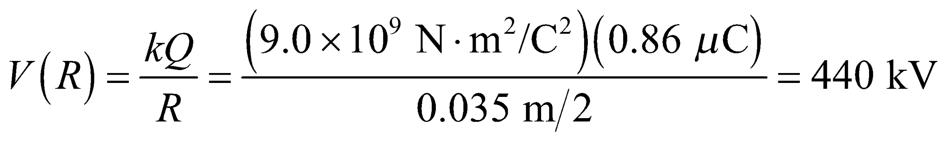

**(b)** The work done by the repulsive electrostatic field (the negative of the change in the proton’s potential energy) equals the proton’s kinetic energy at infinity:

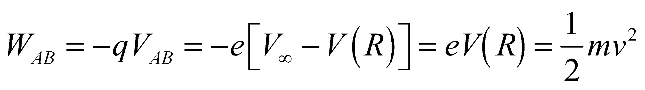

Thus, the speed of the proton far from the sphere is

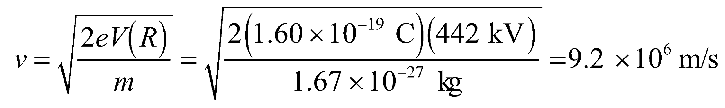

**Assess** As the proton moves away from the metal sphere, its potential energy decreases. However, by energy conservation, its kinetic energy increases. Also, notice that the result of part (a) is given to two significant figures, but that three significant figures are used when we insert that result into part (b) because it serves as an intermediate result for part (b).

**Section 22.3 Potential Difference and the Electric Field**

**28.** **Interpret** We are given the potential difference between two plates a given distance apart and are required to find the strength of the electric field between the plates.

**Develop** Assuming the dimensions of the plate are much, much greater than their 2.5-cm separation, we can assume the electric field between this is uniform (see Example 21.6). For a uniform field, Equation 22.9 can be written as 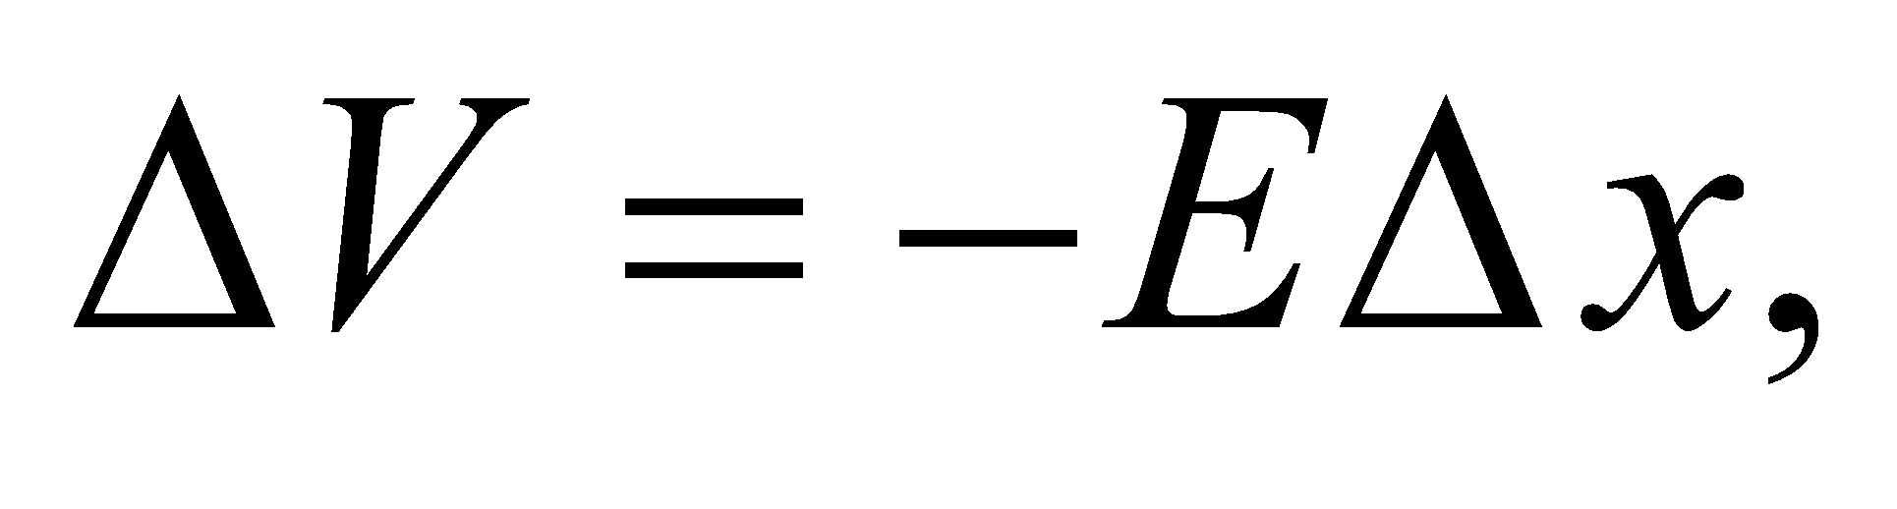 where the *x* axis is in the direction of the field (*V* decreases in the direction of the field).

**Evaluate** Thus,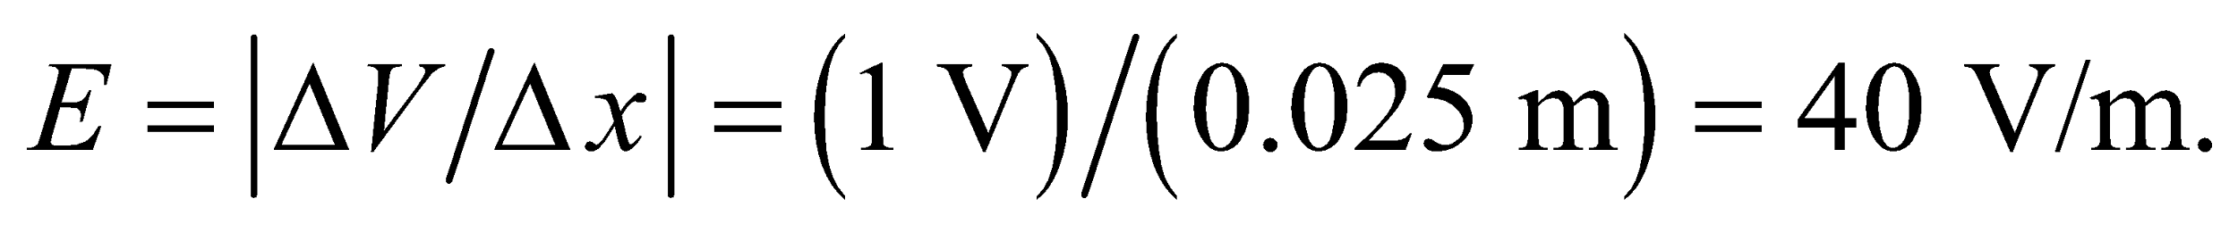

**Assess** This result may be found by a simple dimensional analysis. The electric field can be expressed in units of V/m, so given a voltage and a distance, the electric field is simply the voltage change per unit length.

**29. Interpret** This problem involves calculating the electric field from the electric potential (or voltage).

**Develop** Given electric potential *V*(*x*), the *x* component of the electric field may be obtained as 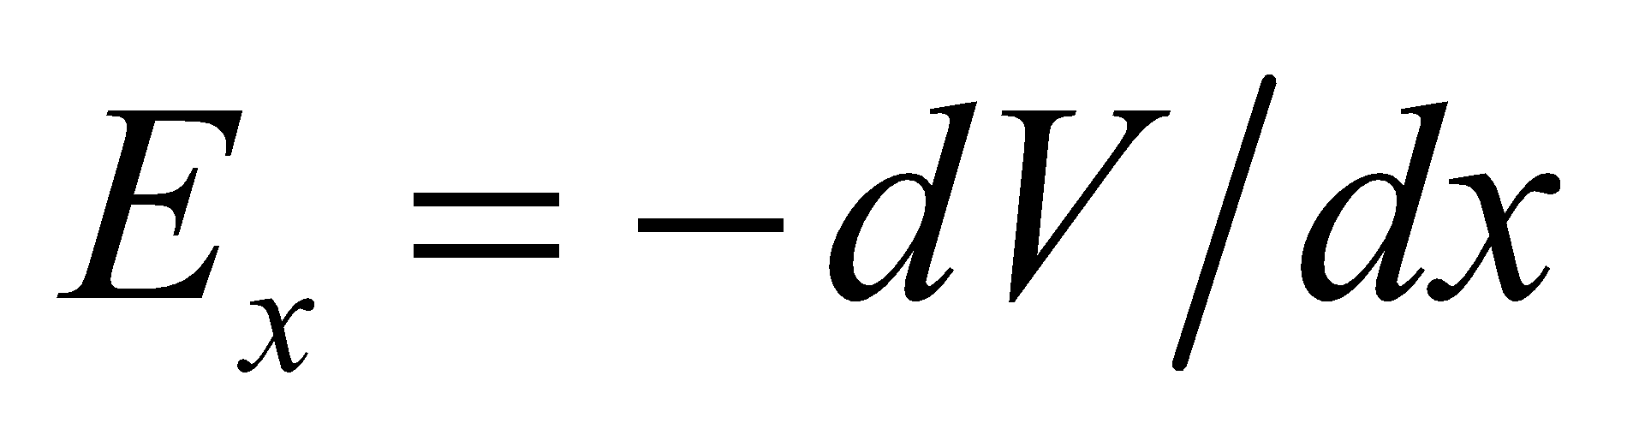 (see Equation 22.9). Use this equation to estimate *Ex* for the seven straight-line segments shown in Fig. 22.20.

**Evaluate** Using the equation above, we find *Ex* = 0 for *x* = 0 to 2 m. Similarly, for x = 2 to 4 m,

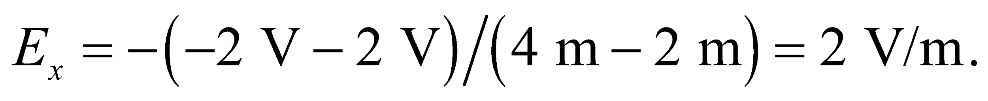 The field strength in other regions can be calculated in a similar manner.

The result is sketched below.



**Assess** The field component 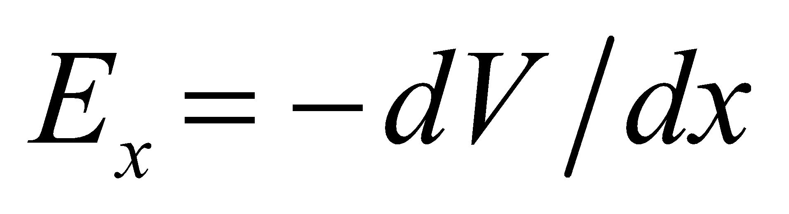 is the negative of the rate of change of *V* with respect to *x*. The negative sign means that if we move in the direction of increasing potential, then we’re moving against the electric field.

**30.** **Interpret** This problem requires us to interpret an equipotential map, which shows lines of constant electric potential. From this plot, we are to find the region where the electric field is the strongest and its magnitude and direction.

**Develop** As explained in Section 22.3 (see discussion accompanying Figure 22.15), the electric field is everywhere perpendicular to the lines of equipotential and is strongest where the equipotential lines are most closely spaced. The electric field direction is always from regions of high potential to regions of low potential. The magnitude of the electric field may be found as per Problem 22.29: by dividing the potential difference by the distance between equipotential lines.

**Evaluate** See figure below. **(a)** The equipotentials in Fig. 22.21 are most closely spaced along the *x* axis between *x* = 2 m and *x* = 5 m. **(b)** The potential decreases in the direction of the electric field which, for the region 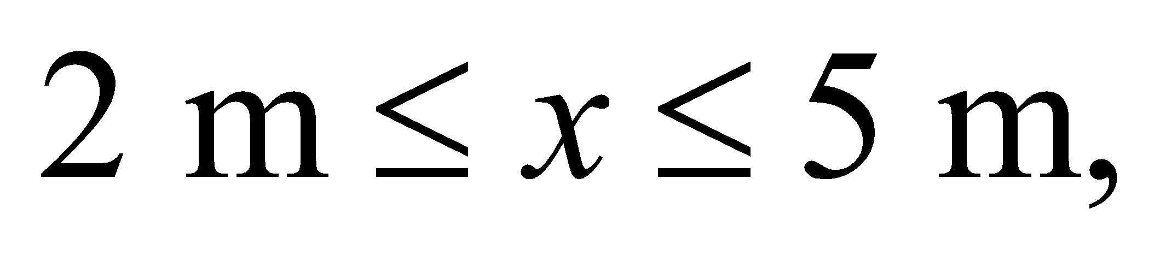 is in the negative *x* direction. **(c)** The potential drops by 10 V/m, which is the field strength in this region.

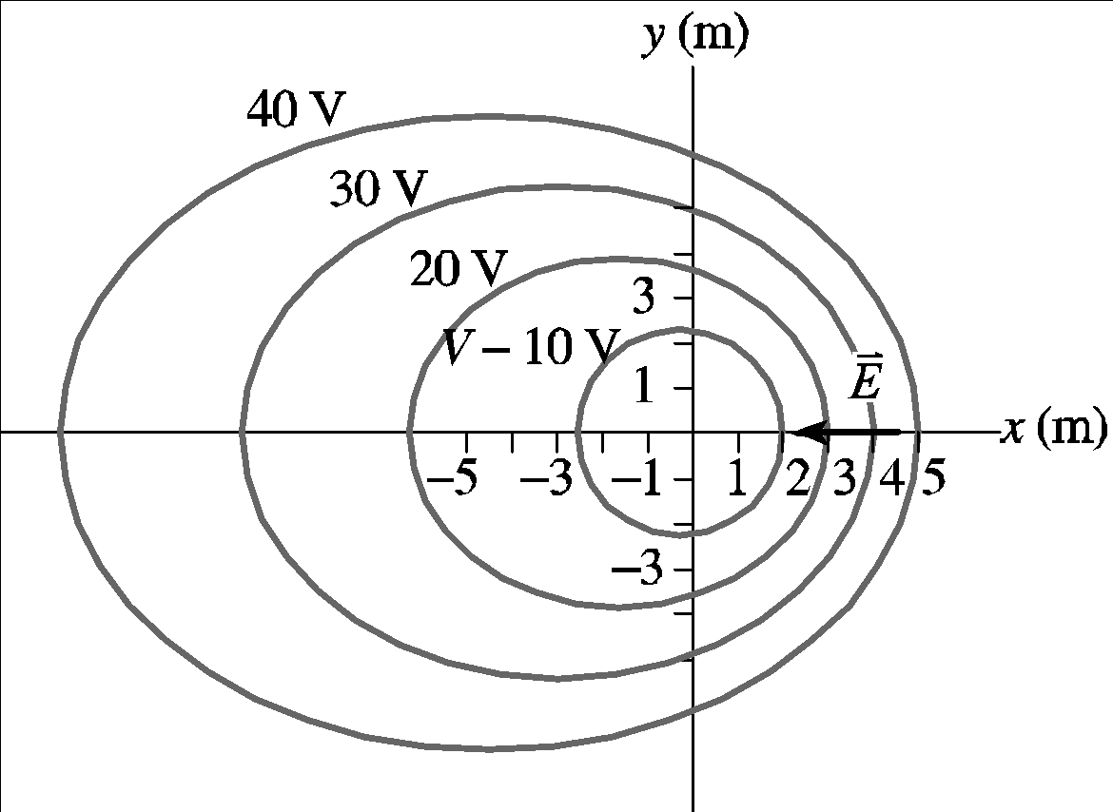

**Assess** Reading an equipotential plot is analogous to reading a topological map. Where the equipotential lines are most closely spaced is the region of most rapidly changing electric potential, just like a topological map where the most closely spaced lines indicate the regions of most rapidly changing gravitational potential (i.e., the steepest inclines).

**31. Interpret** This problem is about calculating electric field given the electric potential.

**Develop** Given the electric potential *V*, the corresponding electric field is (see Equation 22.9)

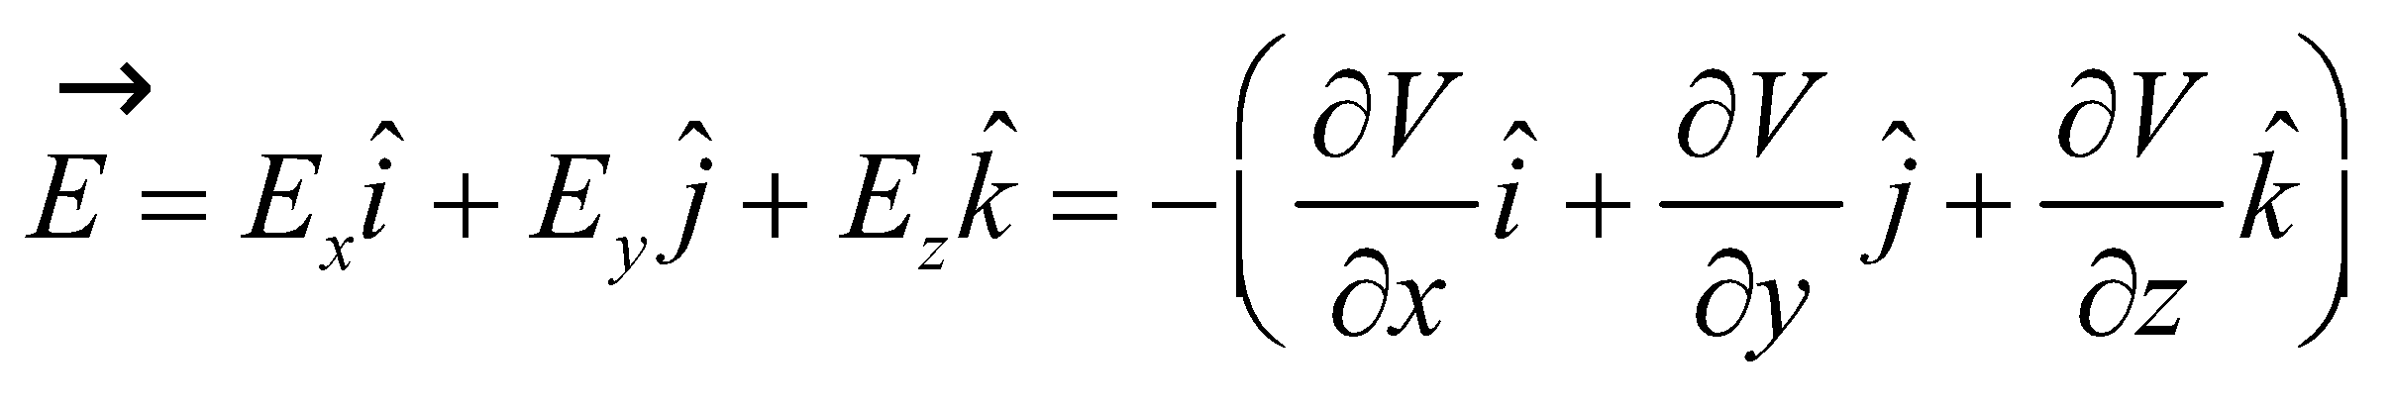

Thus, taking the partial derivatives of *V* allows us to get the field components.

**Evaluate** **(a)** Direct substitution gives the voltage at (*x*, *y*, *z*) = (1 m, 1 m, 1 m):



**(b)** Use of Equation 22.9 gives the components of the electric field:

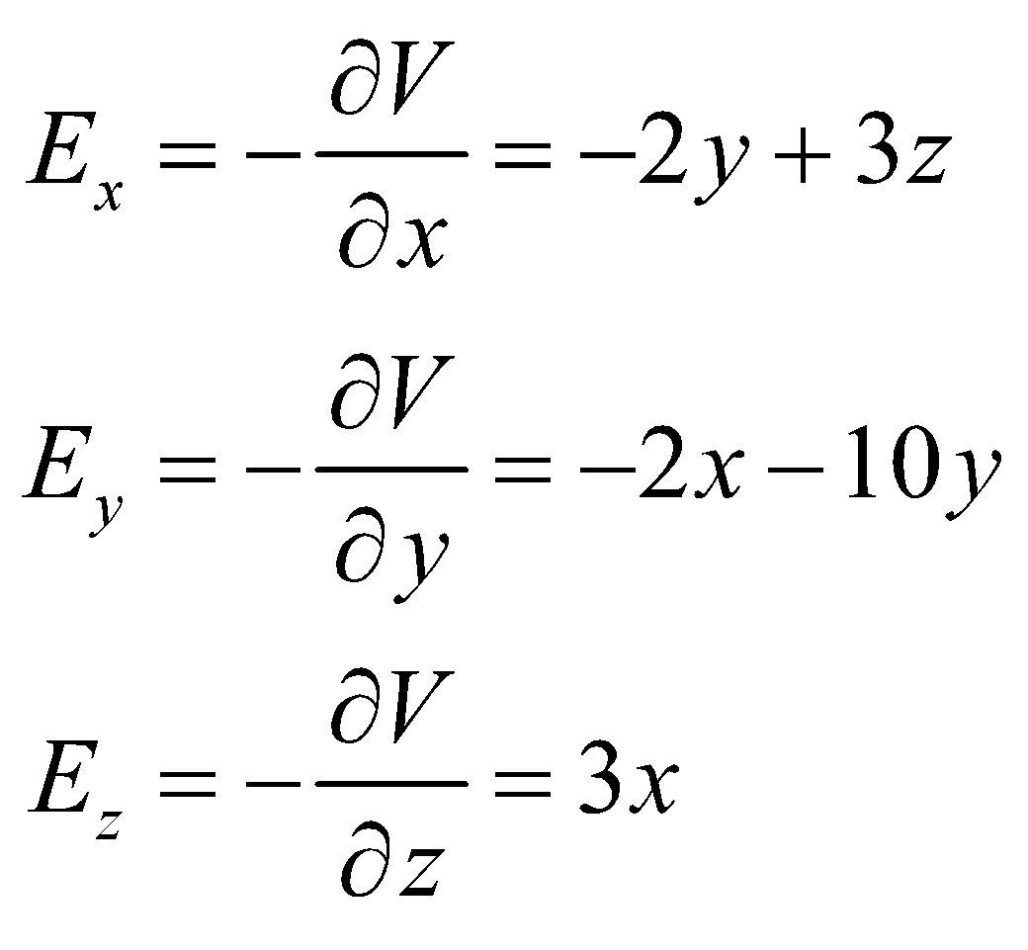

At (*x*, *y*, *z*) = (1 m, 1 m, 1 m), we obtain 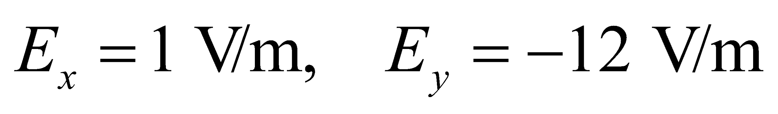 and 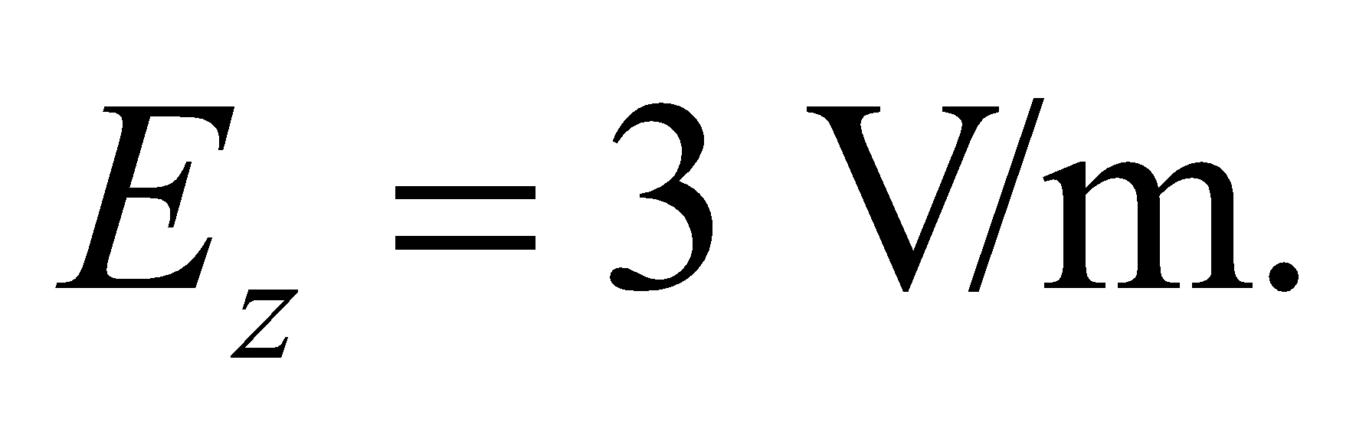

**Assess** Electric field is strong in the region where the potential changes rapidly. At (1 m, 1 m, 1 m), the potential changes most rapidly in the direction of the electric field

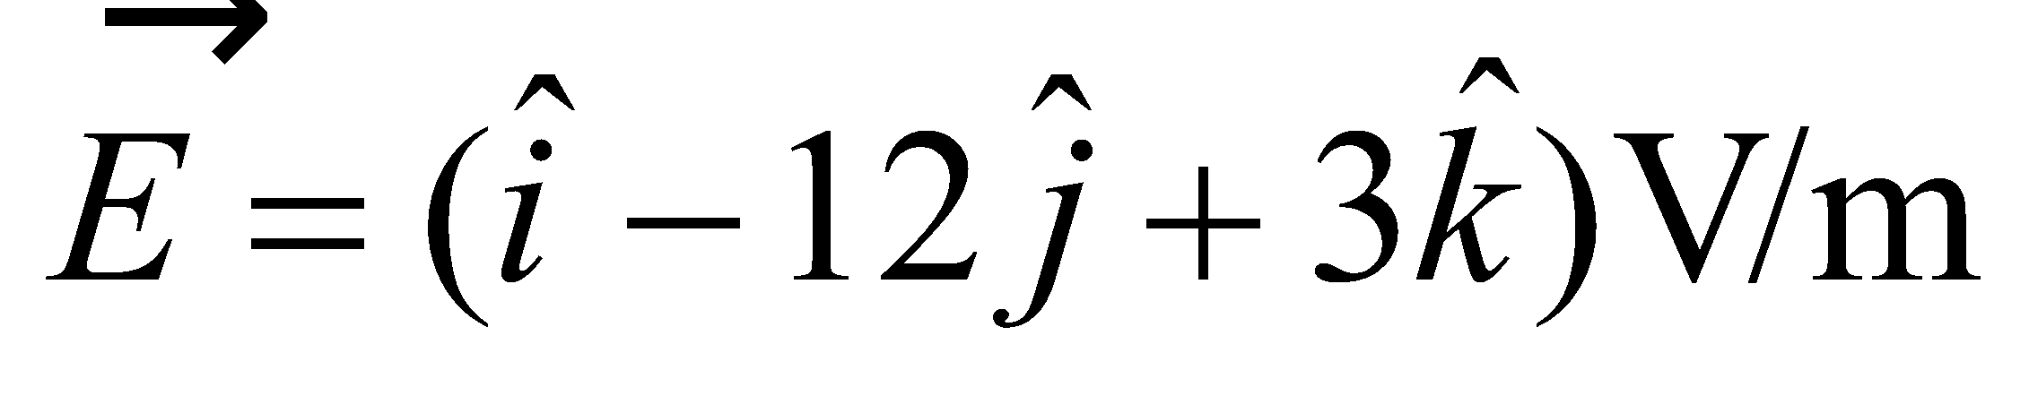

**Section 22.4 Charged Conductors**

**32.** **Interpret**  Given a sphere’s size, we are to find the maximum potential (i.e., voltage) at its surface before dielectric breakdown of air occurs. We can use the result of Problem 22.26 to address this problem.

**Develop** As per Problem 22.26, *V*/*R* < 3 MV/m gives the maximum limit for *V*.

**Evaluate** (a) Inserting the given quantities gives



**(b)** Dielectric breakdown in the air occurs if the field at the surface 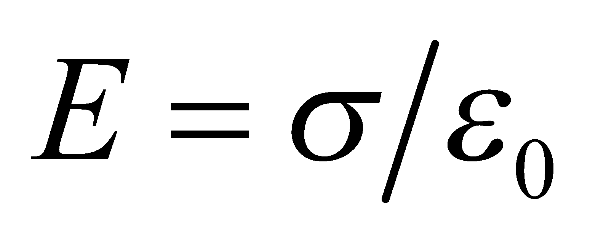 exceeds 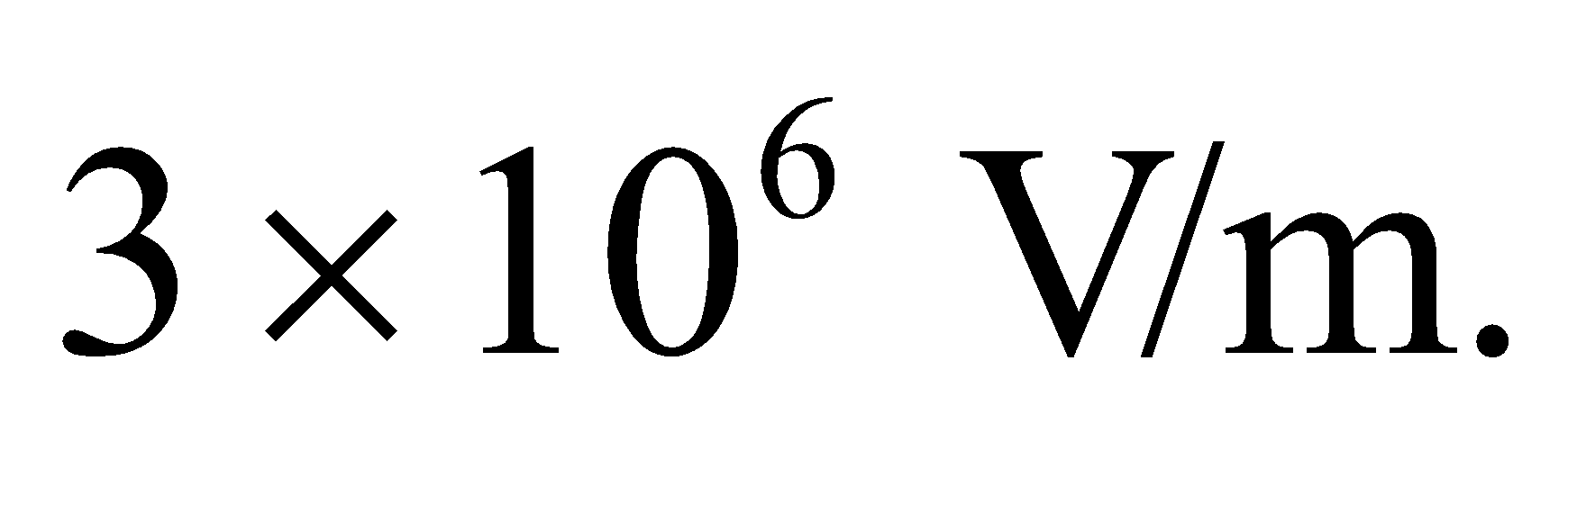 Therefore, the charge (for a uniformly charged sphere) must not be greater than



**Assess** This gives an appreciation of the amount of charge represented by 1 C. If we have some 10−3 C on a conducting sphere 2.3 m in diameter, we risk to engender dielectric breakdown of the air!

**33. Interpret** This problem is about finding the minimum potential that leads to a dielectric breakdown in air.

**Develop** We shall treat the field from the central electrode as if it were from an isolated sphere, for which Equation 20.3 gives the electric field to be 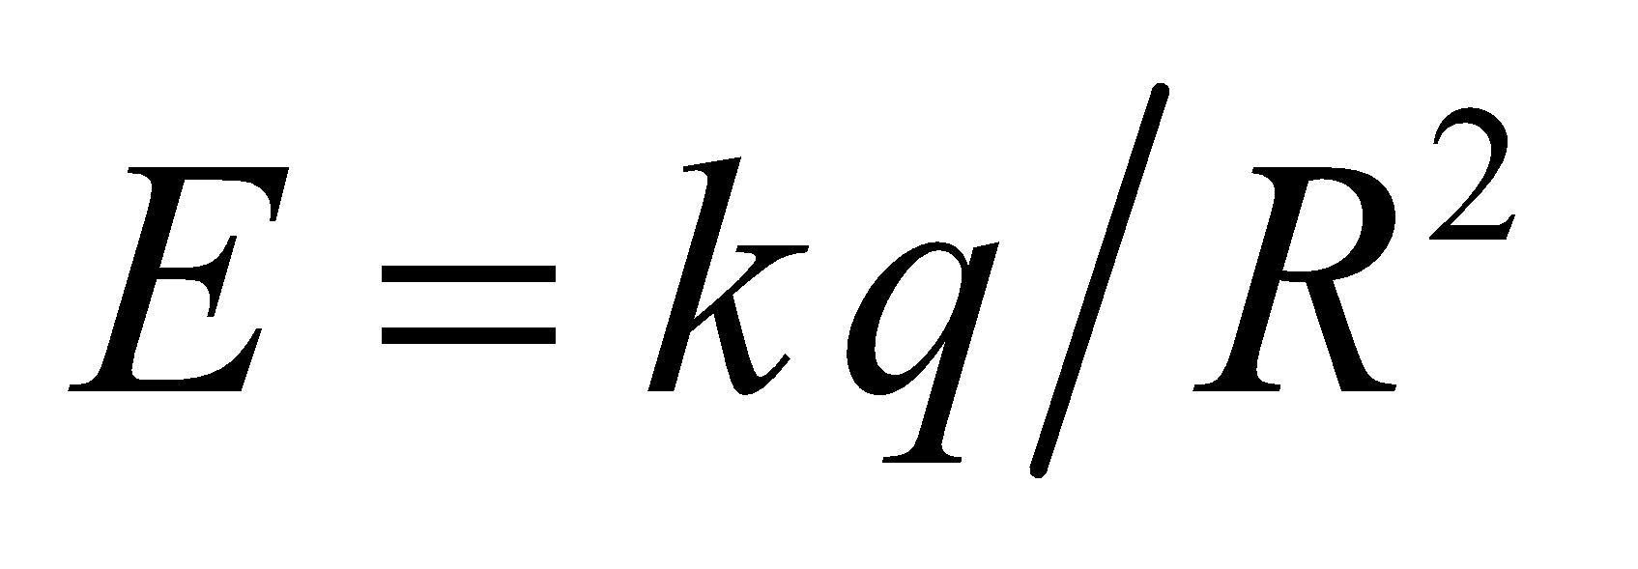 and Equation 22.3 gives the potential to be 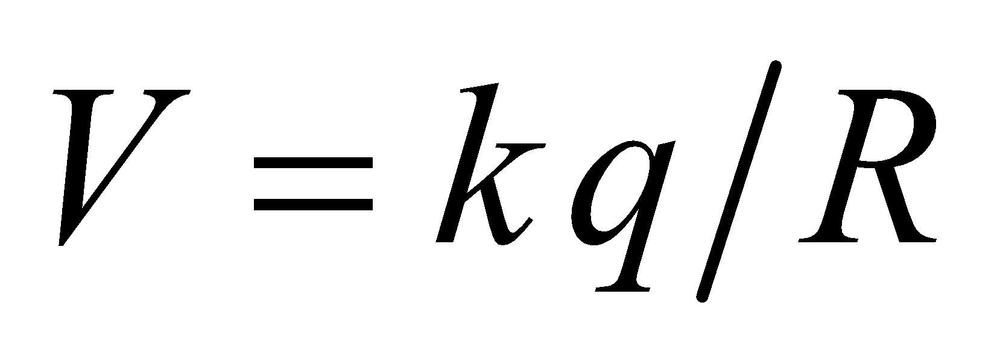. Combining these two expressions gives *V* = *RE*.

**Evaluate** Breakdown of air occurs at a field strength of 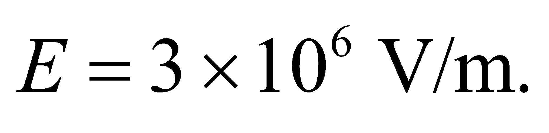 Therefore, dielectric breakdown in air would occur for potentials exceeding

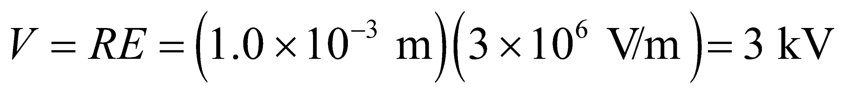

**Assess** The result means that if we attempt to raise the potential of the electrode in air above 3 kV, then the surrounding air would become ionized and conductive; the extra added charge would leak into the air, resulting in plug sparks.

**34.** **Interpret** This problem requires us to find the potential and electric field strength at the surface of two isolated conducting spheres with the given size and charge. Note that the charge distribution is spherically symmetric.

**Develop** Outside a spherically symmetric charge distribution, it may be considered as a point charge with all the charge concentrated at that point. Thus, we can apply Equation 22.3  to find the potential at the surface of the two spheres. In addition, we can use Equation 20.3, , which gives the electric field strength of a point charge, to find the electric field strength at the surface of the two spheres.

**Evaluate** (a) Applying Equation 22.3 to each sphere, we see that the

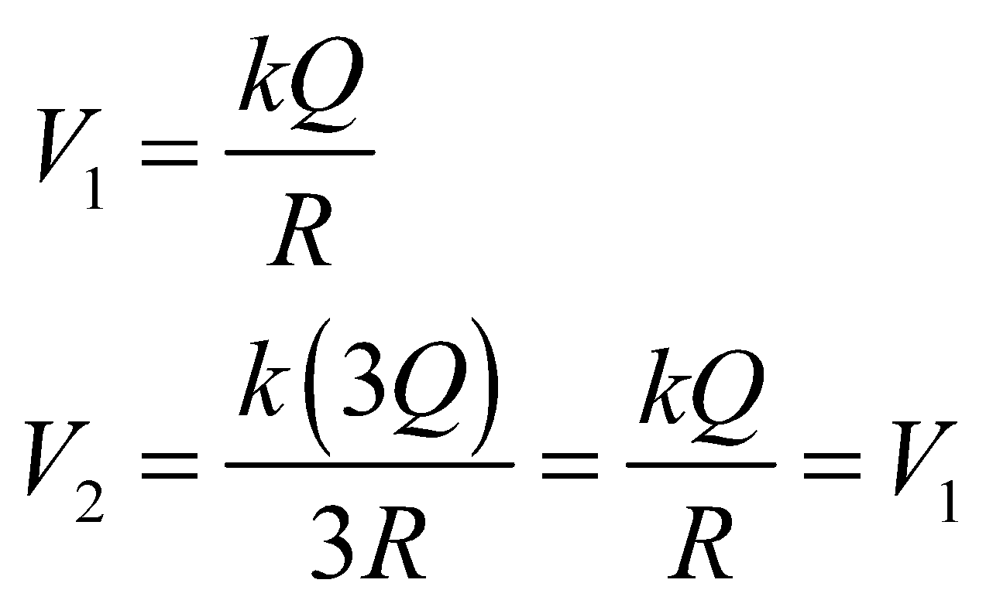

so the potential at the surface of each sphere is the same.

(b) Applying Equation 20.3 to each sphere gives

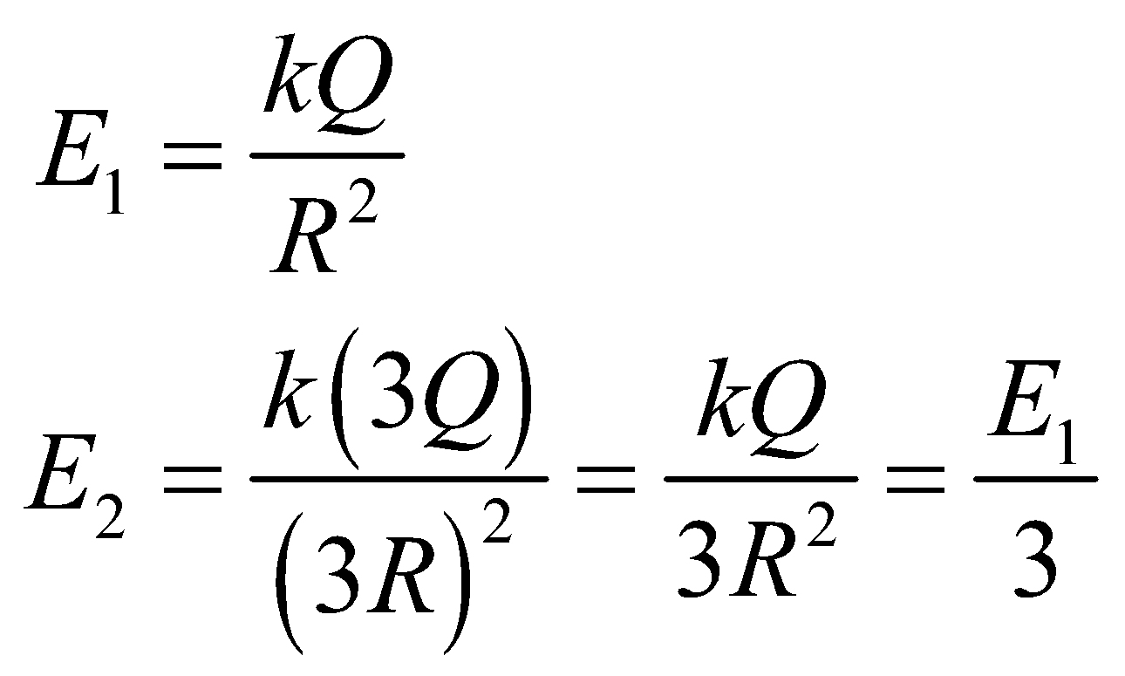

so the electric field strength at the surface of the small sphere is 3 times that at the surface of the large sphere.

**Assess** At the surface of a charged, conducting sphere, you can also use Equation 21.8, 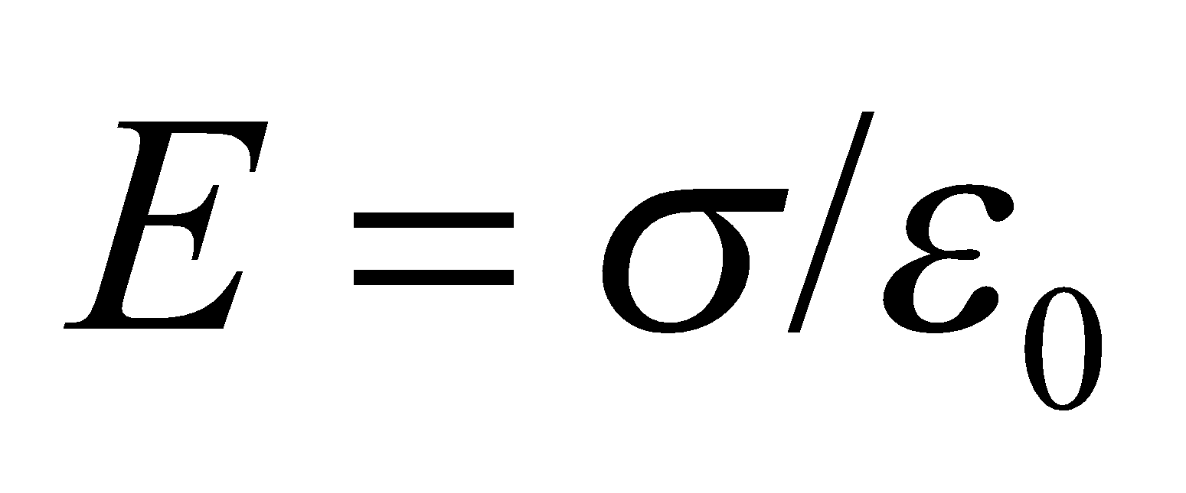, but this gives the same result because *k* = 1/(4*πε*0) and *σ* = *q*/(4*π*R2).

**Problems**

**35. Interpret** This problem is about finding the electric field strength, given the potential difference between two points a given distance apart. We are also given the orientation of the electric field with respect to the line joining the two points.

**Develop** Since the field 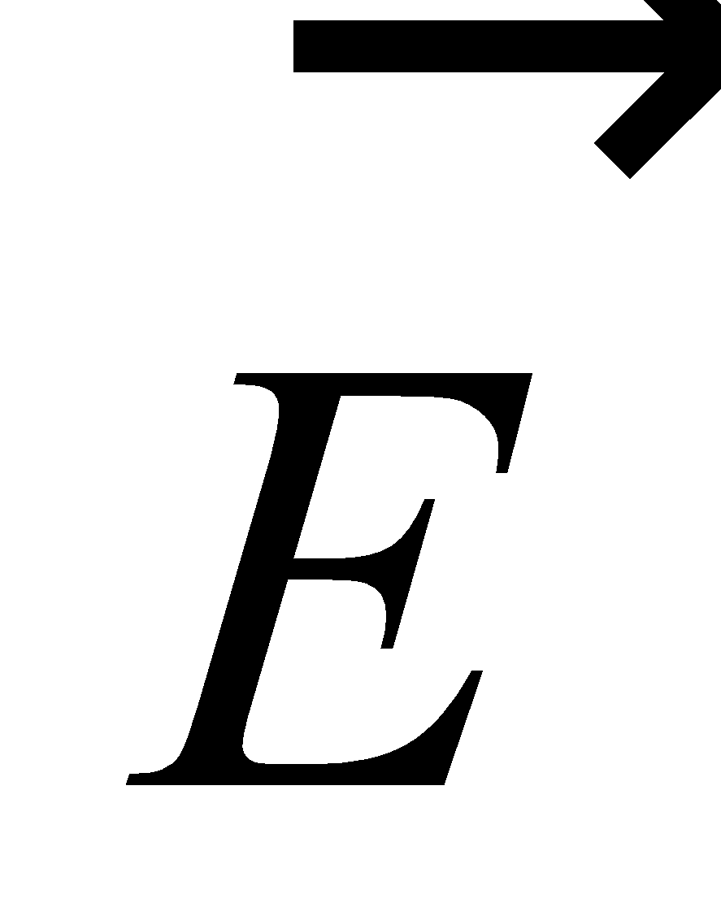 is uniform, Equation 22.1b, 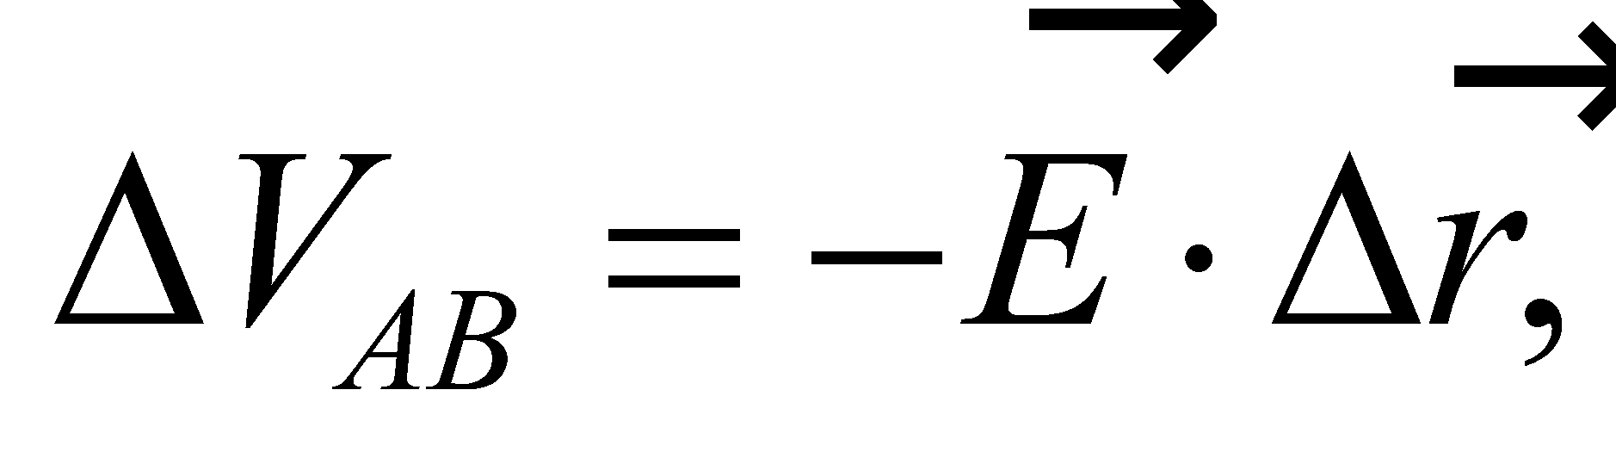 can be used to relate  to the potential difference 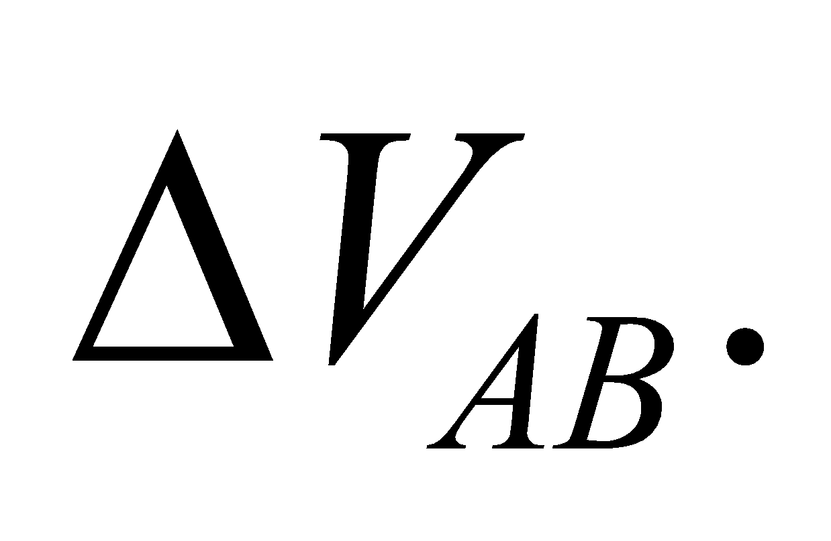 Since the path *AB* is parallel to , the angle between  and  is 0°. Because cos(0°) = 1 the dot product reduces to

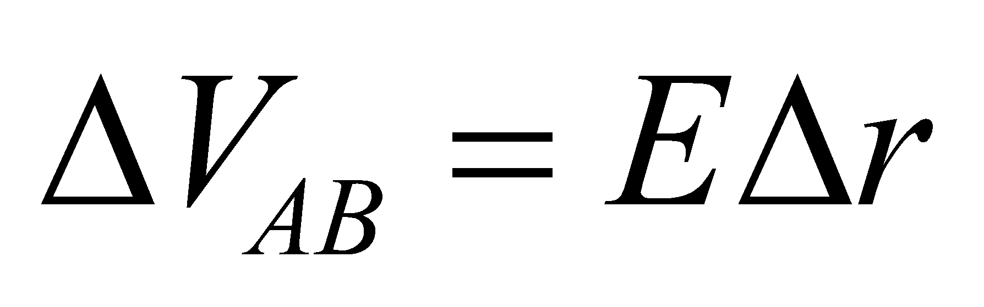

where *E* is the field strength, and *Δr* is the separation between points *A* and *B*.

**Evaluate** The field strength is

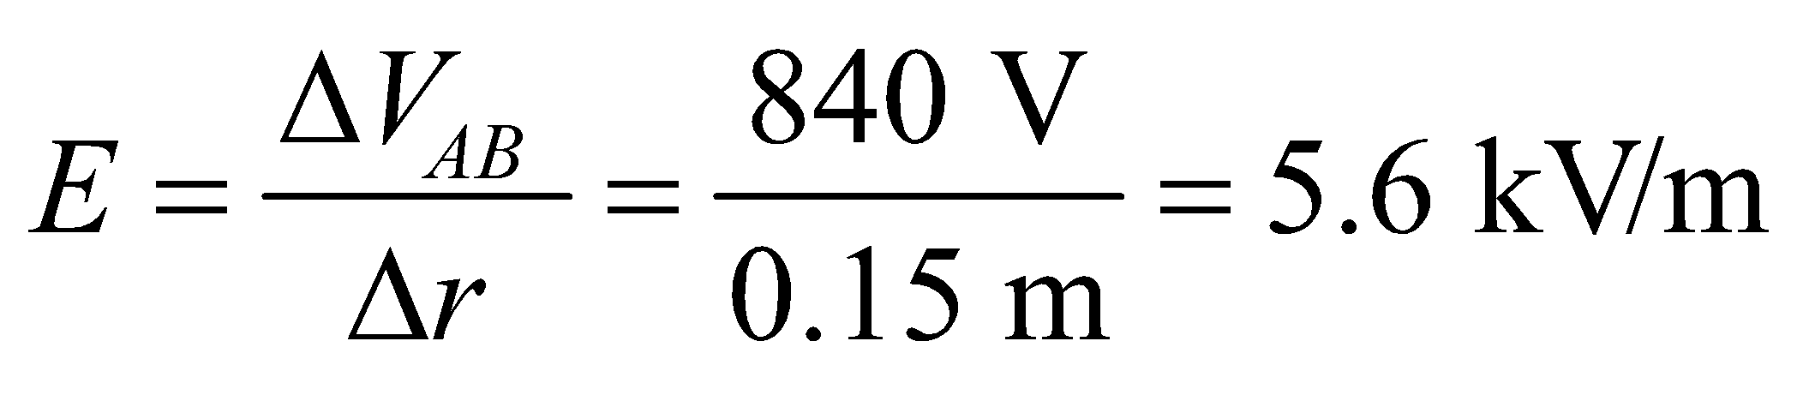

**Assess** Since 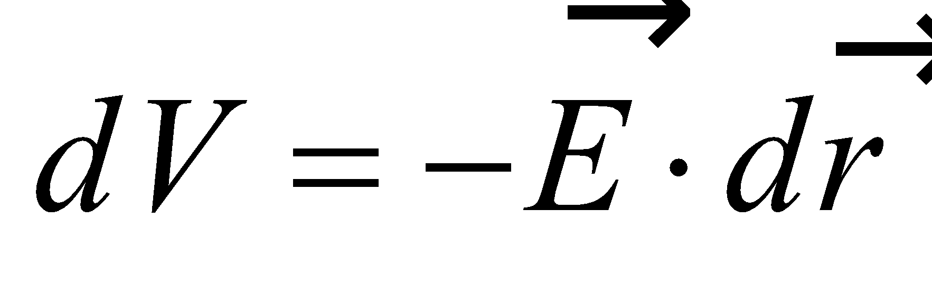 the potential always decreases in the direction of the electric field. Note that the angle between  and  is 180° if the two are antiparallel.

**36. Interpret** This problem is about finding the potential difference between two points, given the electric field strength.

**Develop** Since the field  is uniform, Equation 22.1b, 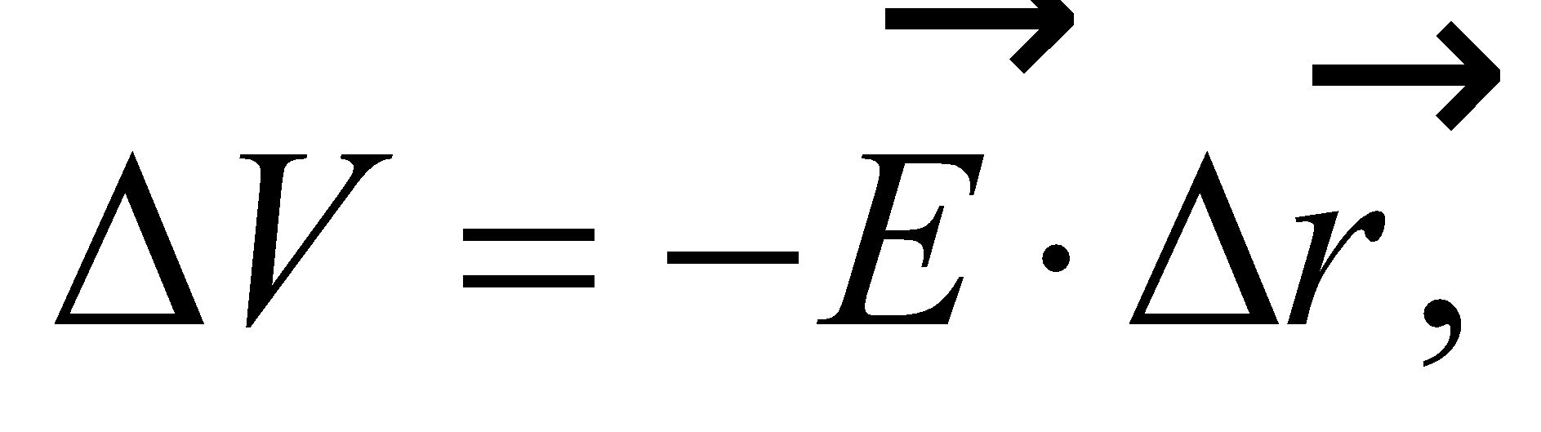 can be used to relate  to the potential difference *ΔV* across the membrane. For a uniform electric field normal to the membrane, we have

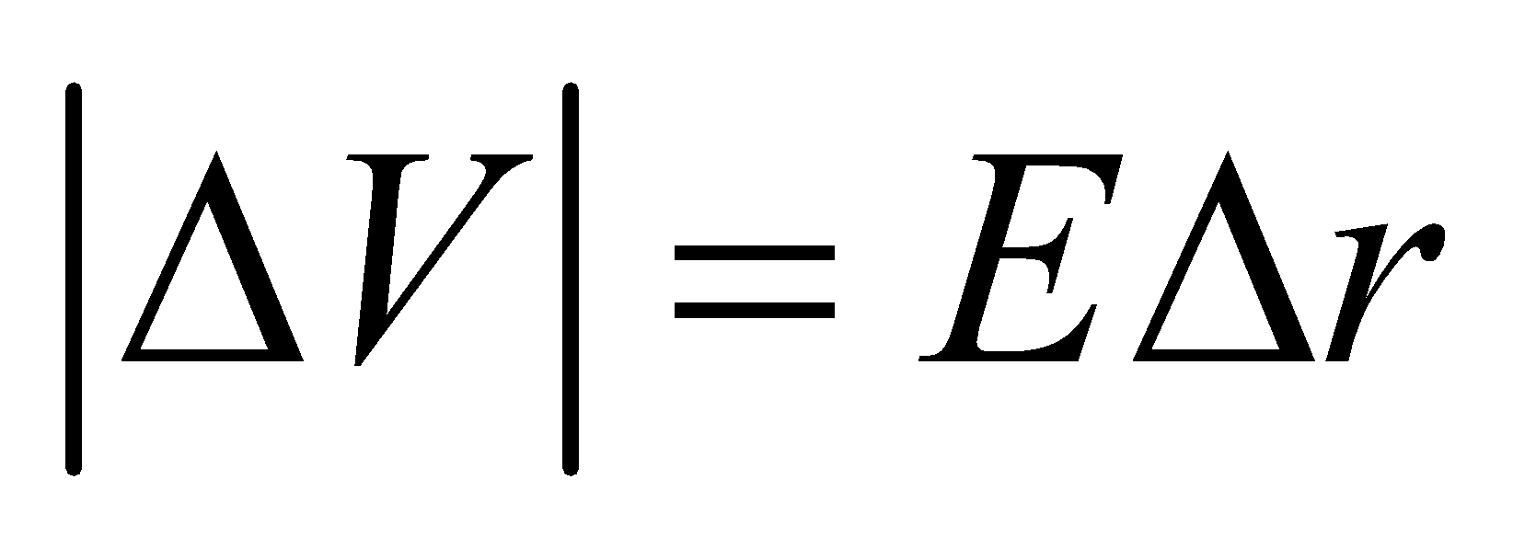

where *E* is the field strength, and *Δr* is the membrane thickness.

**Evaluate** Using the equation above, the potential difference is

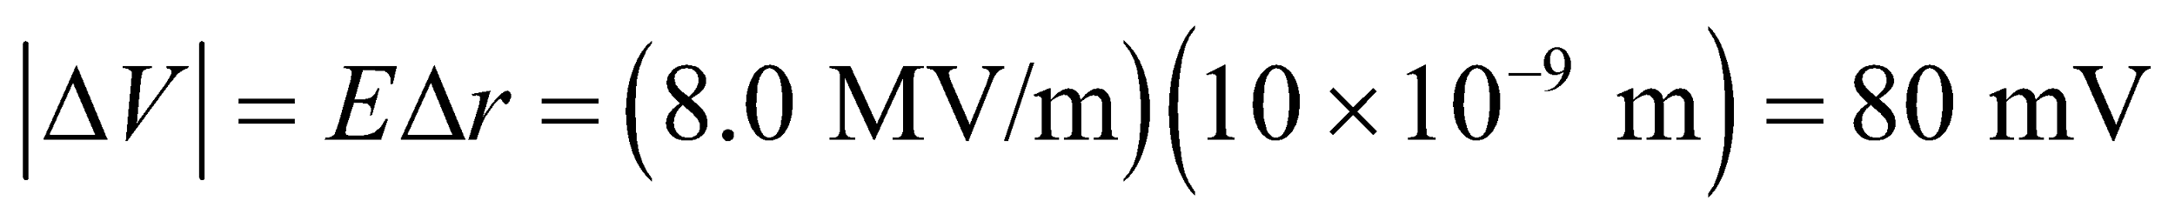

**Assess** Since 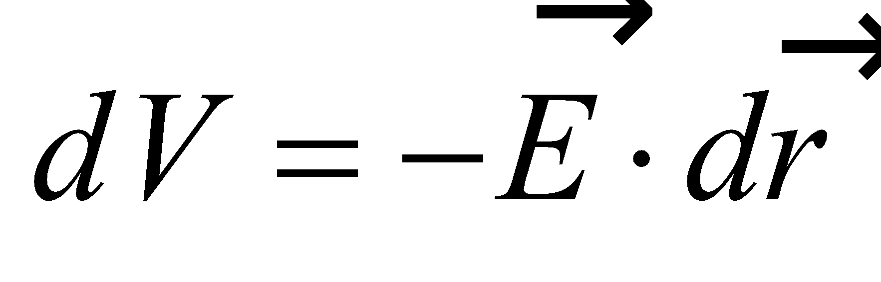 the potential always decreases in the direction of the electric field. Note that we have no information in this problem regarding the direction of the electric field, so we cannot put a sign on the potential difference.

**37.** **Interpret** This problem involves finding the potential difference between two points (i.e., the terminals of the battery) given the work done on each elementary charge that moves between these points.

**Develop** From the discussion in Section 22.1, we know that the work done by the electric field on each charge between two points is the potential difference between the same two points. Thus, 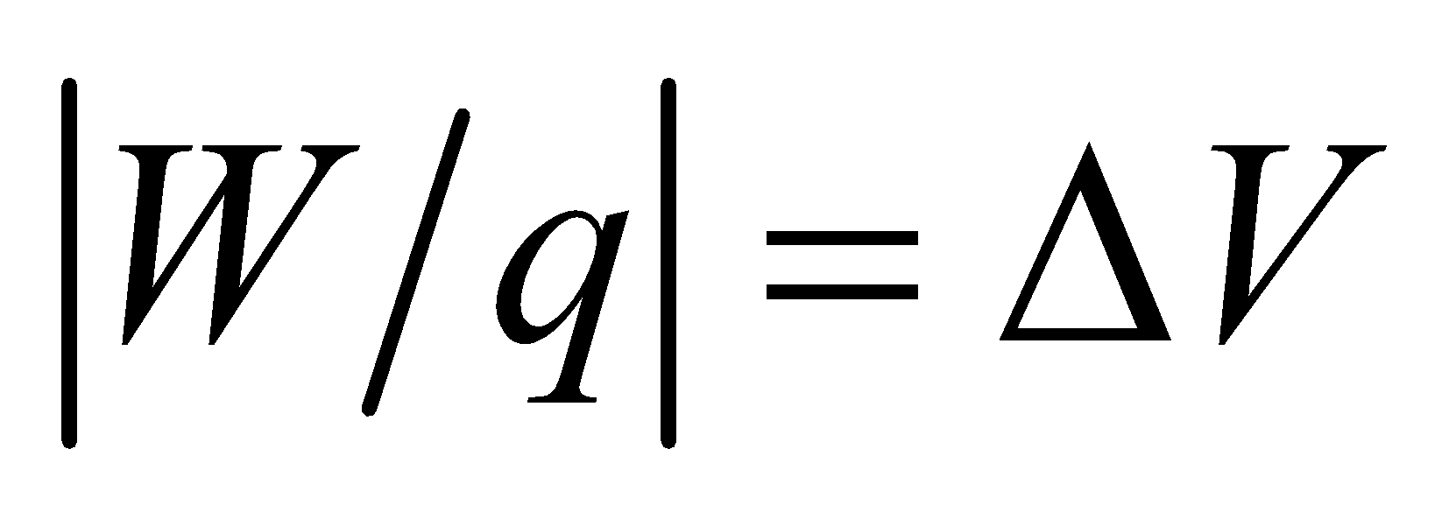.

**Evaluate** Inserting the given quantities gives

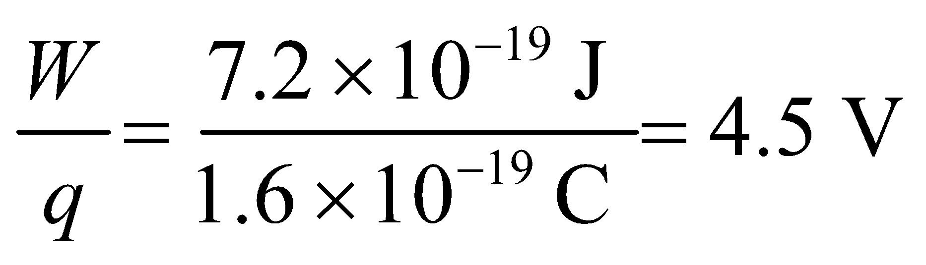

**Assess** The energy imparted per electron is 4.5 eV.

**38.** **Interpret** This problem requires us to find the charge of a particle that gains the given amount of energy due to its passage through the given potential difference.

**Develop** The work done on a charge that traverses a potential difference is

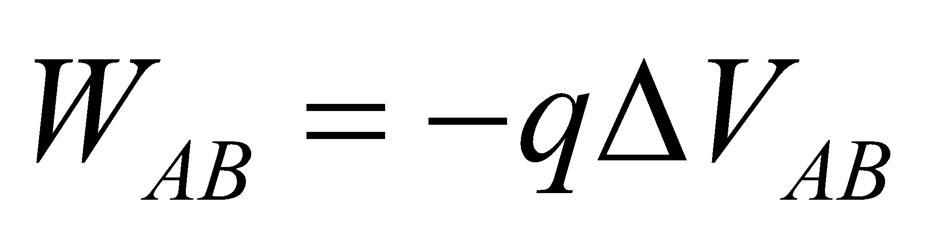

From Equation 22.1b, we see that the potential difference always decreases in the direction of the electric field, so

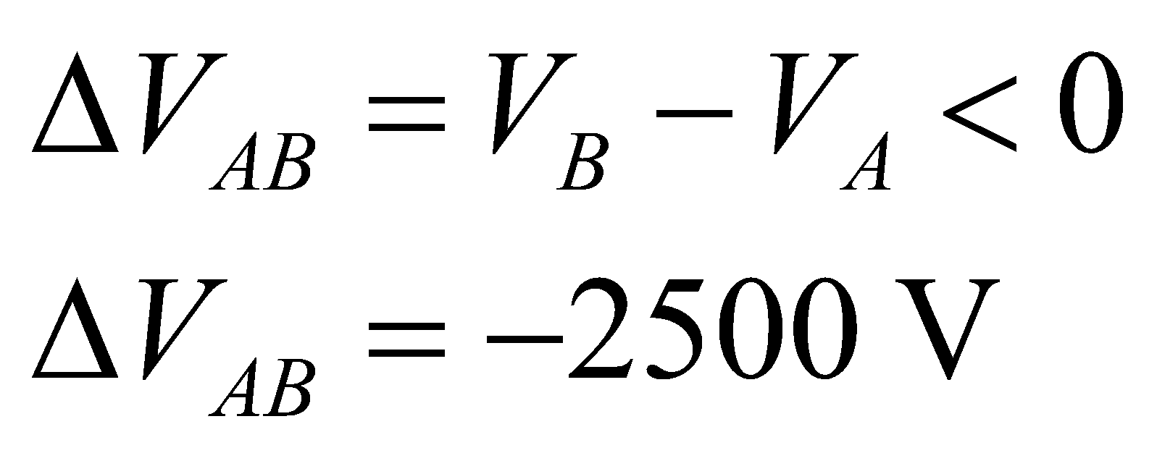

**Evaluate** Solving the expression for potential difference for the charge *q* gives

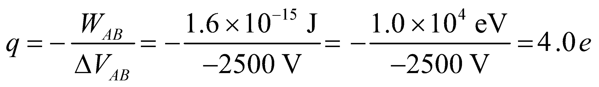

**Assess** The ion is positively charged.

**39. Interpret** This problem involves finding the potential difference between two conducting plates separated by a distance *d* and having opposite charge densities.

**Develop** We first calculate the electric field between the plates. Using the result obtained in Example 21.6 for one sheet of charge, and applying the superposition principle, the electric field strength between the plates is

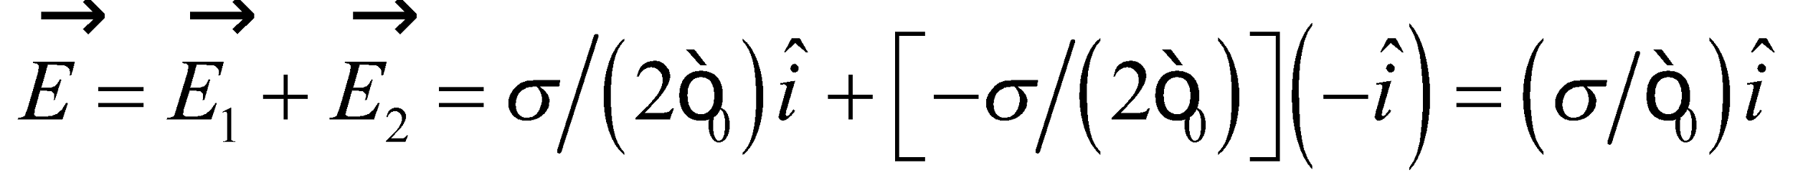

where 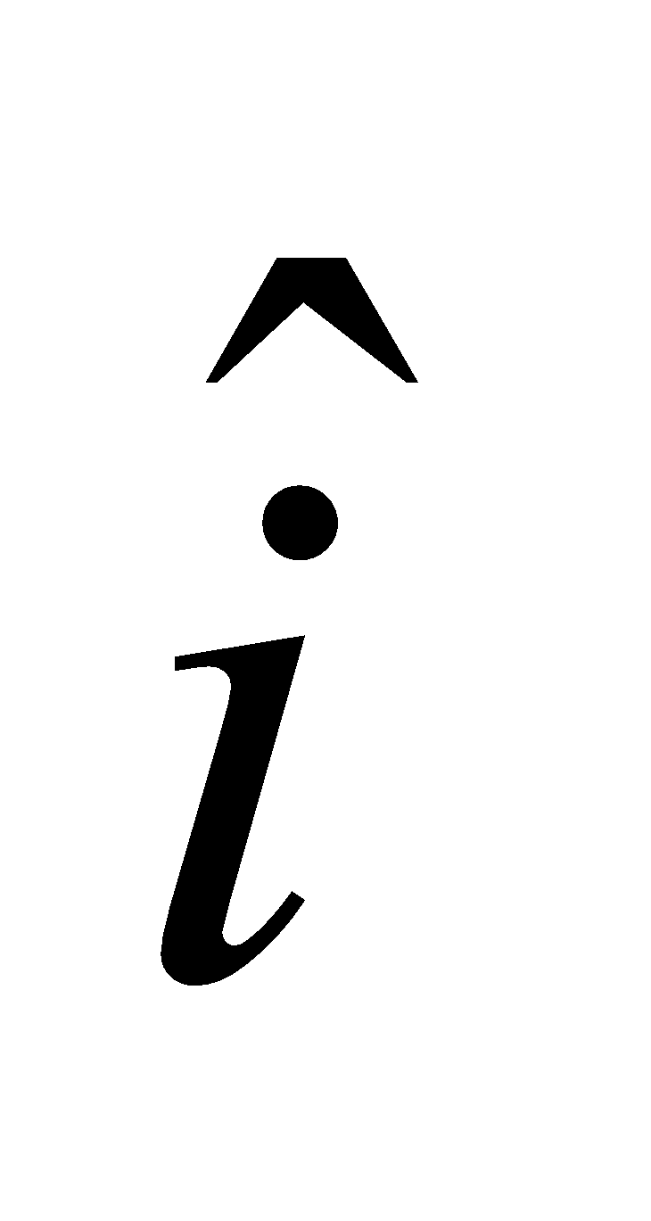 is directed from the positive plate to the negative plate. Once *E* is known, we can use Equation 22.1b to calculate *V*.

**Evaluate** Equation 22.1b gives

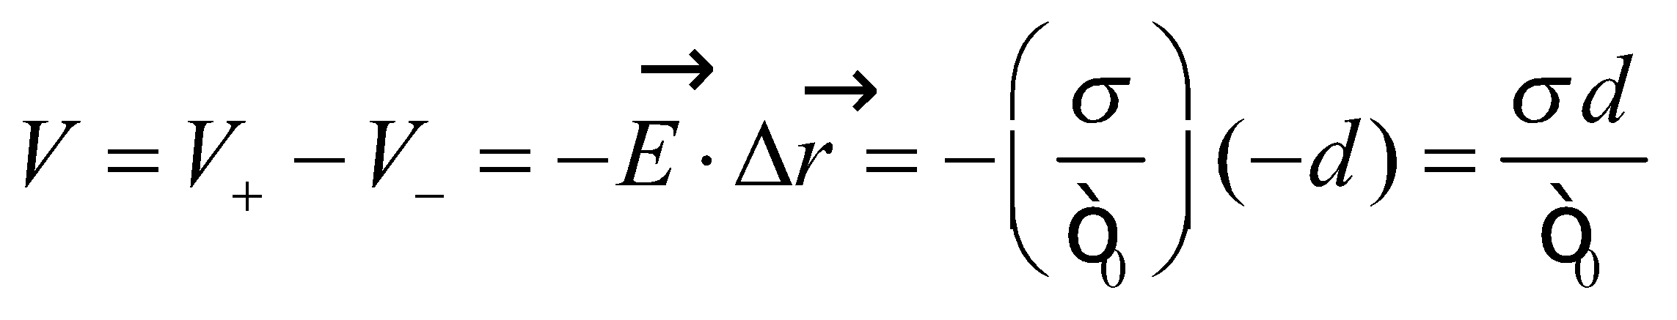

**Assess** The displacement from the negative to the positive plate is opposite to the field direction. In other words, the potential always decreases in the direction of the electric field.

**40.** **Interpret** This problem involves the work-energy theorem (Equation 6.14), which we can use to find the potential energy difference given the change in kinetic energy. Once we know the potential energy difference, we can divide it by the charge to find the potential difference.

**Develop** The work-energy theorem (Equation 6.14) says that the change in an objects kinetic energy is equal to the work done on the object, or 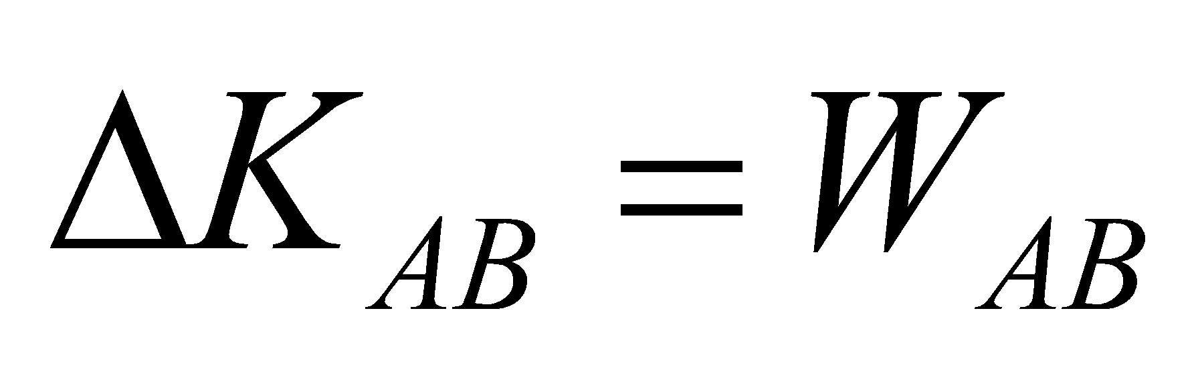. We also know from the discussion preceding Equation 22.1a that the work done on the charge by the electric field is the negative of the potential energy change, or

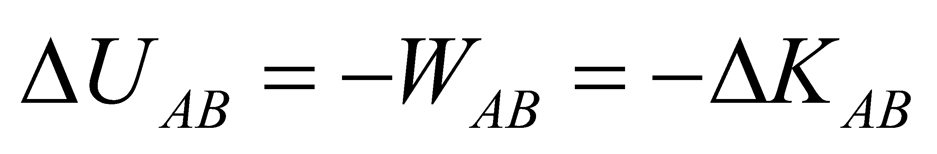

For this problem, the kinetic energy of the electron decreases, so 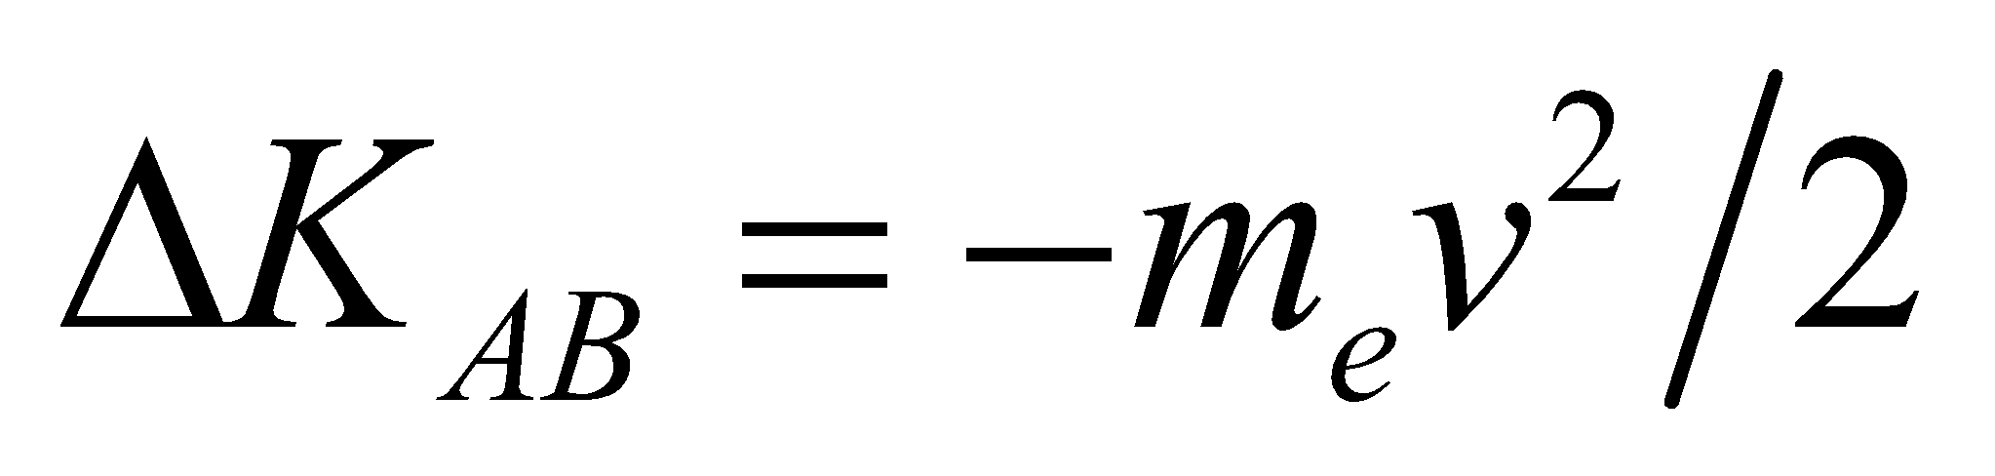.

**Evaluate** Using Equation 22.1b, 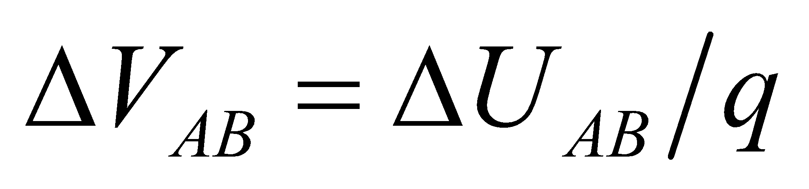, we find

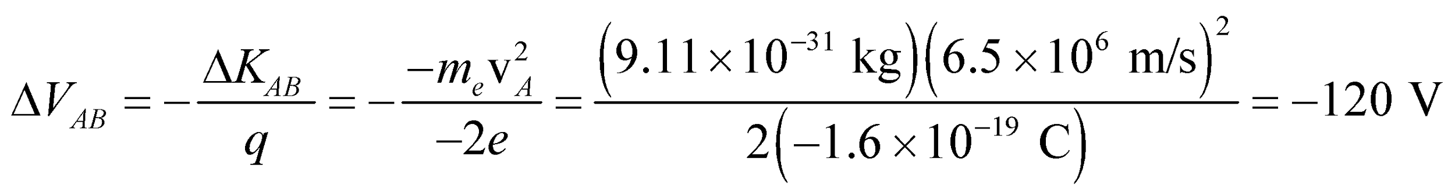

**Assess** There potential difference is negative because we are dealing with an electron, which has negative charge. In other words, to stop an electron, a negative potential difference must be applied.

**41. Interpret** The problem asks for the charge of the particle which has been accelerated through a potential difference. We can find the magnitude of this potential difference given the information of the speed acquired upon traversing the potential difference by the mass with the given charge.

**Develop** The speed acquired by a charge *q*, starting from rest at point *A* and moving through a potential difference of *V* can be found using the work-energy theorem (see Problem 22.40). The result is

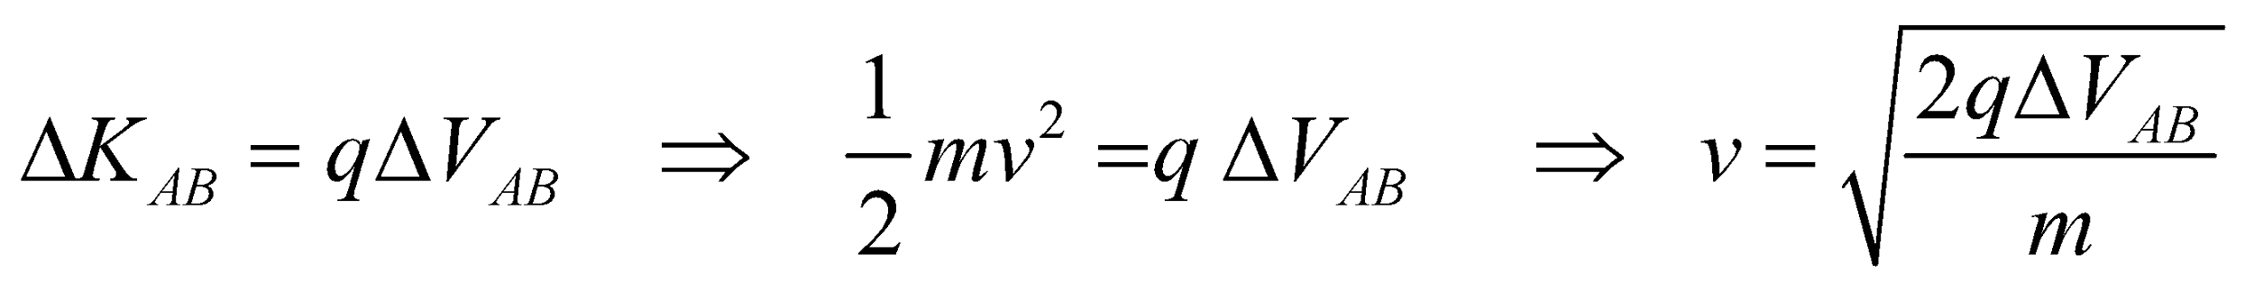

This is the work-energy theorem for the electric force. A positive charge is accelerated in the direction of decreasing potential (i.e., increasing electric field). If we have two masses moving through the same potential difference, the ratio of their speeds would be

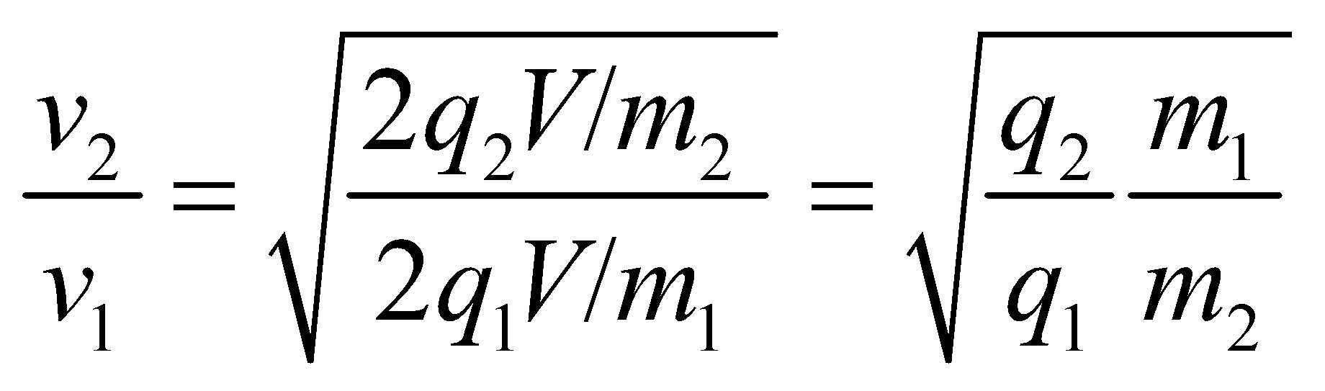

**Evaluate** If the second object acquires twice the speed of the first object 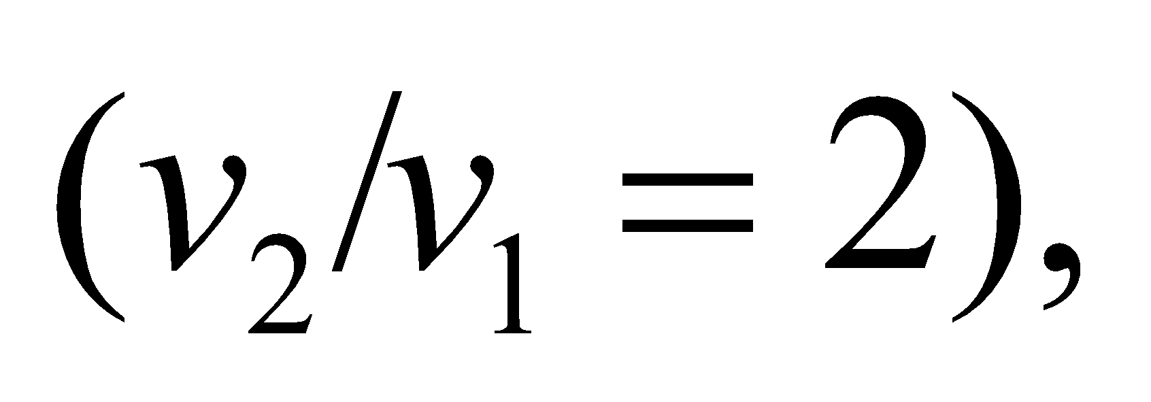 moving through the same potential difference we find its charge from the equation above to be

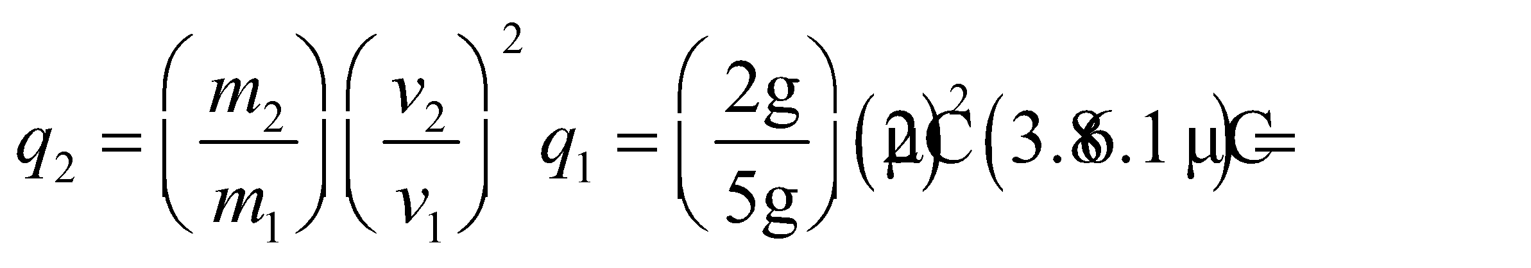

**Assess** The speed of the particle moving through a potential difference is proportional to the square root of its charge, and inversely proportional to the square root of its mass.

**42.** **Interpret** This problem involves finding the point charge that gives rise to the given potential difference between two points on a radial line. We are also to find the distance between the point charge and on of the potential points.

**Develop** Equation 22.3 gives the potential due to a point charge with respect to the potential an infinite distance from the point charge: *V* = *kQ*/*r*. We are given the potential at points *A* and *B* so dividing the two gives

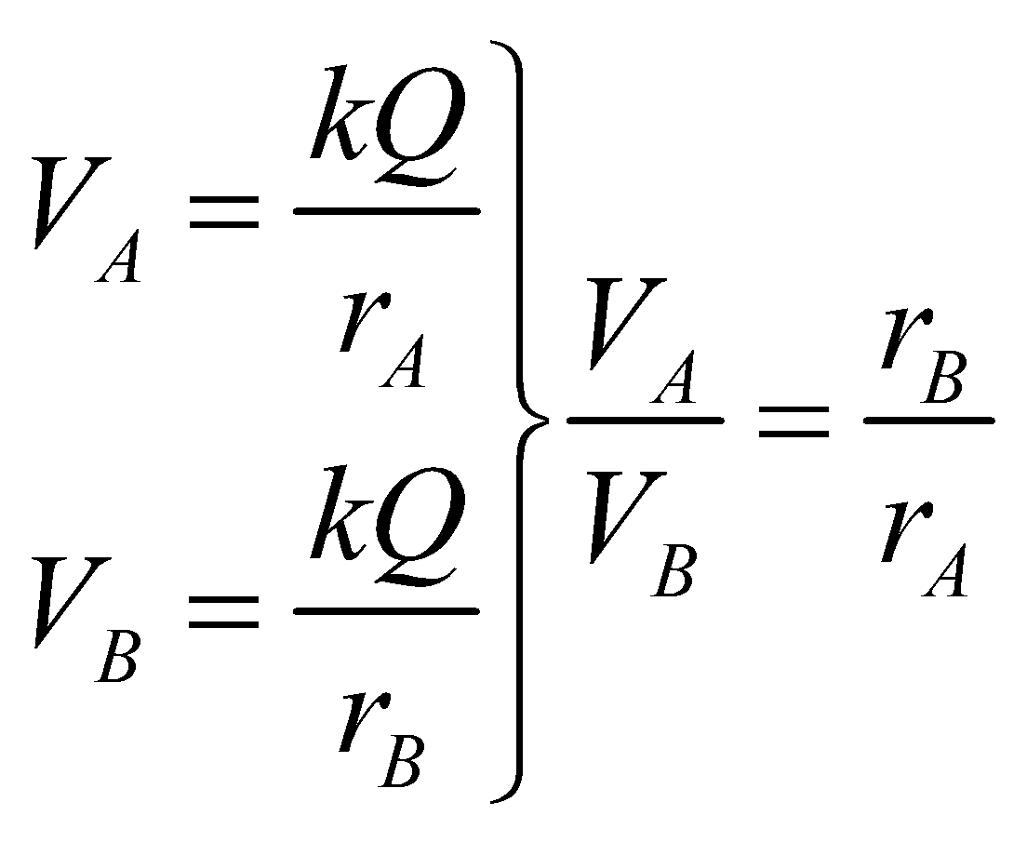

Given this and that *rB* − *rA* = 20 cm, we can solve for *rA* and, knowing *rA*, we can find *Q*.

**Evaluate** Solving for *rA* gives

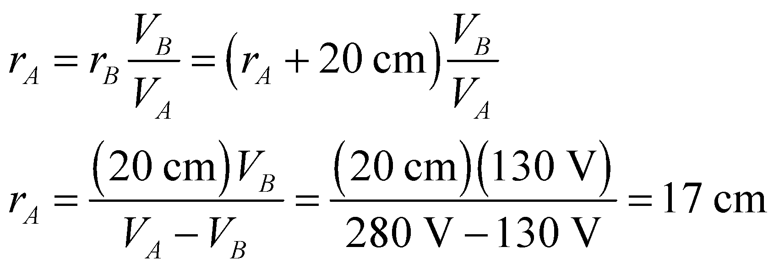

The charge *Q* is

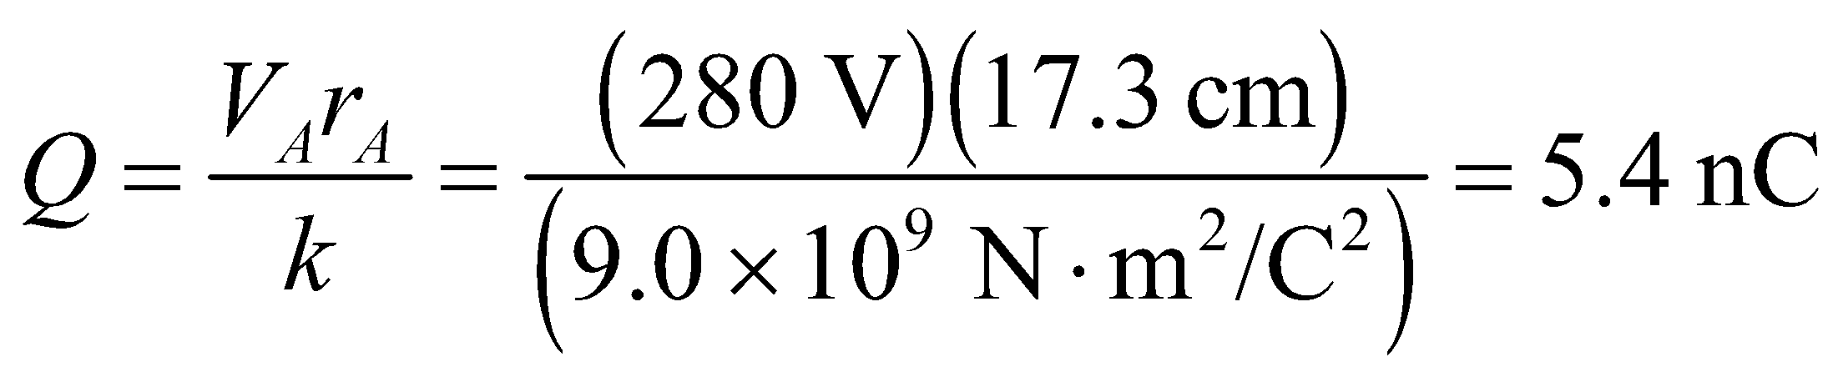

**Assess** The charge is positive, so the electric field points away from the charge and the potential decreases in the direction of the electric field, in agreement with the data.

**43. Interpret** The positively charged proton is attracted to the negatively charged sphere via Coulomb interaction. Work must be done to pull the proton away from the sphere.

**Develop** From the work-energy theorem (Equation 6.14), the work done by the electric field when a proton escapes from the surface to an infinite distance, equals the change in kinetic energy, or

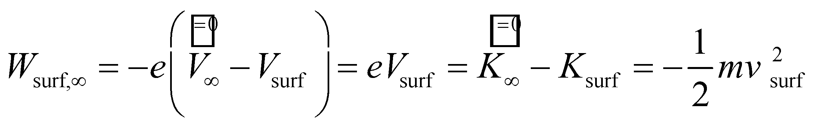

where we have assumed zero kinetic energy for the proton at infinity and that the sphere is stationary.

**Evaluate** For a uniformly charged sphere with a total charge –*Q*, 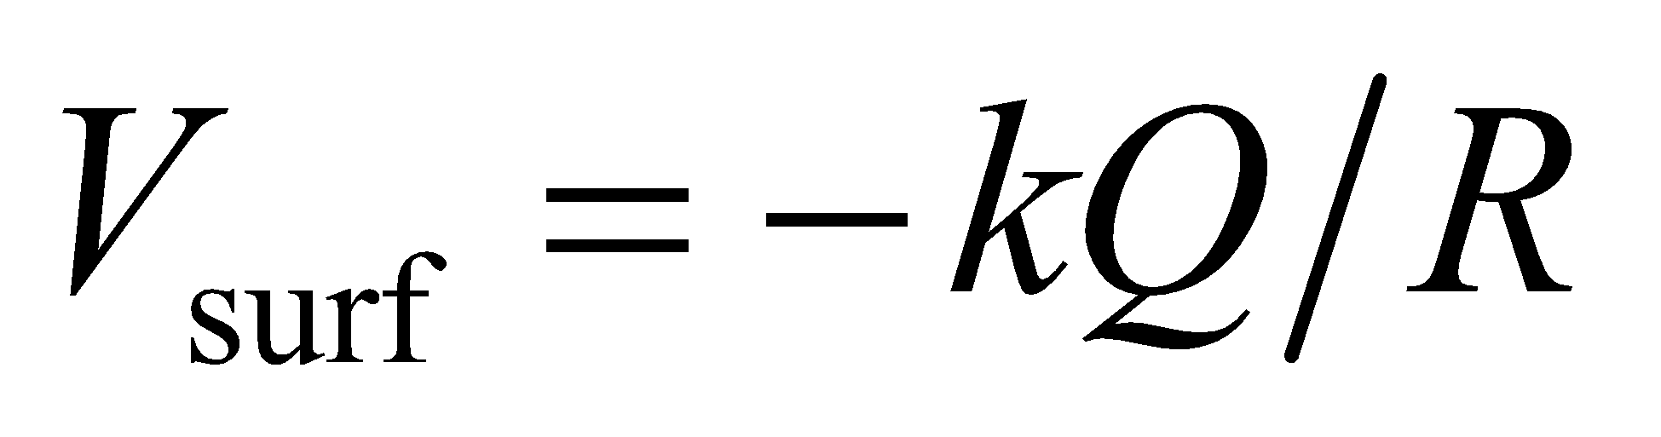 (see Equation 22.3). Inserting this into the expression above and solving for *v*surf gives

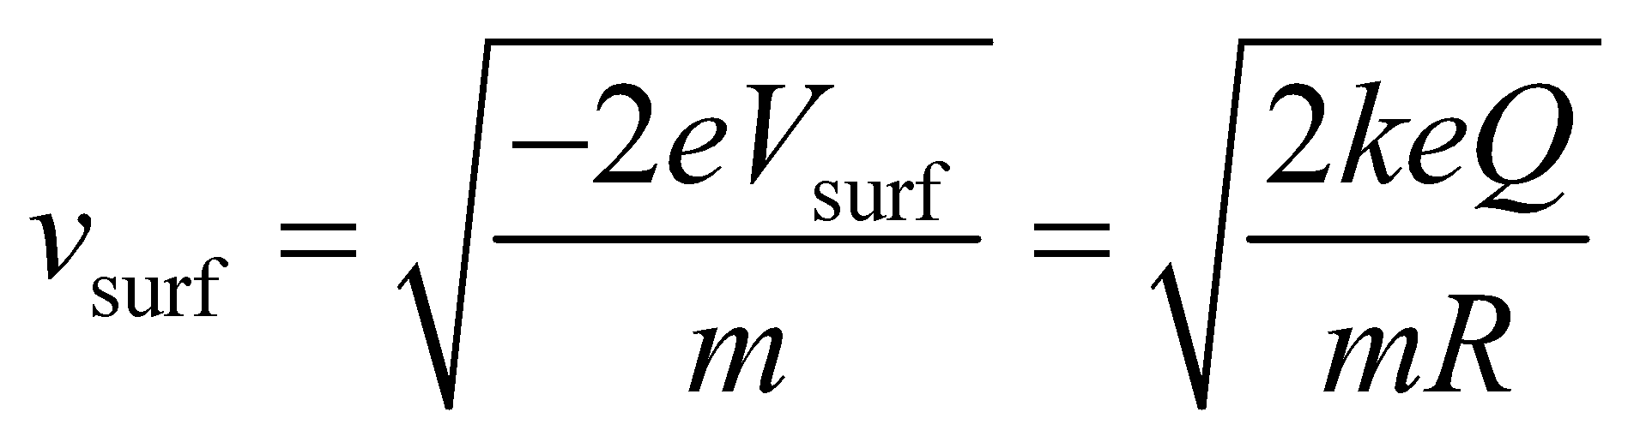

**Assess** The escape speed of a proton from the electric field of the charged sphere in this problem is analogous to the escape speed of a rocket from the Earth’s gravitational field.

**44.** **Interpret** The cyclotron accelerates particles using a potential difference. We want to know how many times a proton must pass through this difference to achieve the desired energy.

**Develop** In each pass, each proton gains kinetic energy: 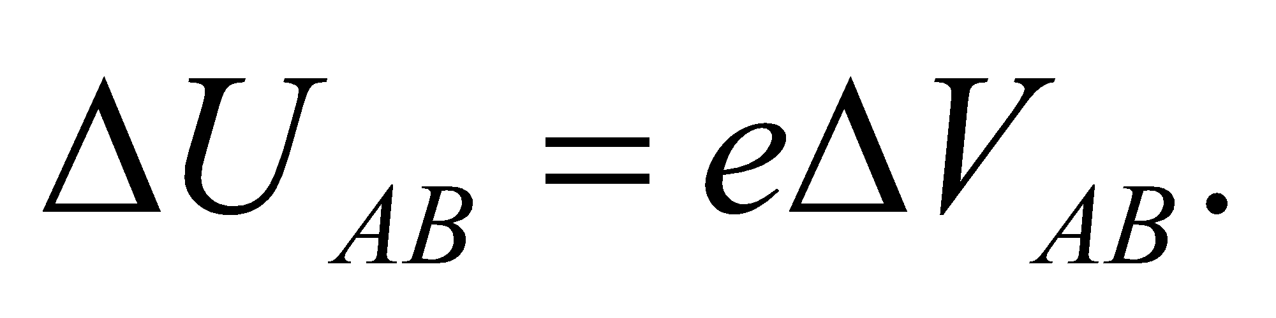

**Evaluate**  (a) The number of passes needed to reach 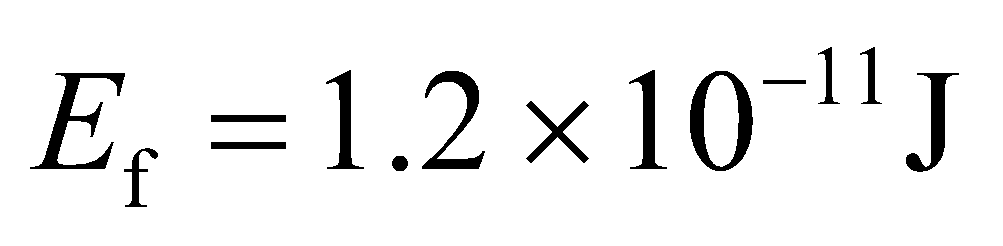is

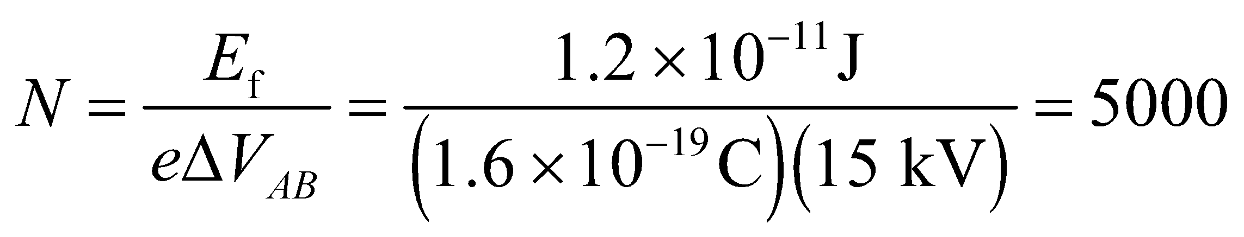

(b) In terms of electronvolts, the final energy of the protons is

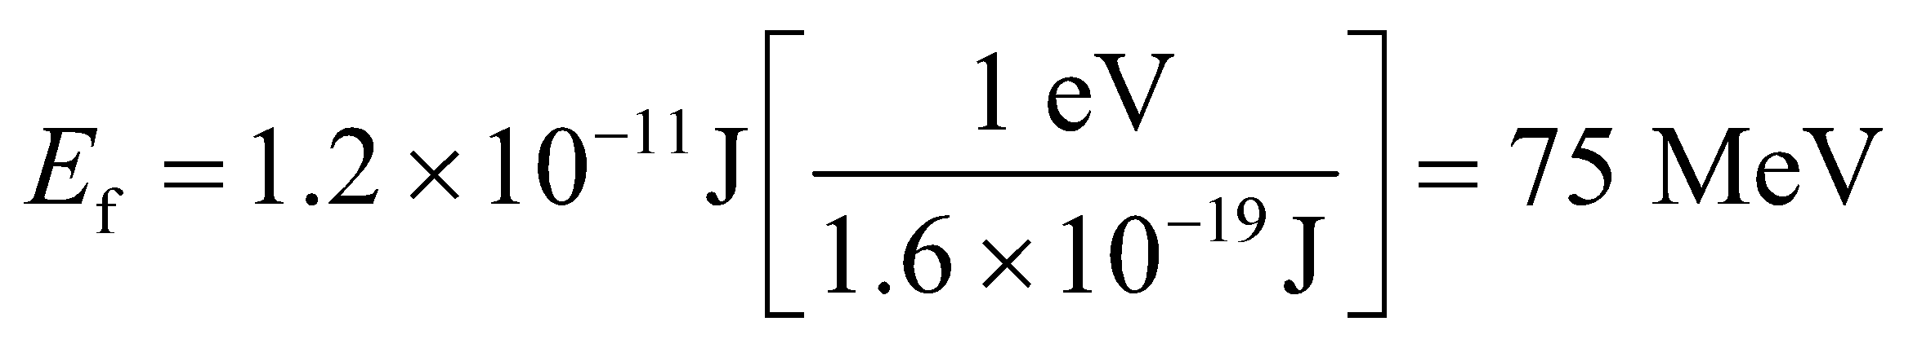

**Assess** The units in part (a) work out because 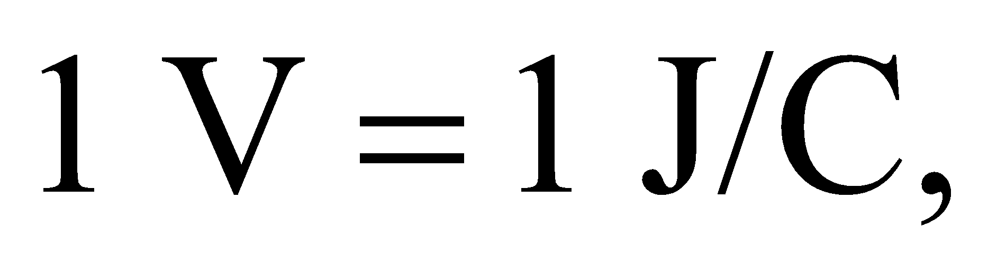but for particles it's much simpler to use electronvolts. The proton gains 15 keV for each pass through the cyclotron, and the number of passes is simply: 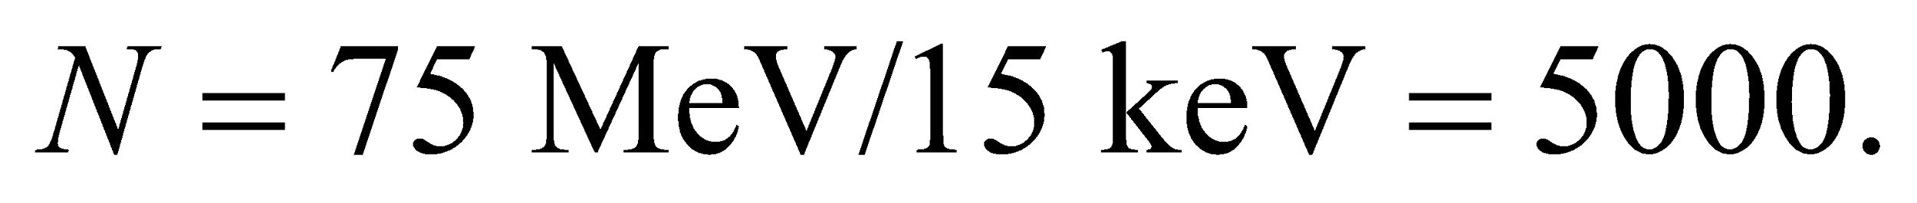

**45.** **Interpret** For this problem, we are to find the potential at the center of a hollow spherical shell that carries a uniform charge density on its surface.

**Develop** From Gauss’s law, we know that the electric field inside the shell is zero, because there is no charge in the shell. Because the electric field is constant, we can apply Equation 22.1b, which shows that the change in the potential between any two points within the sphere must be zero. Consider the boundary condition for the electric potential (at the surface of the sphere) to find the electric potential everywhere in the sphere.

**Evaluate** At the surface of the sphere, the electric potential must be (see Equation 22.3)

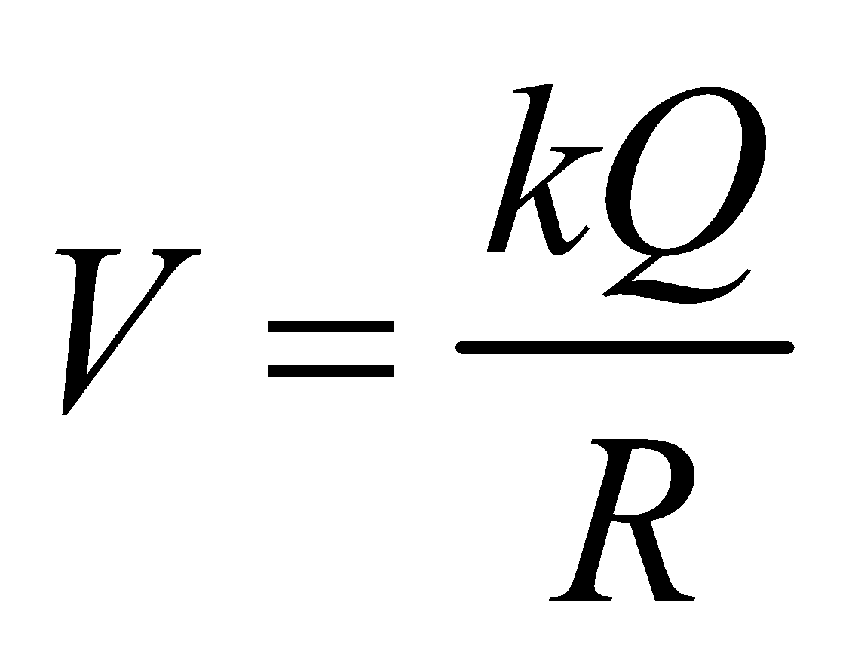

Thus, this must be the potential everywhere inside the sphere, since we have argued above that the potential inside the sphere must be constant.

**Assess** The potential at the surface of the sphere is measured with respect to infinity, which is to say a distance *r*  *R* from the sphere.

**46. Interpret** The problem is about the potential difference between the center of a charged sphere and a point on its surface.

**Develop**From Equation 22.1a, we see that the potential difference from point *A* to point *B* is given by

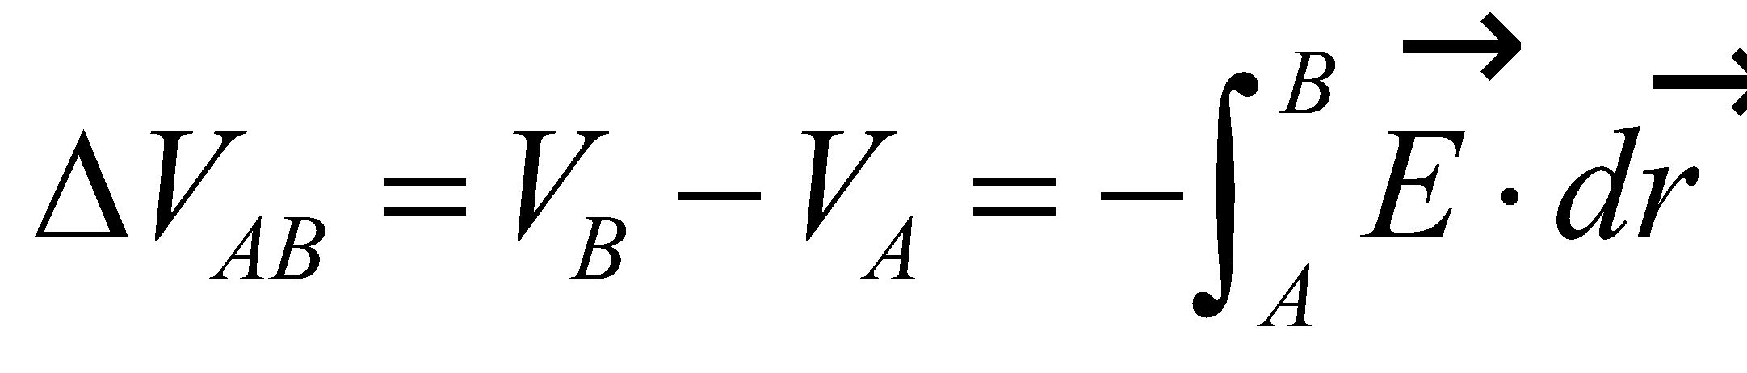

As shown in Example 21.1, the electric field inside a uniformly charged sphere is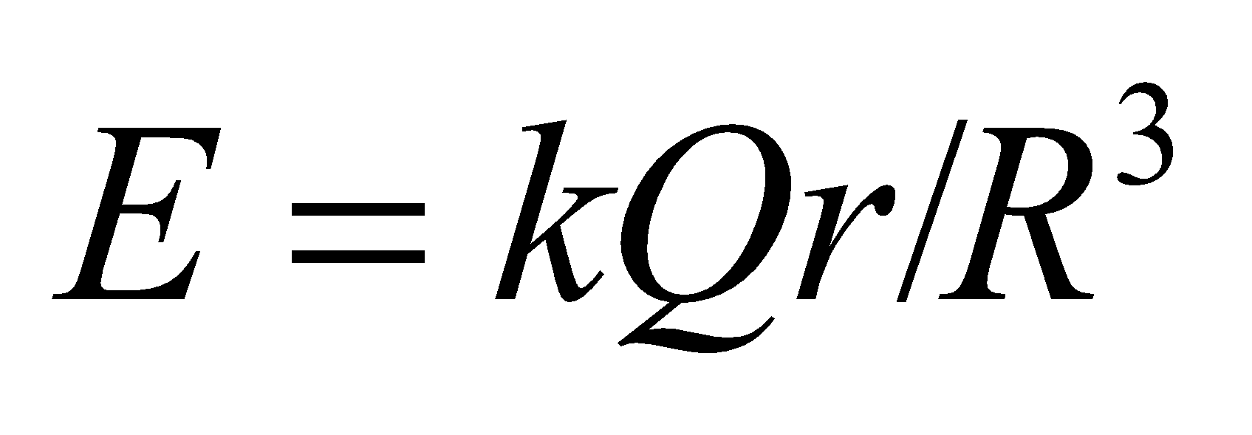and is radially symmetric.

**Evaluate** The integration above gives

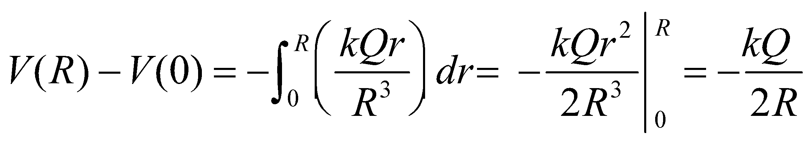

**Assess** The potential is higher at the center if *Q* is positive.

**47.** **Interpret** For this problem, we are given the electric field as a function of position, and we are to find the electric potential as a function of position. We are also given the electric potential at a given point, so we will define our electric potential with respect to this point.

**Develop** Apply Equation 22.1a,

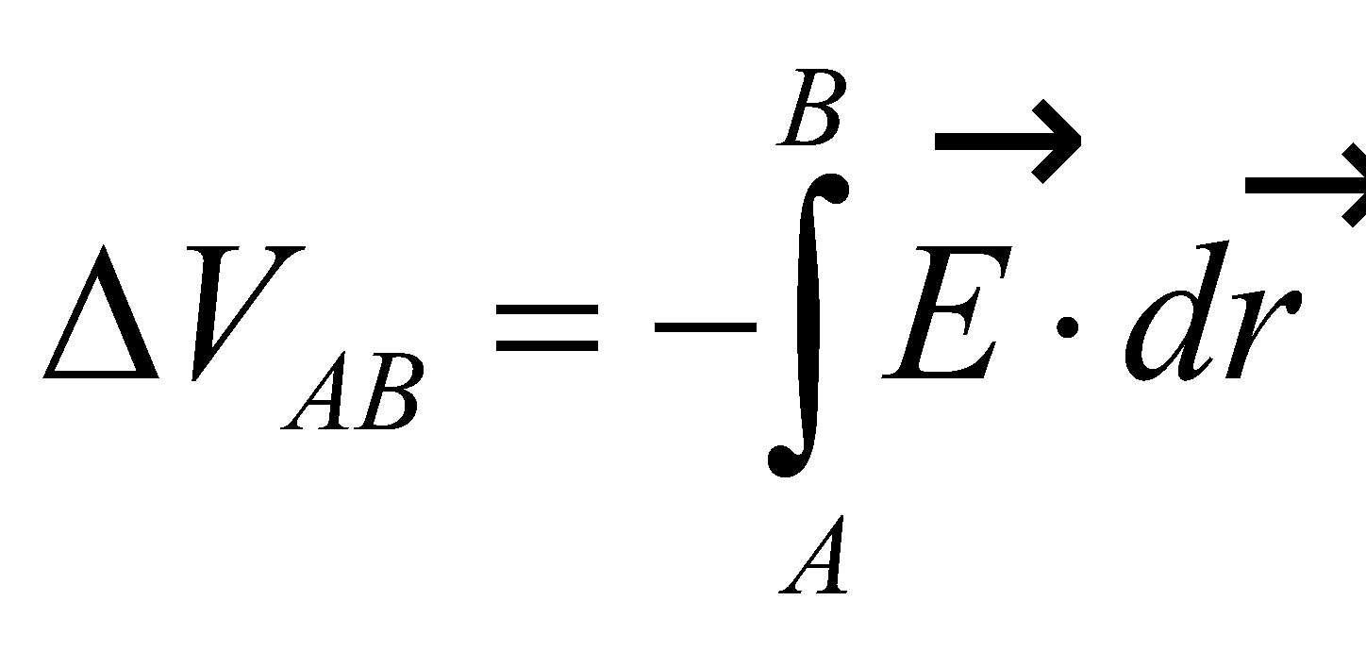

where 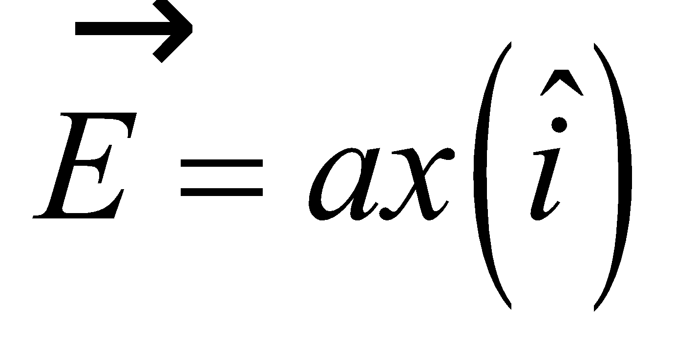 and 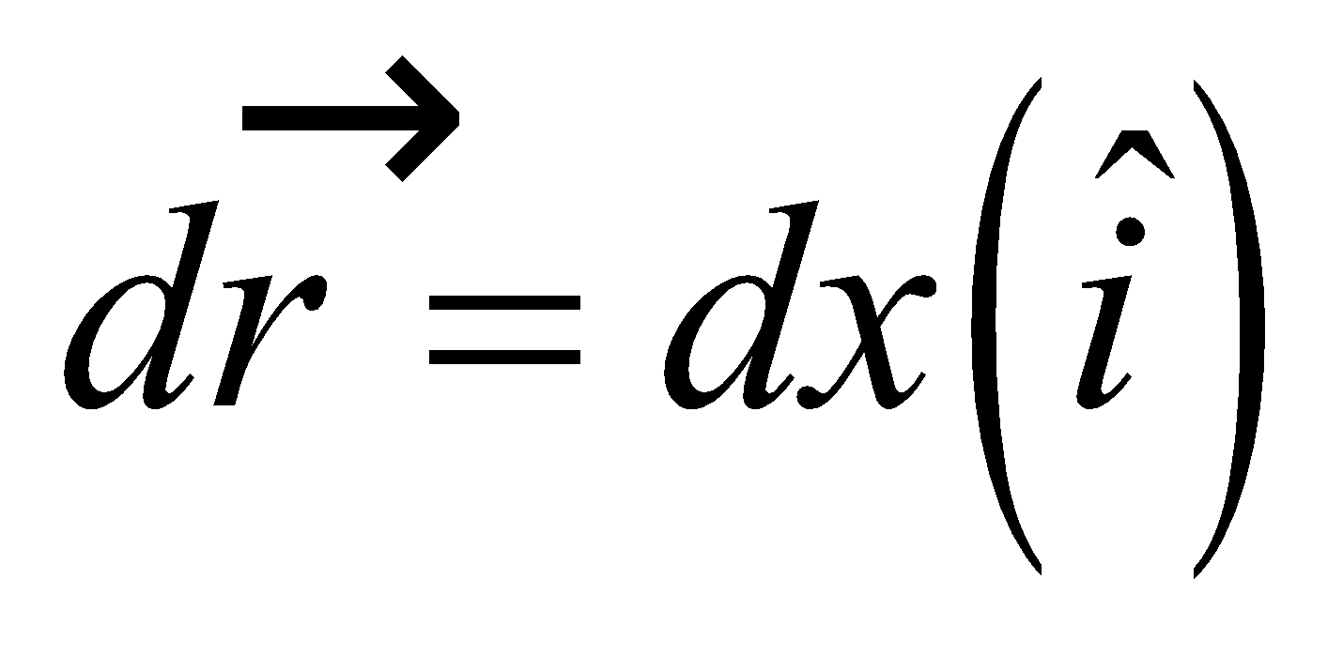. Furthermore, we take point *A* to be x = 0, so *VA* = *V*(*x* = 0) = 0, and point *B* to be an arbitrary point *x*.

**Evaluate** Evaluating the integral gives

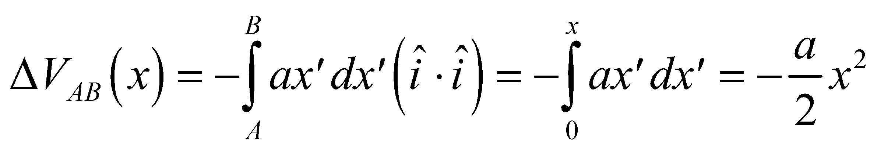

so

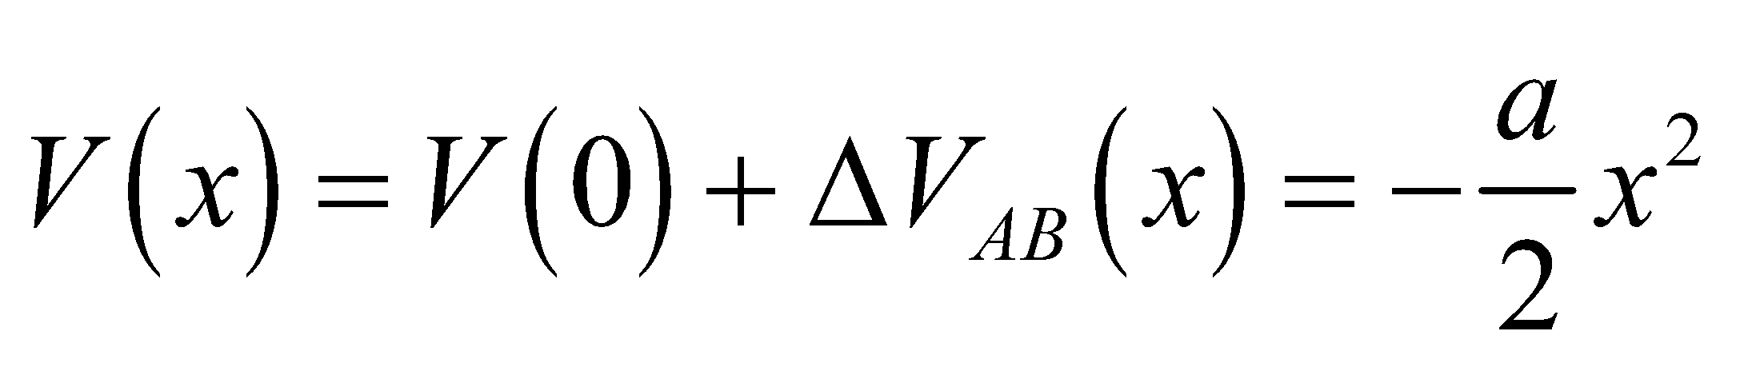

**Assess** This potential increases quadratically with position, whereas the electric field is linear in position.

**48.** **Interpret** You need to check if the charge on a coaxial cable will create an unsafe potential difference.

**Develop** You can assume the cable is long compared to its diameter. Due to the cylindrical symmetry, the electric field should be radial and therefore amenable to Gauss's law. In Equation 22.4, this fact was used to find the potential difference around a long wire:

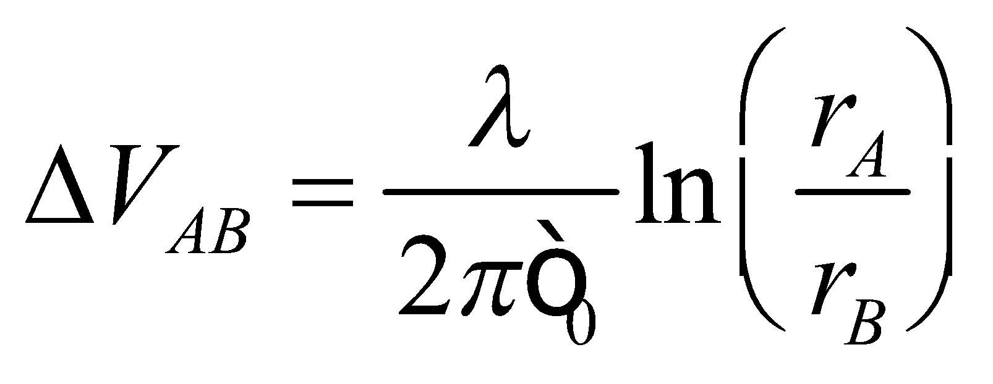

where 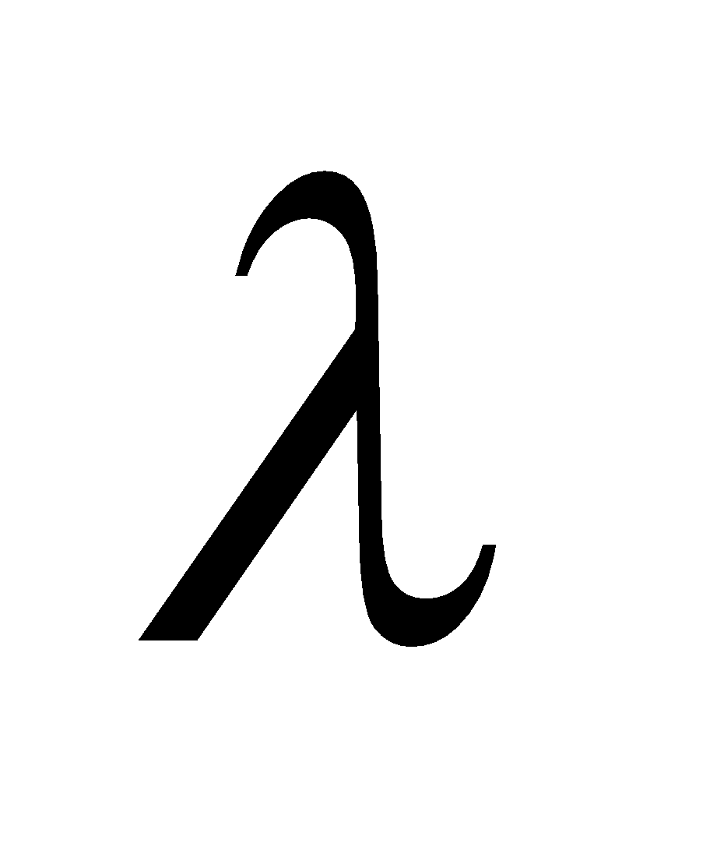 was the charge density per unit length and 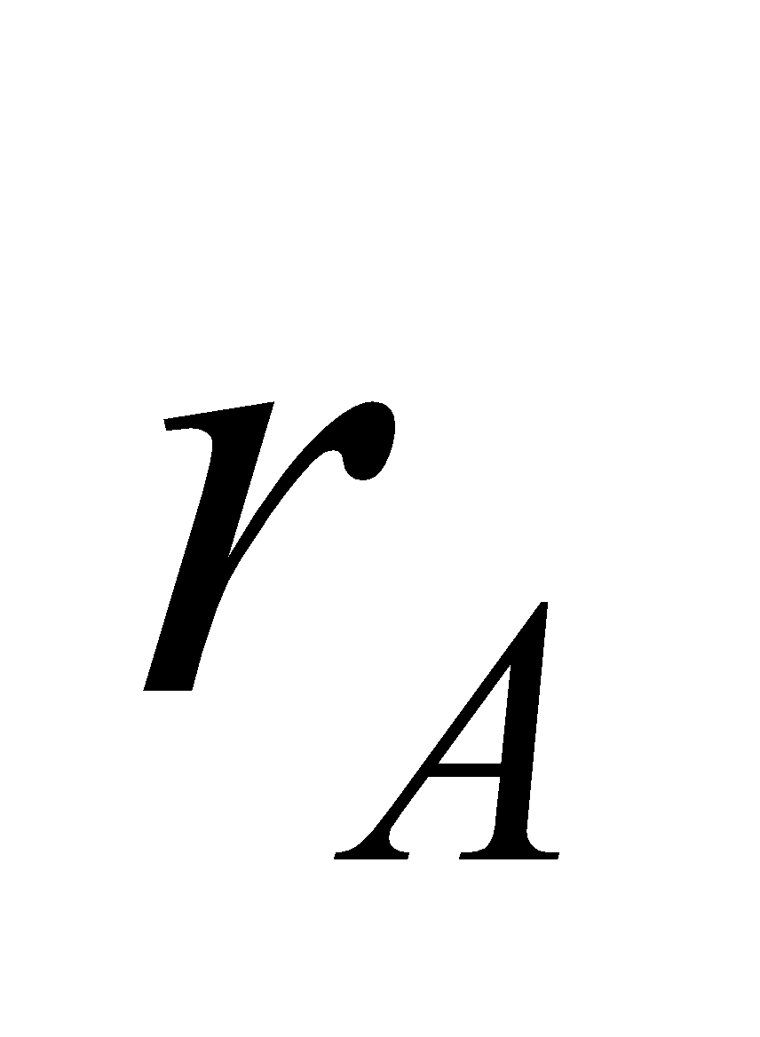was the radius of the wire. In the case of a coaxial cable, the wire is surrounded by a thin conductor in the shape of a cylindrical shell. By Gauss's law, this outer shield has no effect on the field in between the conductors, so we can use Equation 22.4.

**Evaluate** For the given charge density, the voltage difference between the two conductors is

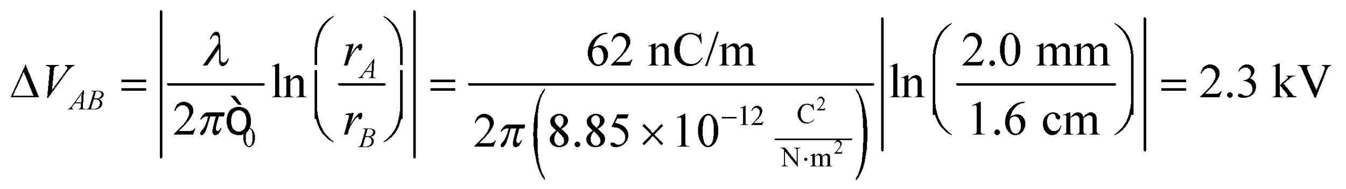

This is 300 V over the safe limit, so the cable won't work.

**Assess** We took the absolute value of the potential difference because we were only concerned with the magnitude (i.e. 2.3 kV is just as unsafe as –2.3kV). It is somewhat striking that the answer doesn't depend on the charge lying on the outer conductor. But this is only true when the cable maintains the cylindrical symmetry. If the cable were bent, for instance, this answer would no longer be valid.

**49.** **Interpret** This problem involves finding the charge density on a power line given the potential difference over a given distance away. To use Gauss’s law for geometries with line symmetry, we will assume that the power line is much, much longer than 1.0 m.

**Develop** The electric potential around an object with line symmetry (such as our power line) is derived in Example 22.4. The result is

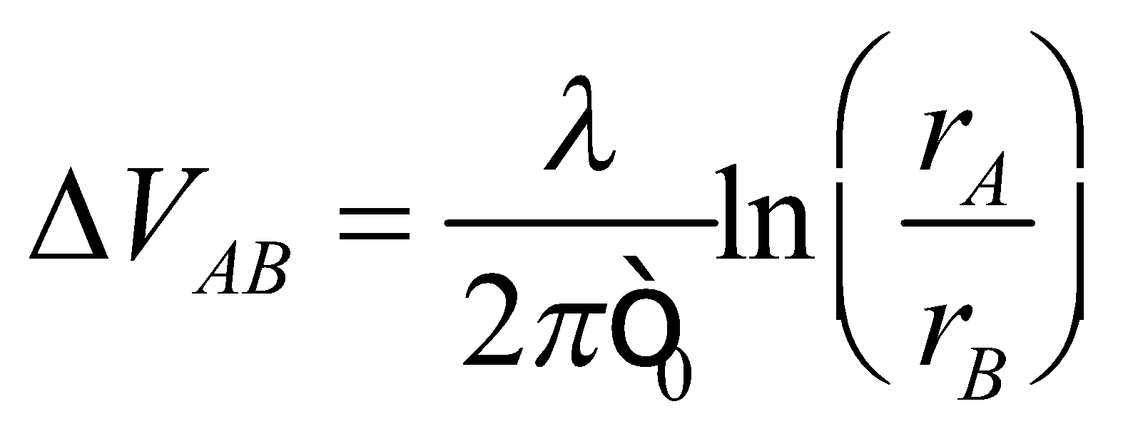

From the problem statement, make a sketch showing the location of the given voltages (see figure below). From this sketch, we see that *rA* = 3.0 cm, *rB* = 1.0 m, and *ΔVAB* = *VB* − *VA* = +3.9 kV for this problem.



**Evaluate** Solving the expression above for the line charge density *λ* gives

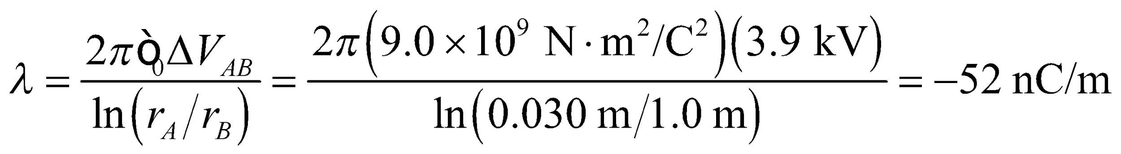

**Assess** Thus, the wire carries excess negative charge.

**50. Interpret** This problem is about the electric potential at a point due to a system of charges. The principle of superposition will be useful for this problem.

**Develop** The electric potential at a point *P* due to a collection of charges is given by the superposition of the potential from each point charge (i.e., Equation 22.5):

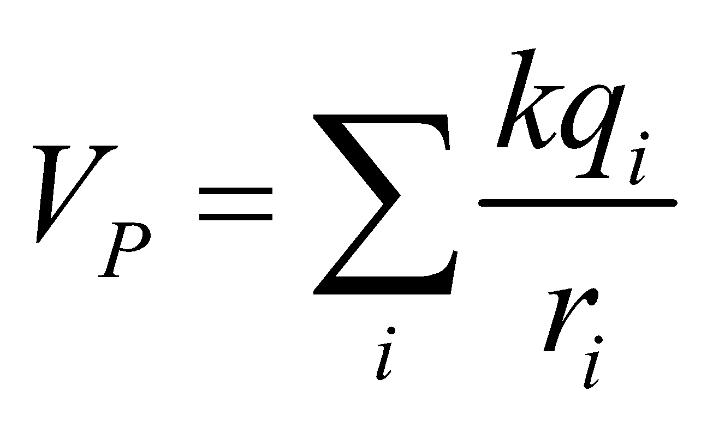

Use this formula to compute the electric potential at the center of a triangle.

**Evaluate** The center is an equidistance *r* from each vertex, with

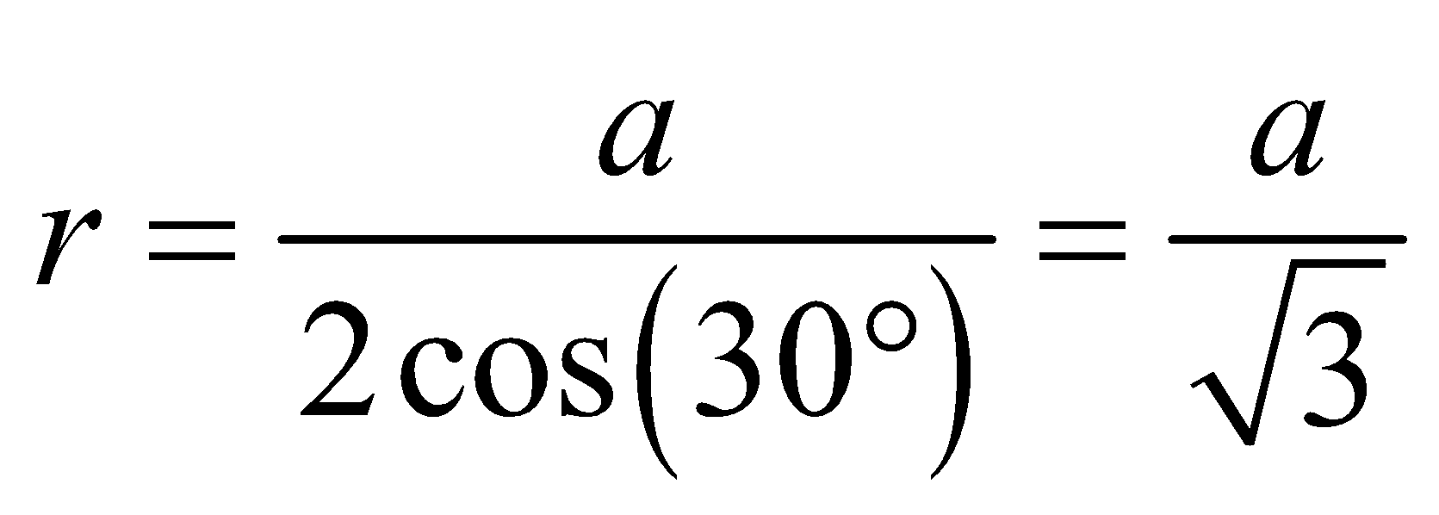

Since each charge contributes equally to the potential, the potential at the center is

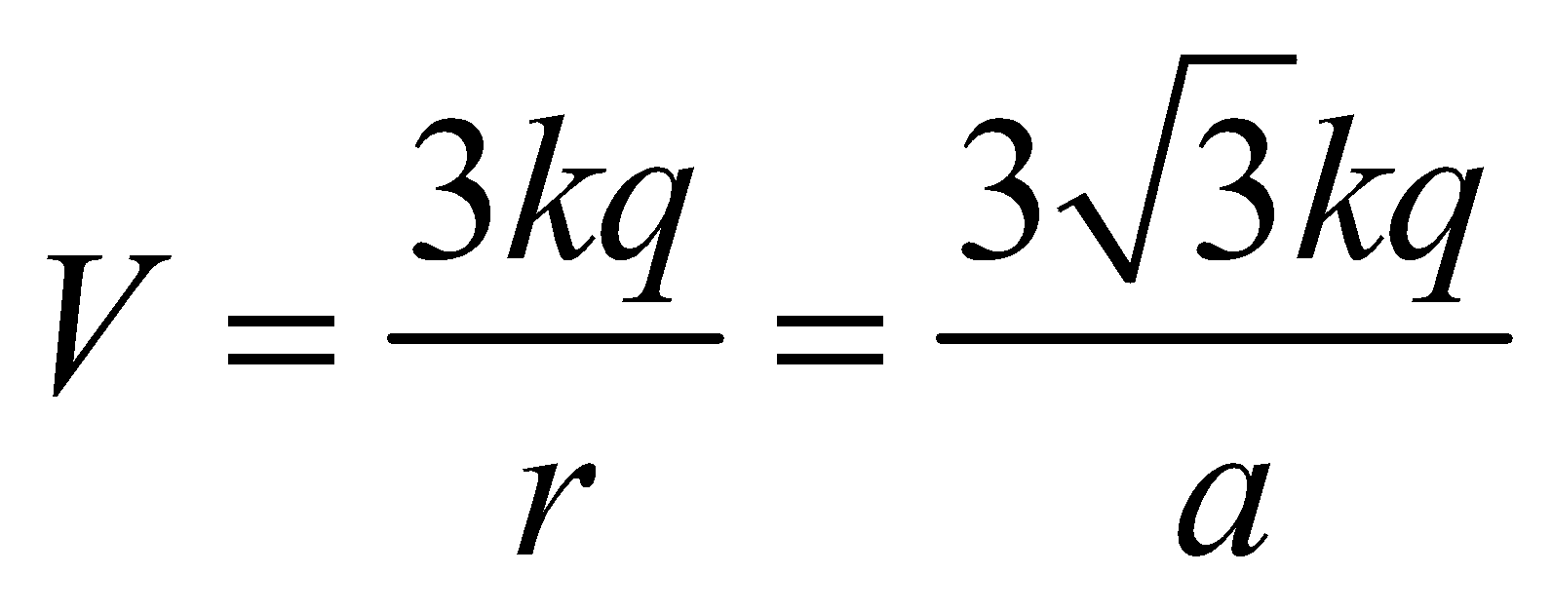



**Assess** Electric potential is a scalar, so there is no need to consider angles, vector components, or unit vectors.

**51.** **Interpret** This problem involves using the superposition principle to find two points on a line joining the two given charges where the electric potential is zero.

**Develop** Using the superposition principle in the form of Equation 22.5, the potential at the *x*-axis is

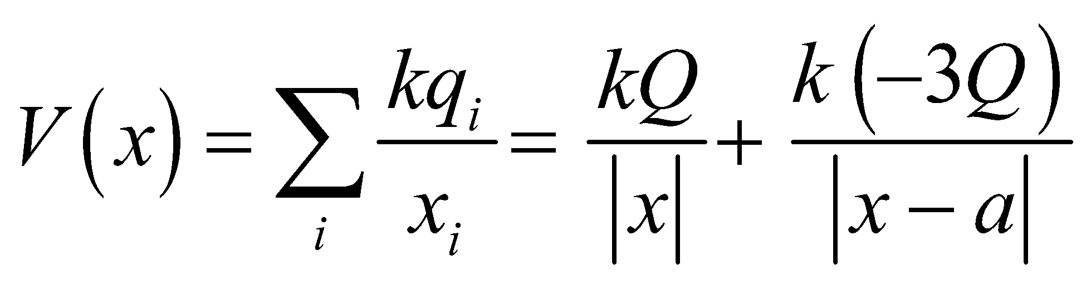

Set this expression equal to zero and solve for the position *x*.

**Evaluate** The potential is zero when 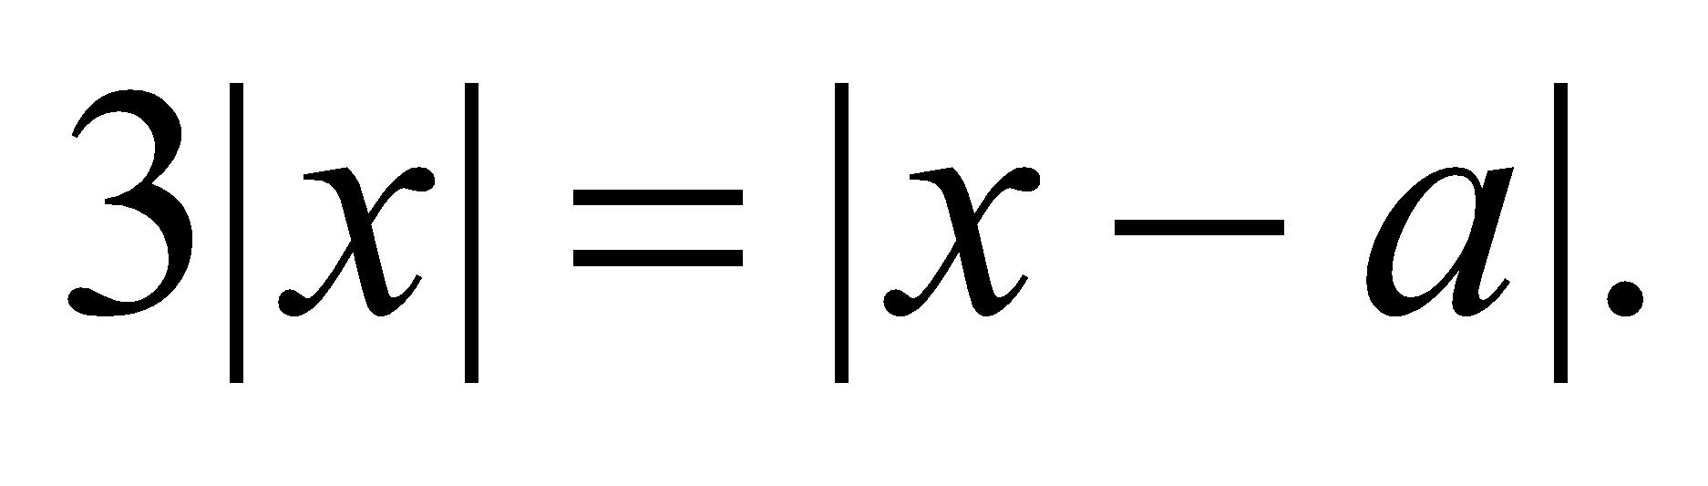 For *x* < 0, this implies 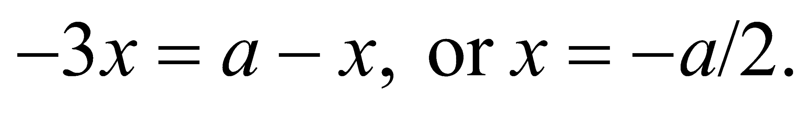 For 0 < *x* < *a*, the condition is 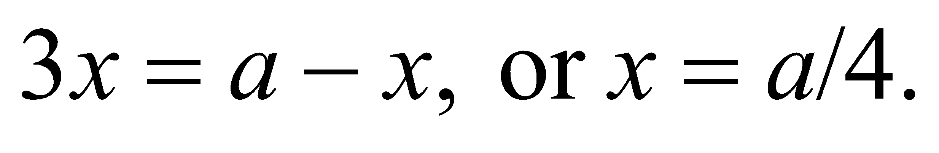 For *x* > *a*, there are no solutions.

**Assess** The same results follow from the quadratic 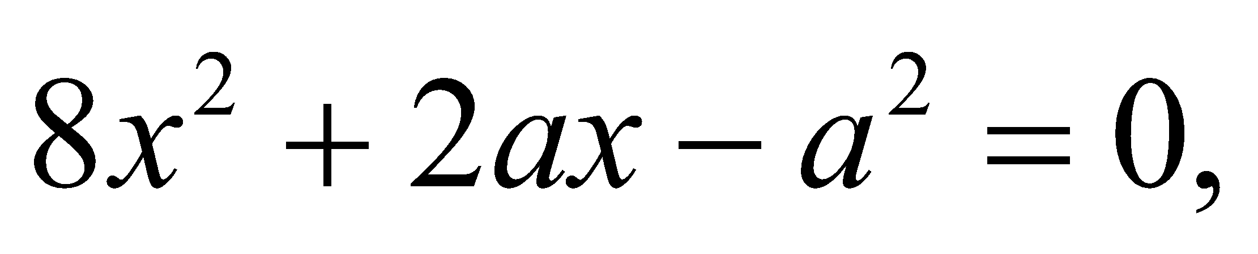 which results from the square of the above condition.

**52. Interpret** This problem involves finding the electric potential everywhere in a plane that contains two identical point charges. This problem involves the principle of superposition.

**Develop** The electric potential at a point *P* due to a collection of charges is given by Equation 22.5:



Consider a point 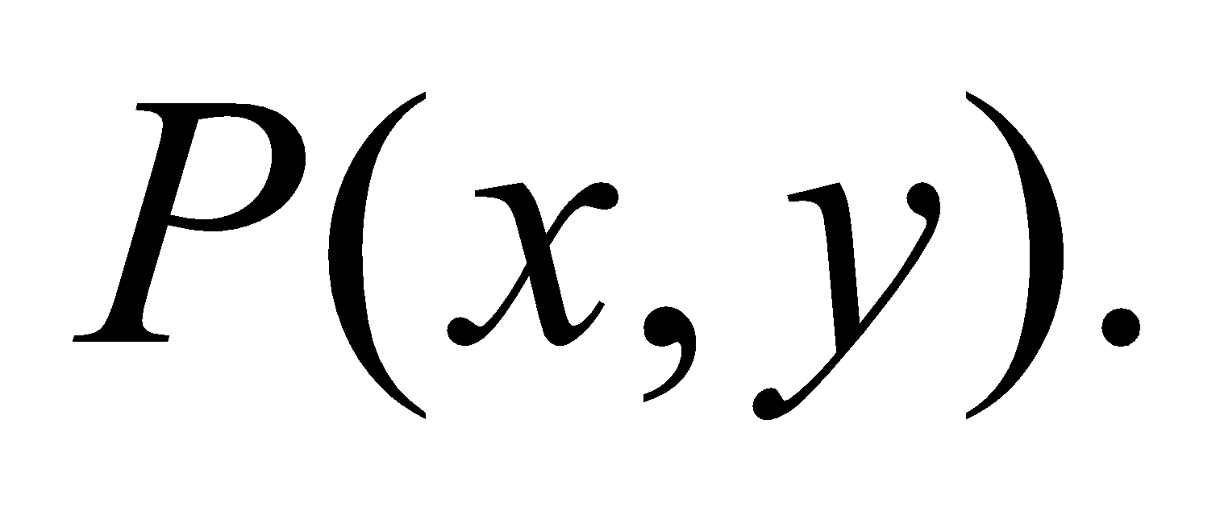 The distance from *P* to (0, *a*) is 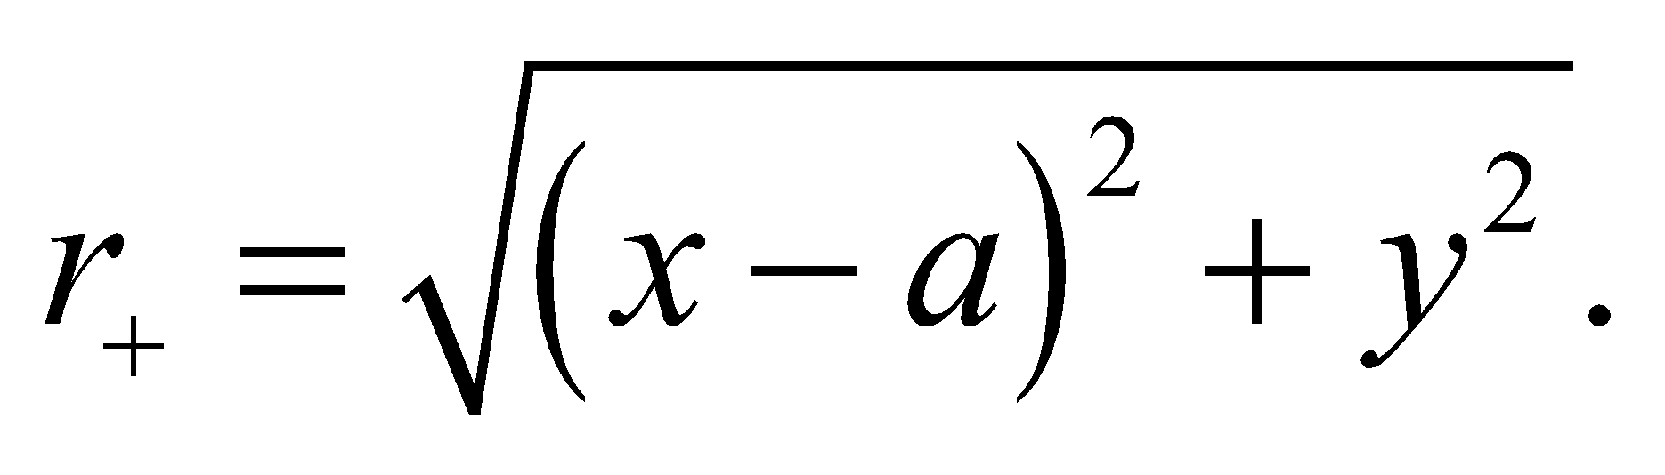 Similarly, the distance from *P* to  
(0, −*a*) is 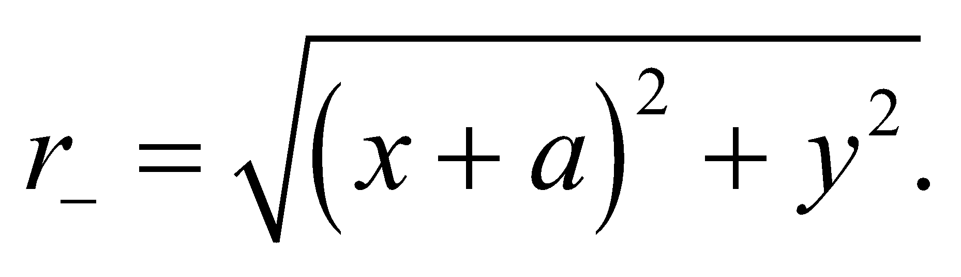

**Evaluate** **(a)** Inserting *r*+ and *r*− into the summation gives

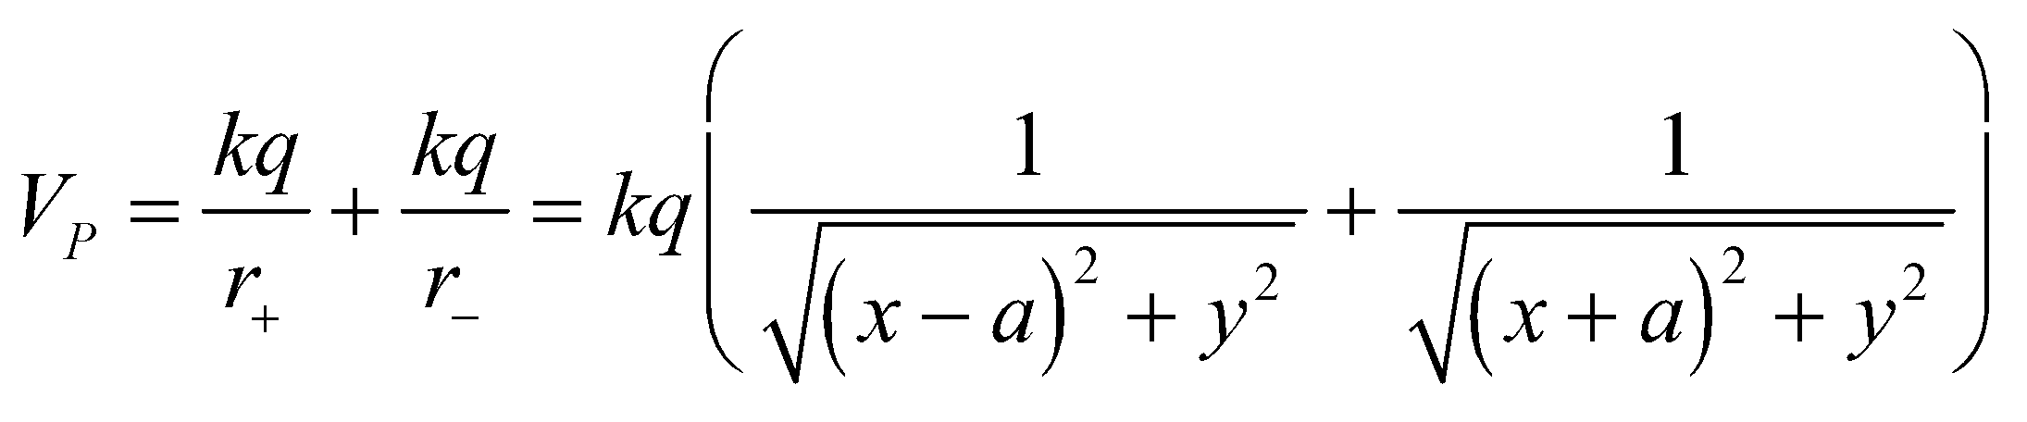

**(b)** If 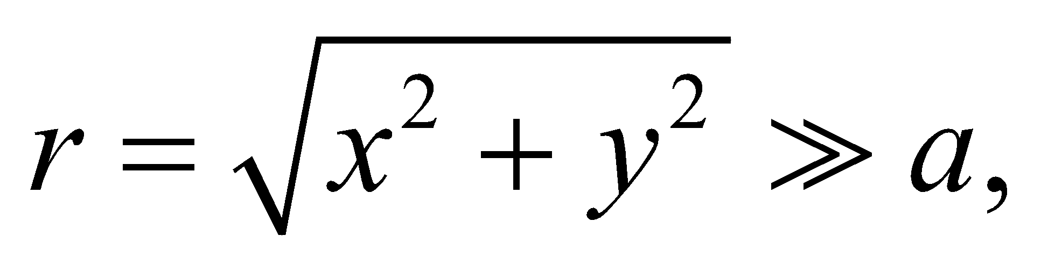 then *a* can be neglected relative to *x* or *y*, so

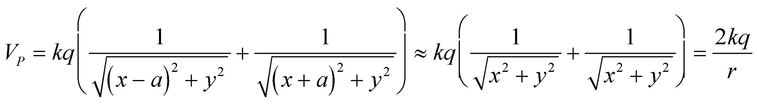

which is the potential of a point charge of magnitude 2*q*.

**Assess** At a distance much greater than the separation of two charges *q*1 and *q*2, the electric potential is like that due to one single point charge 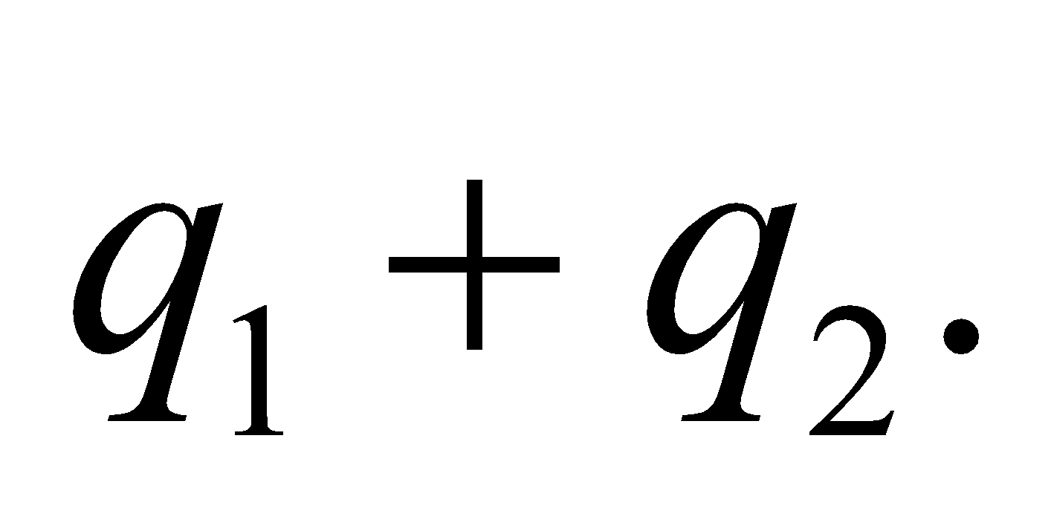 Note that electric potential is a scalar, so there is no need to consider angles, vector components, or unit vectors.

**53.** **Interpret** We're asked to find the electric potential around an electric dipole.

**Develop** Equation 22.6 gives the potential from a dipole at a distance, *r*, much larger than the charge separation:  where 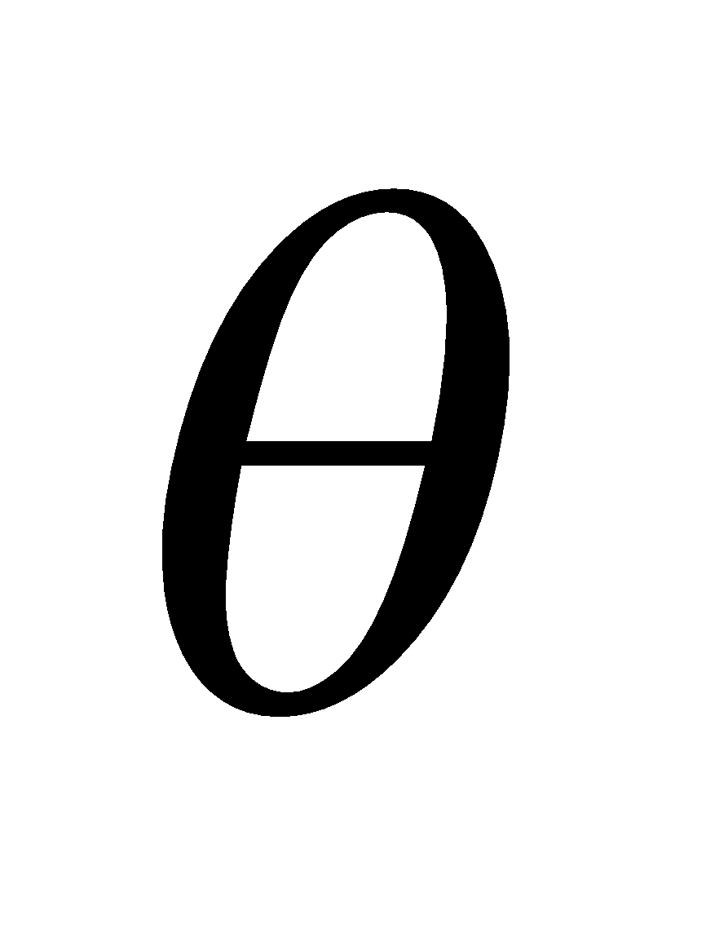 is the angle from the dipole axis.

**Evaluate**  (a) For 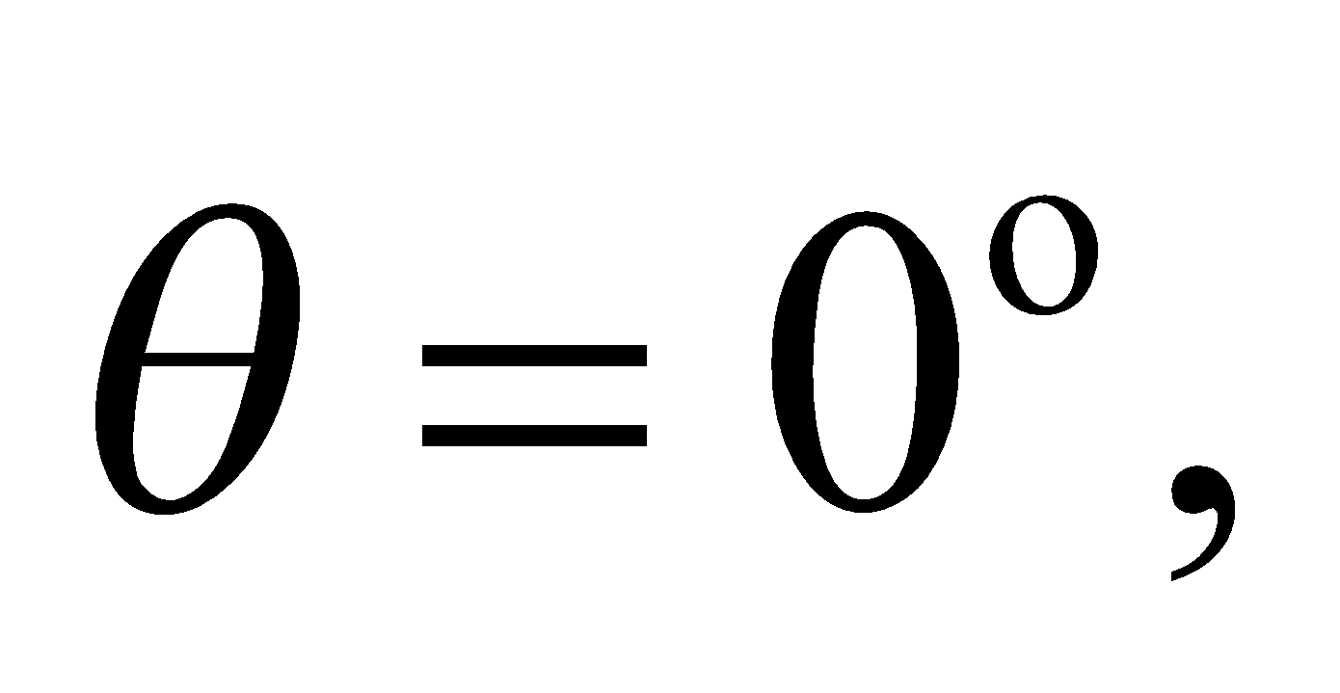

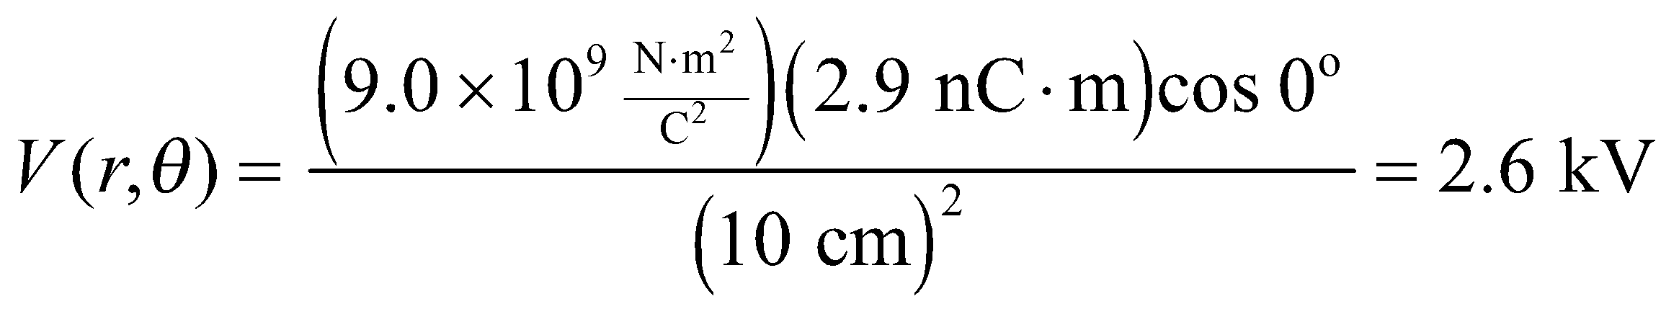

(b) For 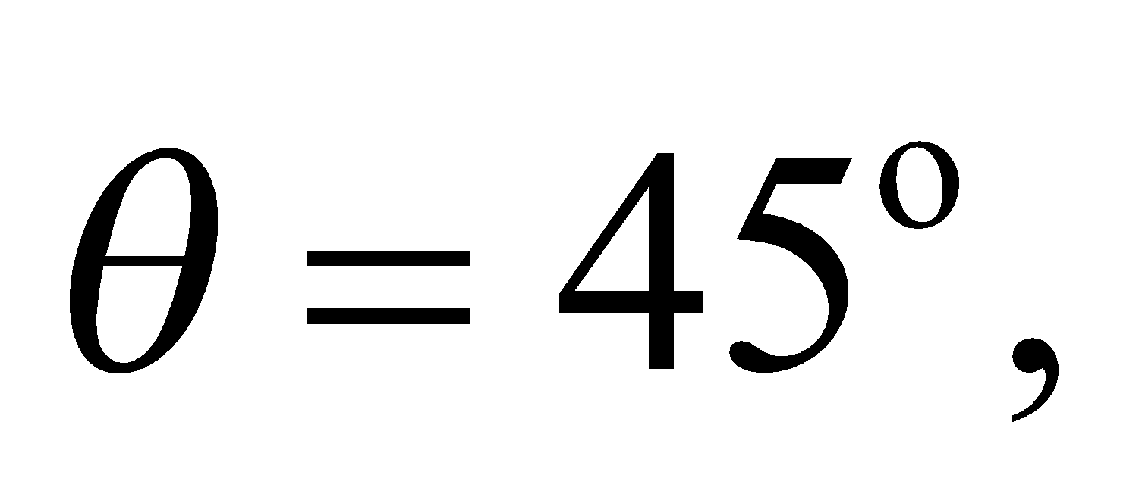

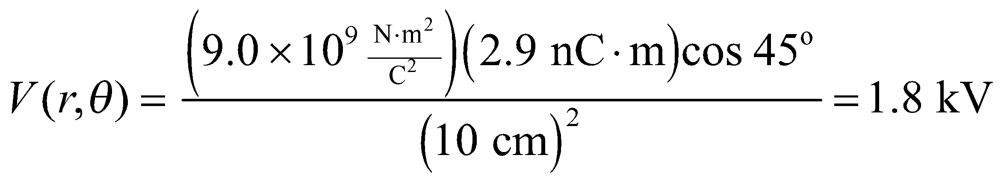

(c) For 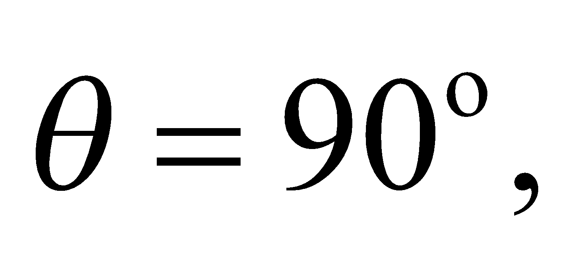

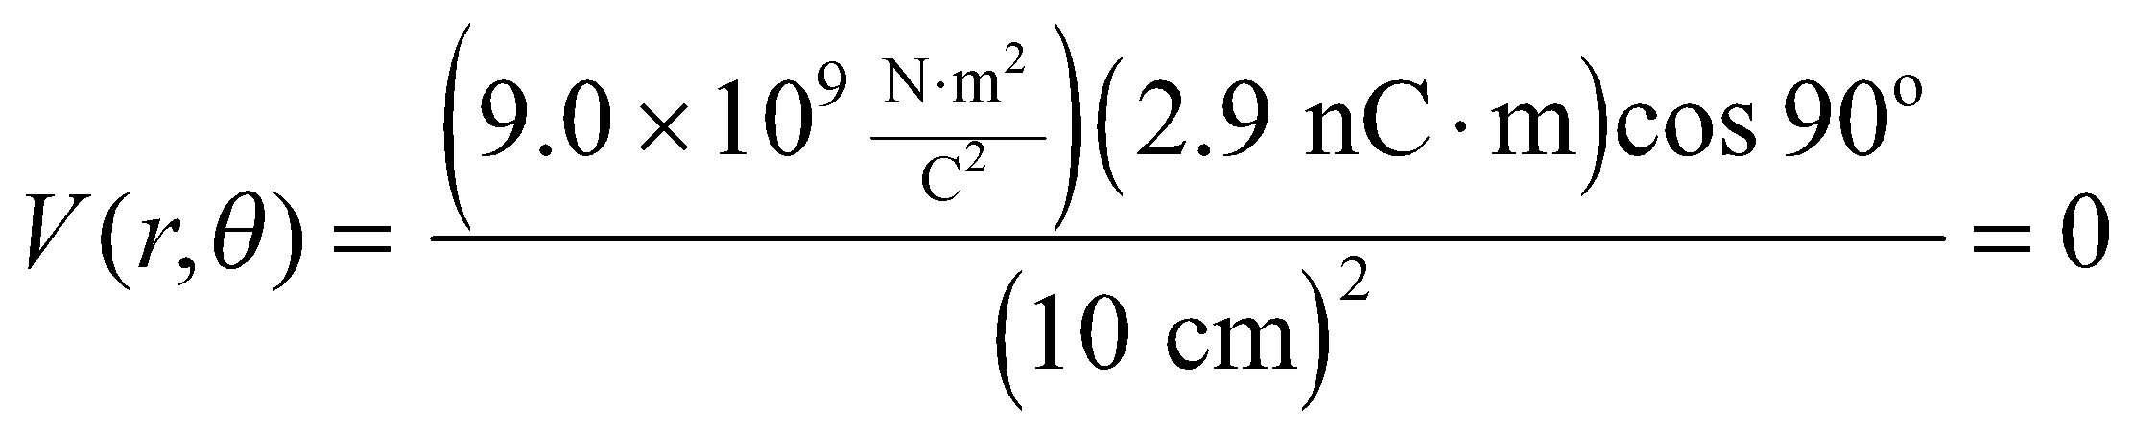

**Assess** The results seem reasonable. It should be made clear that these values assume the potential is zero at infinity. This is an arbitrary choice, since the only physical quantity is the potential difference between two points.

**54. Interpret** The problem is about finding the electric potential due to two continuous charge distributions, both of which have circular symmetry.

**Develop** From Example 22.6, we see that the electric potential at the center of a charged ring (i.e., *x* = 0) of radius *a* is

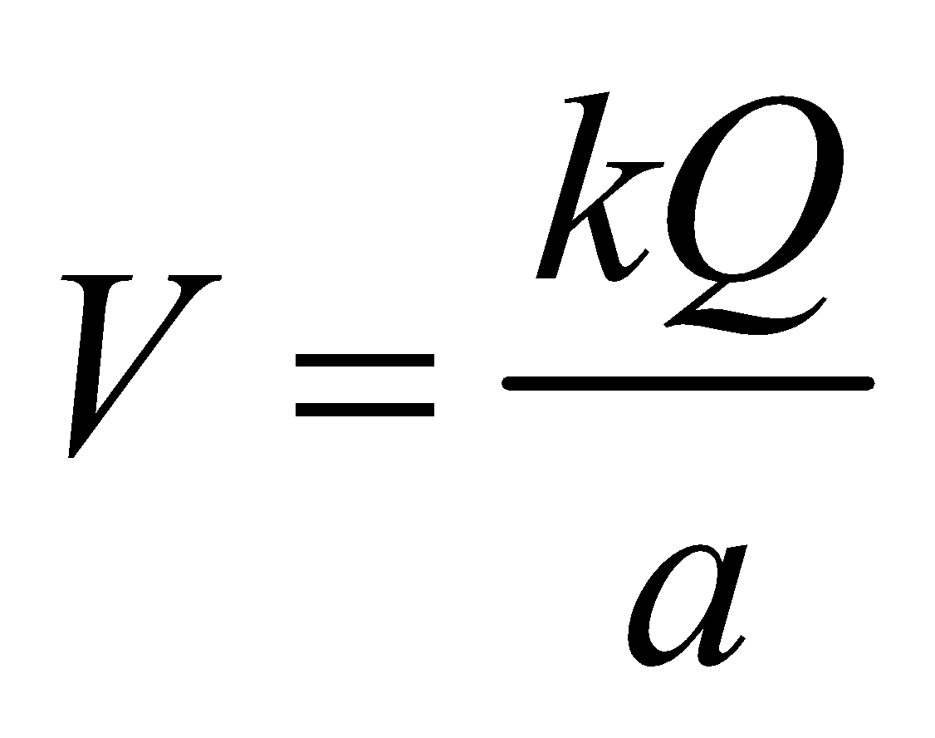

The radius a can be found from the relation *L* = 2*πa*, where *L* is the length of the rod. For the second part, we can use the derivation of Example 22.6 again, the radius of the semicircle is larger because *L* = *πa*. The integration stays the same because the distance to the center of the semicircle is the same (= *a*) for all points on the semicircle and we integrate over the length *L*.

**Evaluate** **(a)** The radius of the circle is 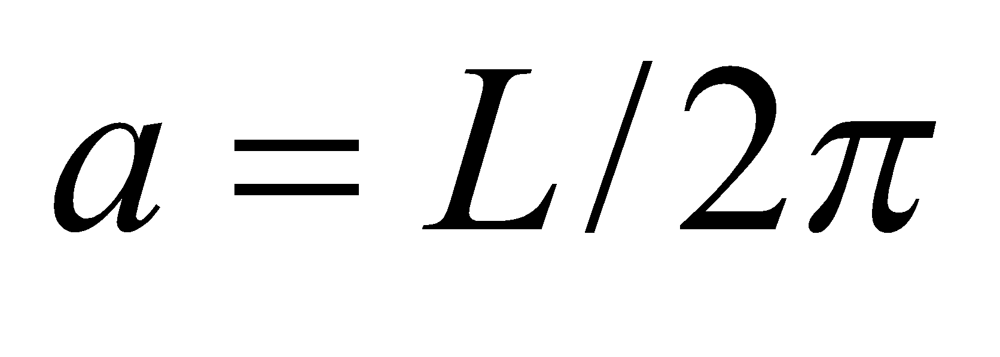. Therefore, the potential at the center of a uniformly charged ring is



to two significant figures.

**(b)** The radius is now *a′* = *L*/*π*, so the potential is



to two significant figures.

**Assess** Electric potential is a scalar, so there is no need to consider angles, vector components, or unit vectors.

**55.** **Interpret** This problem involves finding the electric potential at the center of a non-uniform circular charge distribution. Because the charge is non-uniform, we will need to integrate over it to find the potential.

**Develop** Note that the result of Example 22.6 does not depend on the ring being uniformly charged. For a point on the axis of the ring, the geometrical factors are the same, and  for any arbitrary charge distribution, so



still holds.

**Evaluate** Thus, at the center (i.e., *x* = 0) of a ring of total charge  and radius *a* = *R*, the potential is .

**Assess** This integration was simple, because the charge was all located the same distance from the point of interest (i.e., from the center of the circle).

**56. Interpret** This problem is about the electric potential due to a charged ring, which is a circularly symmetric, continuous charge distribution.

**Develop** From Example 22.6, we see that the electric potential at the center of a charged ring of radius *a* is



At a distance *x* along the ring axis from the center of the ring, the potential is



These two equations allow us to determine the radius *a* and the total charge *Q*.

**Evaluate** Substituting the values given in the problem statement yields



Thus, we find



The charge is



to two significant figures.

**Assess** In this problem, we are given two conditions, which allow us to solve for two unknowns—the radius and the charge of the ring. Note that the electric potential is the greatest at the center of the ring and falls off as *x* increases. When 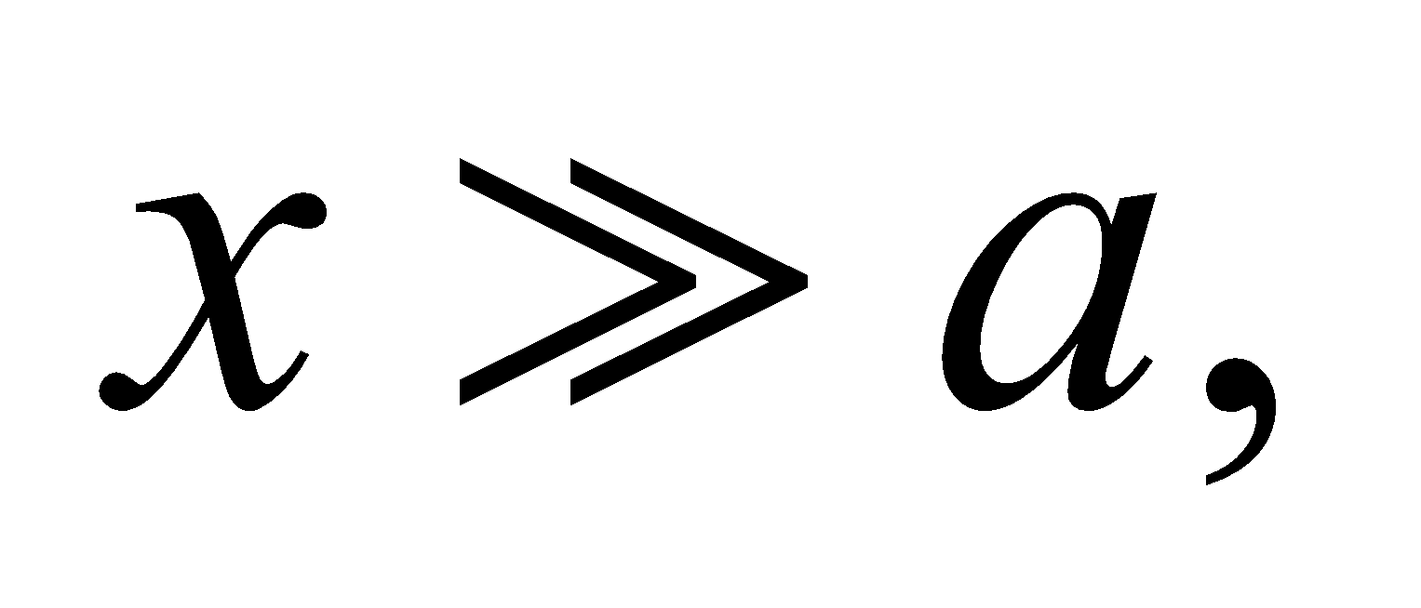 the potential resembles that of a point charge: 

**57.** **Interpret** This problem involves a circularly symmetric, uniform charge distribution for which we are to find an expression for the electric potential at arbitrary points along its axis.

**Develop** The annulus can be considered to be composed of thin rings of radius  and charge  (see Example 22.7 and Figs. 22.12 and 12.13). The contribution from a ring to the electric potential on the axis, a distance *x* from the center, is  (see Example 22.6), which we can integrate from *r* = *a* to *r* = *b* to find the potential *V*.

**Evaluate** The potential from the whole annulus is:



**Assess** This reduces to the potential on the axis of a uniformly charged disk if 

**58.** **Interpret** We are to find the electric field given the electric potential as a function of position and sketch some field and equipotential lines.

**Develop** Apply Equation 22.9 to find the electric field:



For this problem the potential *V* is a function of *x* an *y* only, so the third term in the expression above is zero. To draw the equipotential lines, first draw the electric field lines, then draw the equipotential lines so that they are everywhere perpendicular to the electric field lines.

**Evaluate** **(a)** Using *V*(*x*, *y*) = *axy*, the electric field is



**(b)** See sketch below. The field lines (dashed) are perpendicular to the equipotentials (solid) in the direction of decreasing potential (arrows for *a* > 0 in this case). These equipotentials and field lines are confocal hyperbolas, proportional to *xy* and  respectively, and are sketched only for *x* and *y* in the first quadrant.



**Assess** Notice that the field lines and the equipotential lines are everywhere mutually perpendicular.

**59. Interpret** In this problem we are to use the expression for the electric dipole potential to find the electric field at a point on the perpendicular bisector of the dipole.

**Develop** The dipole potential is given by Equation 22.6:



Using Equation 22.9, the general expressions for the *r* and *θ* components of the electric fields are



**Evaluate** On the bisecting plane,  which yields  and  or  To compare with Equation 20.6a, we take the origin at the center of the dipole, the dipole moment along the *x* axis  and the *y* axis up in Fig. 22.10, so  and  on the bisecting plane. This leads to 

**Assess** Instead of using polar coordinates, one could first express *V* in terms of *x* and *y* (using  and

):



and then differentiate,  and  The result is the same.

**60.** **Interpret** We are to derive an expression for the electric field on the axis of a charged ring given the potential on the axis. This geometry has circular symmetry.

**Develop** On the axis of a uniformly charged ring (the *x* axis), (Equation 22.8). Because of the circular symmetry all contributions to the electric field cancel except for those along the *x* axis (because any contribution in the  or  direction will be cancelled by an equal but opposite contribution from the other side of the ring). Thus, we can apply the *x*-component of Equation 22.9 to find the electric field.

**Evaluate** The electric field on the axis of the ring is



which is the result of Example 20.6.

**Assess** In general, one needs to know the potential in a 3-dimensional region in order to calculate the field from its partial derivatives.

**61. Interpret** We are given the electric potential and asked to find the corresponding electric field.

**Develop** We first note that the potential  depends only on *r*. This implies that the electric field is spherically symmetric and points in the radial direction. The field can be calculated using Equation 22.9,



In spherical coordinates, this is



Because the potential depends only on r, the second two terms in this expression will give zero.

**Evaluate** The electric field is



where  is a unit vector that points radially outward.

**Assess** The electric field is uniform, but the potential is linear in *r*. The difference of one power in *r* is because the potential is an integral of the field over distance.

**62.** **Interpret** For this problem, we are to find the potential of two isolated metal spheres carrying the given charge. After we connect them with a wire, we are to find the new potential of each, and find how much charge moved between them to reach equilibrium.

**Develop** Because the spheres are far apart (approximately isolated), we can use Equation 22.3 *V* = *kq*/*r* to find their potentials with respect to the same zero potential at infinity. When connected by a thin wire, the spheres reach electrostatic equilibrium and the same potential, so  Since the radii are equal, the charges must be equal, so and we can solve this given conservation of charge (i.e. ). Finding the charge that transferred is then a simple problem of finding the difference .

**Evaluate** (a) The initial electric potential on sphere 1 is



The initial electric potential on sphere 2 is



(b) The total charge is  (if we assume that the wire is so thin that it has a negligible charge), so 

(c) In this process, the first sphere loses 38 − 14 = 24 nC to the second.

**Assess** Conservation of charge proved useful in this problem, and is a concept that is used throughout physics.

**63. Interpret** We are given two charge-carrying conducting spheres, and we want to find the electric potential and electric field at various points.

**Develop** Since the spheres are separated by a distance that is over an order of magnitude greater than the radii of the spheres, we can consider them to be isolated spheres. Thus, their charge distributions are essentially spherical and we can apply Equation 22.3 to find the potential.

**Evaluate** **(a)** Using the result obtained in Example 22.3, at the surface of either sphere, the potential is



**(b)** From Equation 22.9 (or Equation 21.3), the electric field at the surface of each sphere is



**(c)** Midway between the spheres, the potential from each one is the same, so we apply the principle of superposition and sum the two potentials to find



**(d)** Since the spheres are at the same potential, the difference is zero.

**Assess** In this problem, the two conducting spheres can be treated as being isolated because they are far apart  and the superposition principle applies. If they were brought close to each other, then the charge distribution would no longer be spherical.

**64.** **Interpret** This problem involves a pair of concentric spheres, the inner one solid and the outer hollow. Both are conducting and carry the given charge. We are to find the potential between the spheres. The principle of superposition will be of use for this problem.

**Develop** From Problem 22.45, we learned that the potential inside a conducting spherical shell is constant and the same as the potential at the surface of the sphere, which we can find using Equation 22.3. The potential difference between the two spheres is the difference in the potential of the each sphere individually.

**Evaluate** (**a**) The potential at the surface of the outer spheres is



and the potential due to the inner sphere is



The potential difference between the spheres is



(**b**) Adding more charge to the outer shell will change *V*1, but this will become the new constant potential inside the sphere to which is added the potential of the inner sphere. Thus, the potential difference will not change. Only the potential difference outside the outer sphere will change with respect to the potential at infinity.

**Assess** Adding the charge to the outer sphere raises the potential of the entire space inside it, so the potential of the inner sphere simply “floats” up on that of the outer sphere. Therefore, the potential difference does not change.

**65.** **Interpret** This problem gives the electric field of a spherically symmetric charge distribution (i.e., it only depends on *r*, not on *θ* or *φ*), and we are to find the difference in electric potential between the sphere center and its outer edge.

**Develop** Apply Equation 22.1a,



where , *A* is the sphere center, and *B* is the outer surface of the sphere.

**Evaluate** Evaluating the integral gives



**Assess** The outer surface of the sphere (point *B*) is thus at a lower potential than the inner surface, which is normal because the potential decreases in the direction of the electric field, which in this case points radially outward.

**66. Interpret** This problem gives an electric potential function from which we are to get several pieces of information. First, we must find the point of zero potential on the *x* axis. Second, we are to find the electric field function. Finally, we are to find the positions on the *x* axis where the electric field is zero.

**Develop** We first note that the potential can be rewritten as



Since the potential *V* is independent of *y* and *z*, the electric field has only an *x* component, which can be computed using Equation 22.9: .

**Evaluate** **(a)** From the equation above, we see that *V*(*x*) = 0 at *x* = 0, 1, and 3 m.

**(b)** Differentiating *V* with respect to *x*, we find



**(c)** Solving the quadratic equation, the solutions for  are



**Assess** The component of the electric field is the negative of the rate of change of the potential. So the points where  are where the slope of *V*(*x*) vanishes (see figure below).



**67.** **Interpret** This problem concerns a conducting sphere surrounded by a concentric conducting shell. We are given the charge on each and are to find the electric potential at the sphere’s surface.

**Develop** Recall from Example 21.1 that the electric field outside a spherically symmetric charge distribution is that of a point charge with all the charge *Q* at that point (i.e., ). Use this result in Equation 22.1a to find the potential of the inner sphere with respect to the potential at infinity. This gives



**Evaluate** (a) Inserting *Q*1 = 60 nC and *Q*2 = −60 nC into the expression above gives



(b) Inserting *Q*1 = 60 nC and *Q*2 = 60 nC into the expression above gives



**Assess** As discussed in Problem 22.64, the potential inside a conducting shell is constant and is equal to the potential at the surface of the shell (with respect to the potential at infinity). Thus, the potential of any object inside the shell “floats” on the potential of the shell.

**68. Interpret** This problem deals with the electric field of a charged disk. We want to show that the expression derived in Example 22.8 has the correct asymptotic behavior.

**Develop** From Example 22.8, the electric field on the axis (*x* > 0) of a charged disk of radius *a* is



In the limit where  the quantity  may be approximated as



**Evaluate** Inserting the above approximation into the exact expression, we obtain



which is like that of a point charge.

**Assess** As always, a finite-size charge distribution looks like a point charge at a large distance.

**69.** **Interpret** We are given the potential of a disk on its axis at two distances from the disk and are to find the disk radius and its total charge.

**Develop** Combining the given data with the potential in Example 22.7, we find





Taking the ratio of these two equations eliminates the charge, so we can solve for the radius *a*, following which we can solve for the charge *Q*.

**Evaluate** The ratio of these two expressions gives



Several lines of algebra to remove the square roots finally yields



We can now solve for *Q* from either of the first two equations, which gives



**Assess** The units for the expression for charge is V·C2/(N·m) = (N/C)·m·C2/(N·m) = C.

**70. Interpret** This problem is about the work done by the electric field in separating the thorium nucleus and the alpha particle.

**Develop** The work done by the Coulomb repulsion as the thorium nucleus and the alpha particle separate is



where *R* = 7.4 fm is the initial separation. (The final separation is essentially infinity.) However, the work-energy theorem requires that this equal the change in the kinetic energy of the two particles:



Note that the two particles start from rest. The conservation of momentum (under the same assumptions) requires also that  (since the total momentum is zero initially), so that  can be determined.

**Evaluate** Combining the two expressions, and noting that  gives



The speeds are  and  where we have used 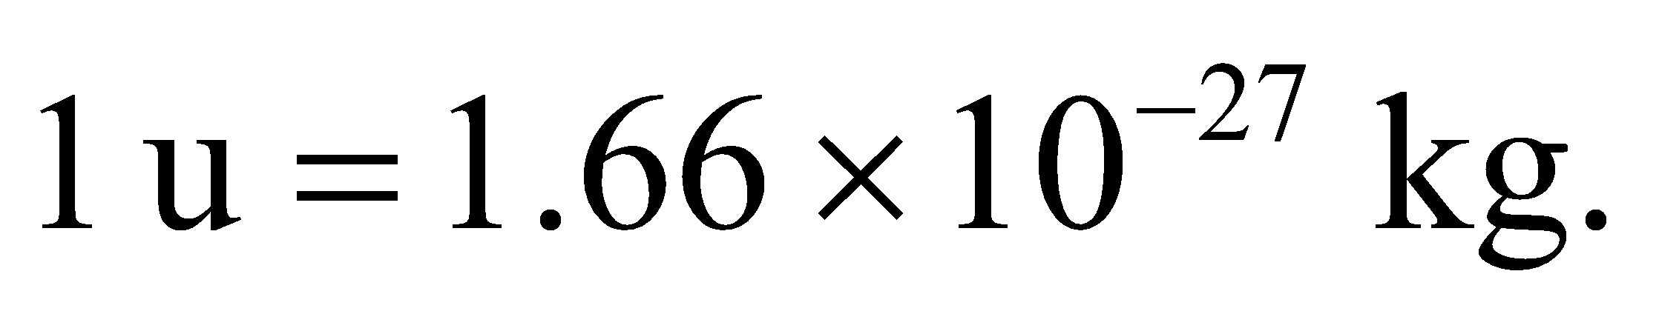

**Assess** Since  we expect which is what we found.

**71.** **Interpret** This problem involves a disk with a circularly symmetric charge distribution. We are to find an expression for the potential on the disk axis, the electric field on the disk axis, and show that the electric field decays as 1/*x*2 for 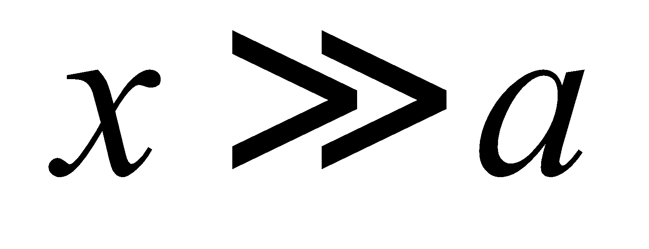 (*a* is the disk radius).

**Develop** For part (a), use the integral expression for voltage of Example 22.7,



For this problem,  with, which gives



The electric field is the spatial derivative of the potential (see Equation 22.9).

**Evaluate** **(a)** Reference to standard integral tables gives



**(b)** As in Example 22.8,  results in



**(c)** The logarithm has to be expanded carefully, up to order  to evaluate  for  Thus,



Also,



Then,



which is the field for a point charge with



**Assess** Checking the limits is a good manner to test the validity of expressions. If we were to have found that our expression for the electric field did not reduce at large distances to that of a point charge, then we could be sure that the expression is wrong. Of course, the correct asymptotic behavior does not guarantee that the expression is valid!

**72. Interpret** The cylinder is a continuous charge distribution, and we want to find the potential at its center on the axis.

**Develop** Following the hint given in the problem, we consider the cylinder to be composed of rings of radius *a*, width *dx*, and charge The potential at the center of the cylinder (which we take as the origin, with *x* axis along the cylinder axis) due to a ring at  is (see Example 22.6)



**Evaluate** The potential at the center is given by integrating the expression above, which gives



**Assess** The result can be compared with that at the center of a charged ring of radius *a*: . For the cylinder, the charge elements generally are farther away from the center compared to the ring, so we expect , which is what we find.

**73. Interpret** We need to find the potential due to a line charge with a non-constant charge density. The problem is one-dimensional: the line and the point of interest are all on the *x* axis. We will use the integral expression for potential. We must also show that the result reduces to that of a point charge for distances much, much larger than the length of the line charge.

**Develop** Consider the line charge to be a superposition of many point charges. The potential for each point charge is given by Equation 22.3, *dV* = *kdq*/*r*. Integrate this expression over the length of the line charge to find the total potential:



with  and .

**Evaluate** Evaluating the integral gives



For  we rearrange slightly and use the approximation  for small 



The total charge on the rod is



so in the limit of 



**Assess**At large distances, the potential looks like that of a point charge, as expected.

**74. Interpret** We need to find the potential due to a line of charge with a non-constant charge density. The problem is one-dimensional: the line and the point of interest are all on the *x* axis. We will use the integral expression for potential. We must also show that the result reduces to that of a point charge for distances much, much larger than the length of the line charge.

**Develop** Use the same strategy as for the previous problem. Start with



where  and  We must also check to see that our expression reduces to the expected result for  Because the total charge is zero for this charge distribution, we expect that the potential at large *x* goes as the potential for a dipole:

**Evaluate**



For  we rearrange slightly and use the approximation  for small 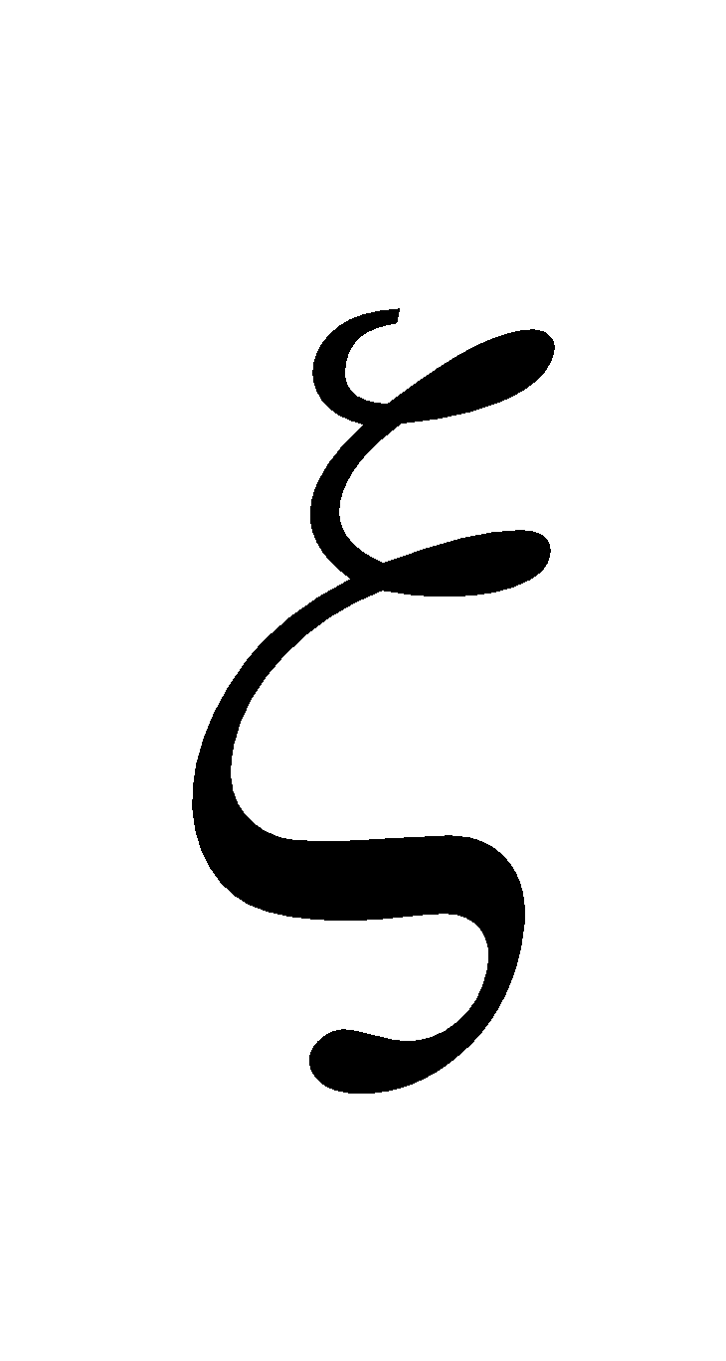:



**Assess** The potential at large distances goes as 1/*x*2, as predicted.

**75.** **Interpret** You need to find the minimum possible wire diameter that won't be susceptible to breakdown, which is when the air gets ionized by the electric field near the wire.

**Develop** You're told to neglect any charge distributions on the ground. Therefore, the electric field around the wire can be found with Gauss's law:  (Equation 21.6). The maximum field, which will be at the outer surface of the wire at radius needs to be at most 25% of the breakdown field in air, 3MV/m. The potential difference for a long wire was given in Equation 22.4: 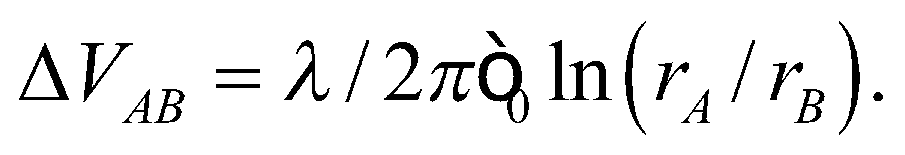 You know that there will be 115 kV between the wire's outer surface and the ground below You can combine the field and potential equations to solve for the radius 

**Evaluate** Combining the above information gives



where a negative sign has been added to the potential difference to be consistent with the fact that One way to solve this equation is with Newton's method. Let  and let  be your best guess for the root of *y*. Then you use the derivative of *y*, which in this case is  to find a better guess:

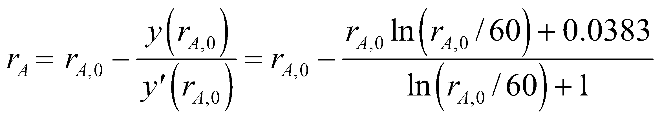

This process can be repeated several times with the of one iteration becoming the  of the next iteration. A good first guess for the radius might be 1 cm. The table below shows how quickly Newton's method converges on the root.

| ***rA*,0** | ***y(rA)*** | ***y'(rA)*** | ***rA*** |
| --- | --- | --- | --- |
| 0.01 | –0.048695147 | –7.699514748 | 0.003675556 |
| 0.003675556 | 0.002645651 | –8.700395344 | 0.00397964 |
| 0.00397964 | 1.22454E-05 | –8.62090841 | 0.003981061 |
| 0.003981061 | 2.53465E-10 | –8.620551548 | 0.003981061 |
| 0.003981061 | 0 | –8.620551541 | 0.003981061 |

The minimum radius is 4.0 mm, so the minimum diameter is 8.0 mm.

**Assess** An 8-mm wire would likely be too fragile for a transmission line, but this at least gives you the lower limit on what you could use.

**76.** **Interpret** We are asked to analyze an electrocardiograph showing equipotentials in a human torso.

**Develop** Let's first imagine what each of the answer possibilities might look like. A charged sheet would vary linearly with distance from the sheet (see Example 22.2), so the equipotentials would be straight lines parallel to the sheet. A dipole would have a "hill" and a "hole" in the electric potential separated by a bisector with (see Figures 22.11 and 22.16). A point charge would have concentric circles around it as equipotentials, as would a charged sphere (see Figure 22.15).

**Evaluate** The electrocardiograph shows a zero potential line running from the bottom left to the upper right. Above this line, there appears to be a sharp peak in the potential, whereas below the line we see a sharp valley. This is in rough agreement with the electric potential of a dipole.

The answer is (b).

**Assess** Recall Problems 20.80 through 20.83, where we explored how heart muscles gain a dipole moment when the heart contracts.

**77.** **Interpret** We are asked to analyze an electrocardiograph showing equipotentials in a human torso.

**Develop** From the 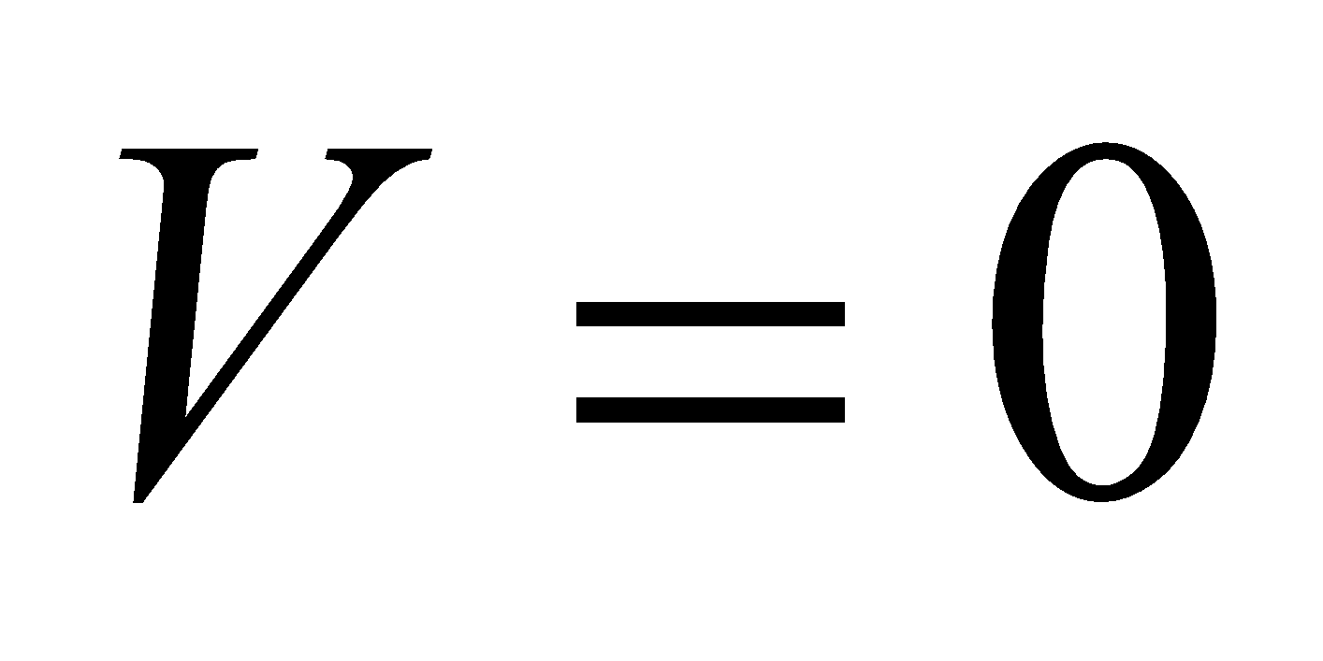 and the equipotentials, we can surmise that the potential rises to a peak in the upper left corner of the heart, and drops to a valley in the lower right corner of the heart.

**Evaluate** Since electric field lines point downhill, the electric field in the heart must point from the upper left to the lower right.

The answer is (a).

**Assess** Between the two charges of the dipole, the electric field is parallel to the dipole moment (see Figure 22.16).

**78.** **Interpret** We are asked to analyze an electrocardiograph showing equipotentials in a human torso.

**Develop** The electric field will point downhill with respect to the electric potential, and it will be stronger where the hill is steeper. The electric potential is steepest where the equipotential lines are closer together.

**Evaluate** Of all the points, *C* has the most equipotential lines crammed together, so the electric field will be the strongest there.

The answer is (c).

**Assess** The point C is right between the two charges of the dipole, so there is a large contribution from both charges to the field.

**79.** **Interpret** We are asked to analyze an electrocardiograph showing equipotentials in a human torso.

**Develop** The equipotential line at point *A* has  This line is approximately parallel and midway between the two surrounding equipotentials at 0.1 mV and 0.3 mV. Therefore, we can assume that the electric potential is approximately linear in this region with regard to the distance *x* from the 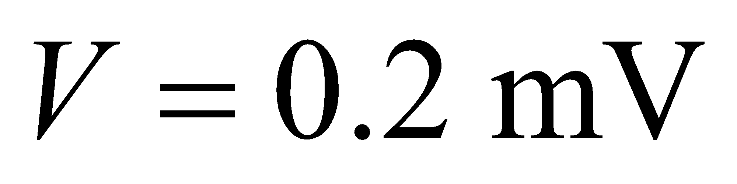 equipotential, i.e.,

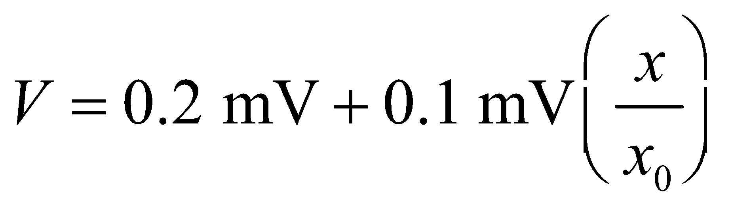

where  is the distance between the equipotential lines. Assuming the torso is about 30 cm across, we estimate that 

**Evaluate** The electric field is the derivative of the electric potential (Equation 22.9), so at the point *A* the field should be roughly:



The closest answer is (b).

**Assess** The units work out because  You can arrive at a similar answer by taking the derivative in radial components of the dipole potential in Equation 22.6:

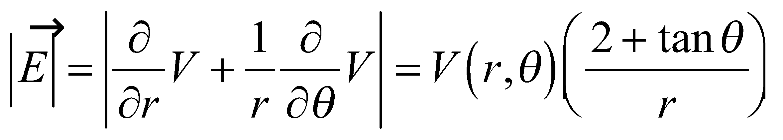

If we assume point *A* is located about 15 cm from the dipole center and at an angle of about 60° from the dipole axis, then the magnitude of the electric field at point A is about